BizTalk Adapter Pack 2.0 Installation and Configuration Guide For SAP Integration
Development and Test Installation and Configuration(64-bit Runtimes/SDKs/Adapters and 32-bit Visual Studio/SDKs/Adapters)_v1.4
Jay Kladiva
Energizer Holdings, Inc.
MCSE, MCSD, MCAD .NET, MCT, MCP + Site Builder
4/16/2010
This document outlines the complete installation and configuration for the BizTalk Adapter Pack 2.0 for integration scenarios with SAP. This whitepaper contains the required 32-bit and 64-bit installation and configuration so that you can development your solutions using Visual Studio and the WCF SDK running 32-bit and deploy it to the same machine and run it utilizing only 64-bit components, so essentially your BizTalk Development box serves two roles; BizTalk Development and BizTalk Production. This installation and configuration was built using Hyper-V R2 on a Dell Latitude D620 with 4GIG of RAM running Windows 2008 R2 Standard 64-bit.

Table of Contents
1. Document Information 4
1.1. Revision History 4
1.2. Reviewers and Sign-off 4
1.3. References 4
2. BizTalk Adapter Pack 2.0 64-bit Installation & Configuration Guide 5
2.1. Pre-requisites 5
2.2. Validate That the .NET Framework 3.5 SP1(x64) is Installed 5
2.3. RFCSDK(Unicode)(64-bit) 6
2.4. RFCSDK(Unicode)(32-bit) 6
2.5. R3DLLINS (64-bit) DLLs 7
2.6. R3DLLINS (32-bit) DLLs 8
2.7. Install Microsoft Visual C++ 2008 SP1 Redistributable Package (x64) 9
2.8. Install Microsoft Visual C++ 2008 SP1 Redistributable Package (x86) 12
2.9. Install the WCF LOB Adapter SDK SP2 (64-bit) 15
2.10. BizTalk Adapter Pack 2.0 (64-bit) 20
2.11. BizTalk Adapter Pack 2.0 (32-bit) 25
2.12. Post Install Configuration for BizTalk Adapter Pack 2.0 31
2.13. Add the Adapters to the BizTalk Admin Tool 35
2.14. Programs and Features Review 39
2.15. Test the SAP Microsoft BizTalk Adapter 3.0 for mySAP Business Suite 40
2.16. Configure the Microsoft BizTalk Adapter 3.0 for mySAP Business Suite to Utilize tRFC Calls 51

Document Information

Revision History
Revision | Description | Revised By | Revised on
v0.9 | Original Version | Jay Kladiva | 03/21/2010
v1.1 |  | Jay Kladiva | 03/30/2010
v1.4 |  | Jay Kladiva | 04/16/2010

Reviewers and Sign-off
Name | Role | Sign-off comments

References
Name of Document | Link/Location

BizTalk Adapter Pack 2.0 64-bit Installation & Configuration Guide

Pre-requisites
In order to utilize the BizTalk Adapter Pack 2.0 from within BizTalk you must have BizTalk 2009 or BizTalk 2006 R2 installed and configured, see BizTalk 2009 Installation and Configuration Guide at;
http://www.microsoftconnectedsystems.net/
listed under the BizTalk 2009 section.

Validate That the .NET Framework 3.5 SP1(x64) is Installed
Validate the .NET Framework 3.5 SP1(x64) is installed. There is a bunch of ways to do this, an easy way is to click this link;
http://www.hanselman.com/smallestdotnet/
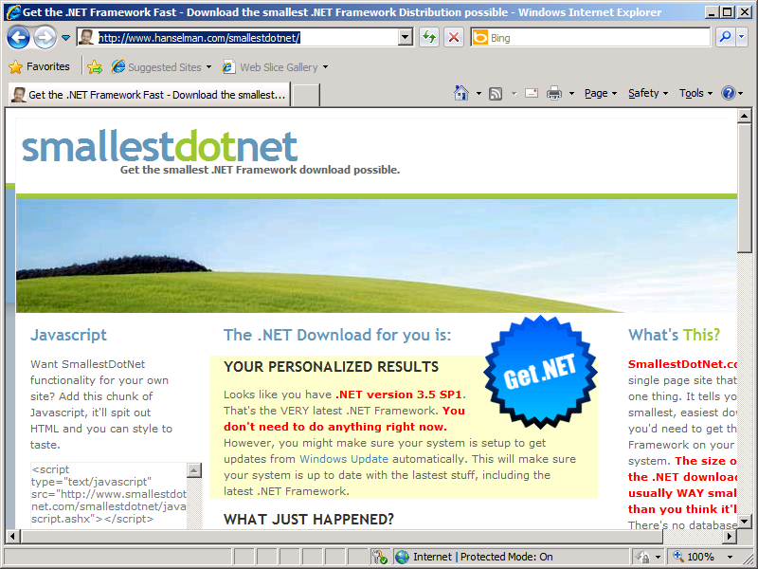

RFCSDK(Unicode)(64-bit)
Install the appropriate version of the RFCSDK. Always install the Unicode version of the RFCSDK even if your SAP system is Non-Unicode.
Download RFCSDK 7.0 (Unicode)(64-bit) and save the DLLS off to a folder on your BizTalk Server
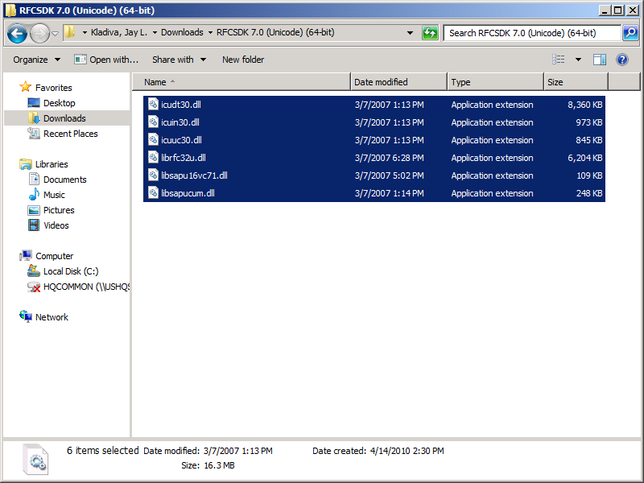
Copy the 6 DLLs from the SAP Software Download Center to the ‘C:\Windows\system32’ directory
NOTE: SAP GUI should not be installed, if it is installed on your BizTalk Server then you must remove it

RFCSDK(Unicode)(32-bit)
Install the appropriate version of the RFCSDK. Always install the Unicode version of the RFCSDK even if your SAP system is Non-Unicode.
Download RFCSDK 7.0 (Unicode)(32-bit) and save the DLLS off to a folder on your BizTalk Server
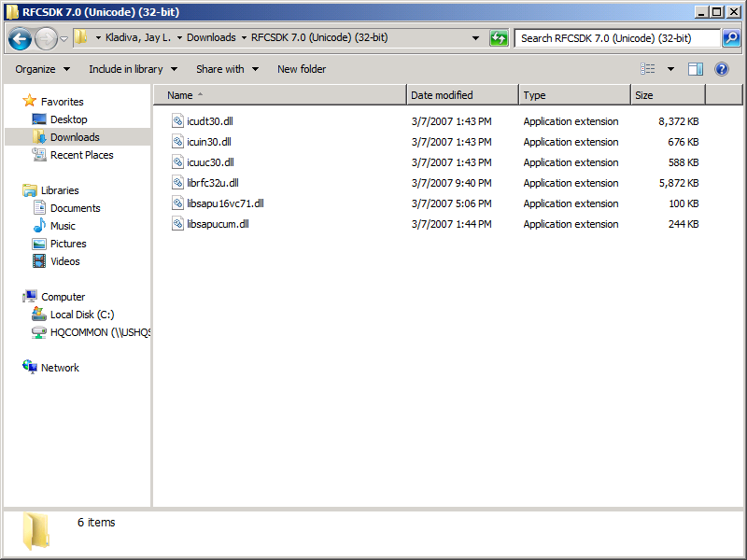
Copy the 6 DLLs from the SAP Software Download Center to the ‘C:\Windows\SysWOW64’ directory

R3DLLINS (64-bit) DLLs
Copy the 4 DLLS from the ‘ntpatch’ directory from the R3DLLINS.EXE program to the ‘C:\Windows\system32’ directory
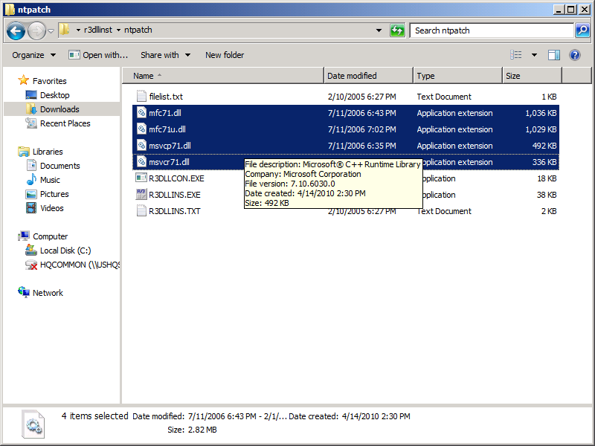

R3DLLINS (32-bit) DLLs
Copy the 4 DLLS from the ‘ntpatch’ directory from the R3DLLINS.EXE program to the ‘C:\Windows\SysWOW64’ directory
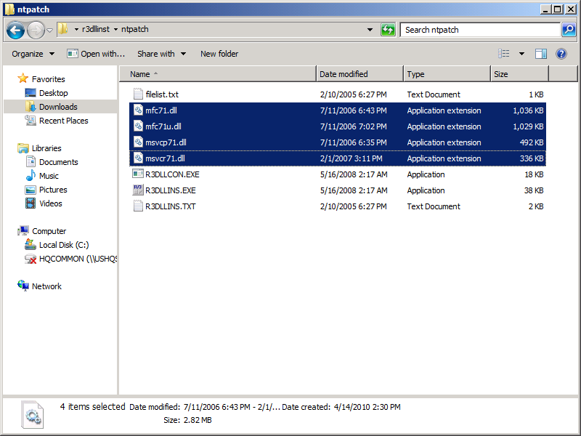

Install Microsoft Visual C++ 2008 SP1 Redistributable Package (x64)
Install the Microsoft Visual C++ 2008 SP1 (x64) Redistributable Package.
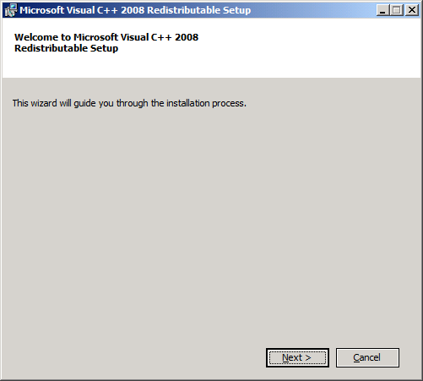
Click ‘Next’
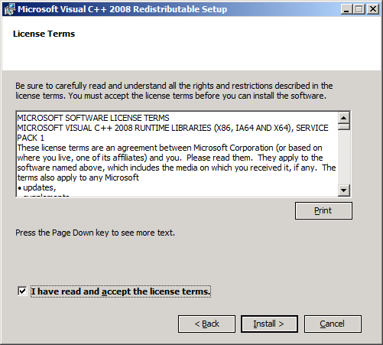
Accept the terms and click ‘Install’
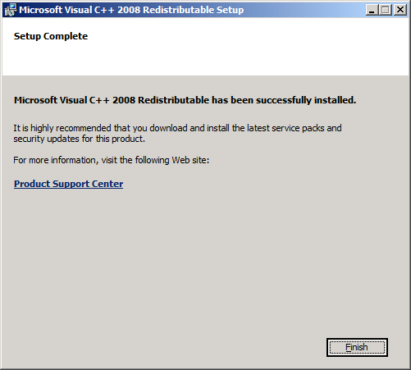
Click ‘Finish’

Install Microsoft Visual C++ 2008 SP1 Redistributable Package (x86)
Install the Microsoft Visual C++ 2008 SP1 (x86) Redistributable Package
Click ‘Next’
Accept the terms and click ‘Install’
Click ‘Finish’

Install the WCF LOB Adapter SDK SP2 (64-bit)
Install the WCF LOB Adapter SDK SP2 (64-bit)
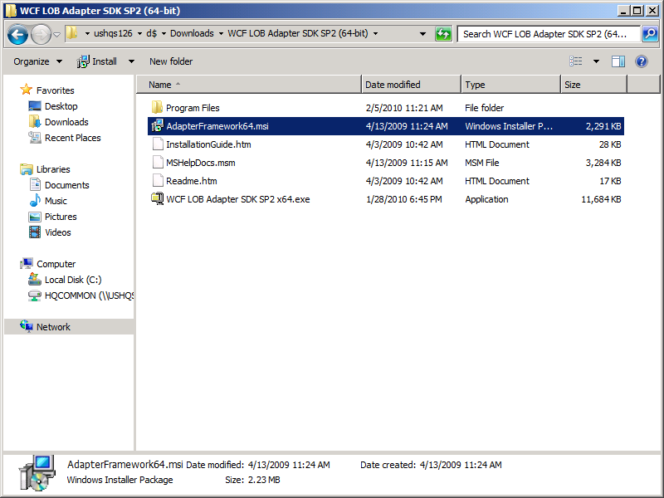
Execute the AdapterFramework64.msi
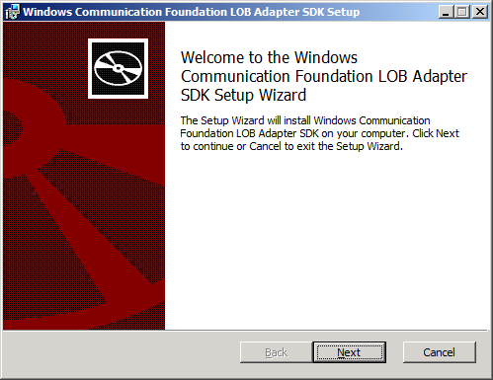
Click ‘Next’

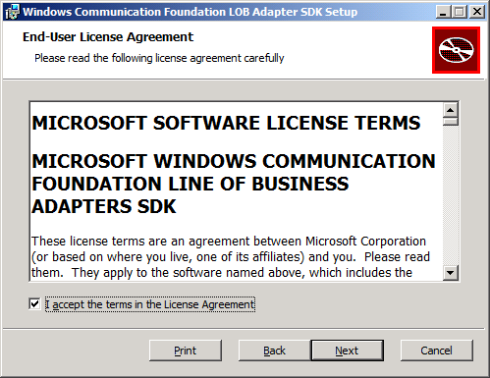
Accept the terms and click ‘Next’

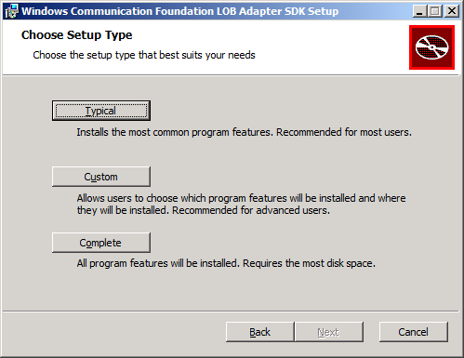
Click ‘Custom’
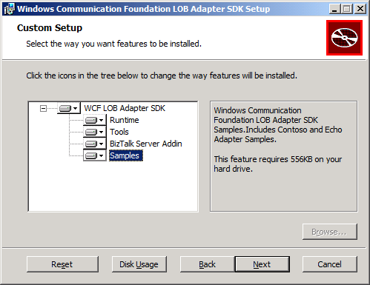
Select all of the features and then click ‘Next’

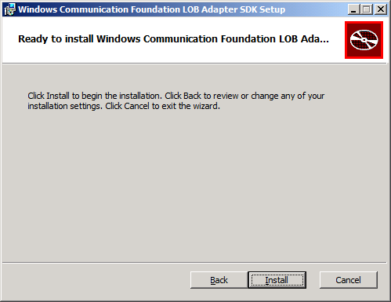
Click ‘Install’

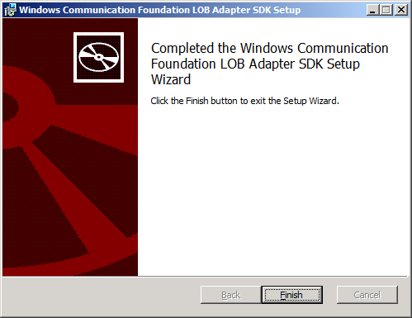
Click ‘Finish’

BizTalk Adapter Pack 2.0 (64-bit)
Install the BizTalk Adapter Pack 2.0 (64-bit)
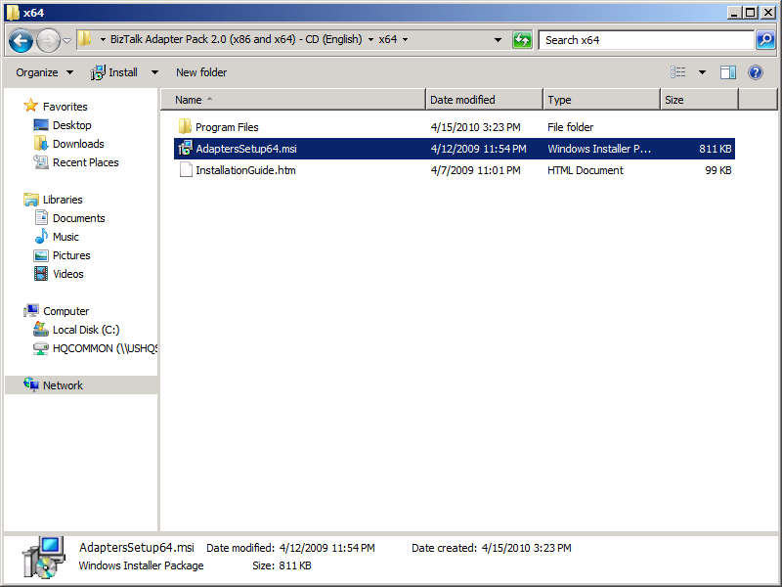
Execute the AdapterSetup64.msi
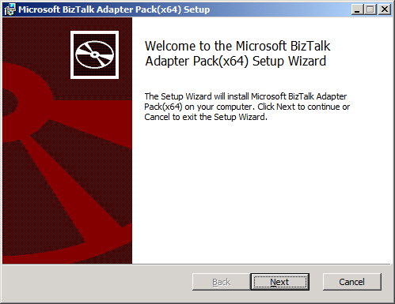
Click ‘Next’

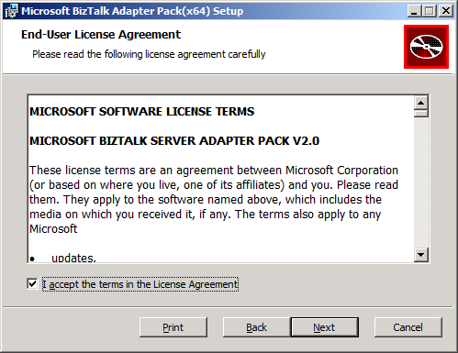
Accept the terms and click ‘Next’

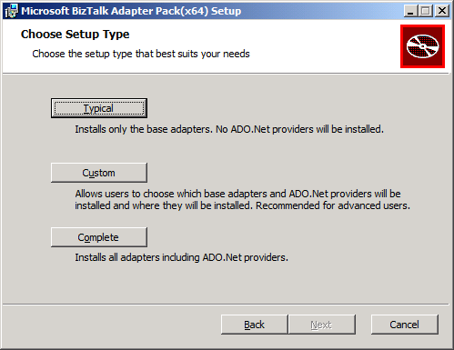
Click ‘Custom’
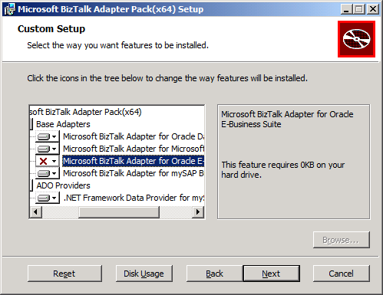
Choose the SAP Adapter and any others you need, click ‘Next’

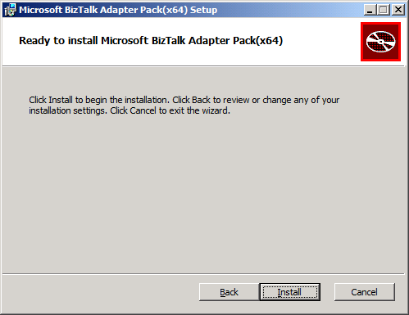
Click ‘Install’

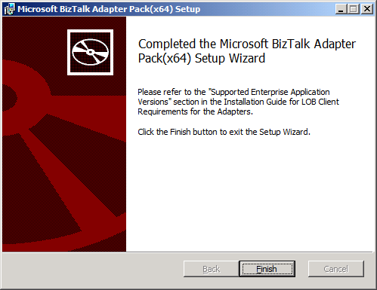
Click ‘Finish’
NOTE: Post Install, the SAP and SQL Adapters need some configuration that is listed in the InstallationGuide.htm, a portion of the InstallationGuide.htm is listed in section 2.12.

BizTalk Adapter Pack 2.0 (32-bit)
Install the 32-bit BizTalk Adapter Pack 2.0 32-bit.
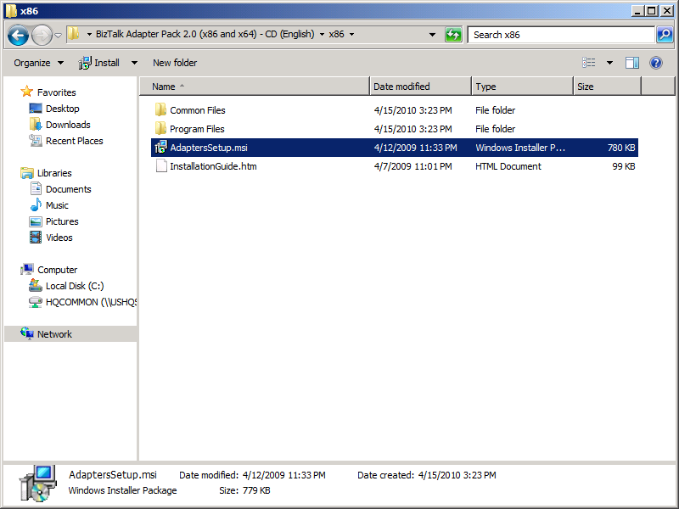
Execute the ‘ApaptersSetup.msi
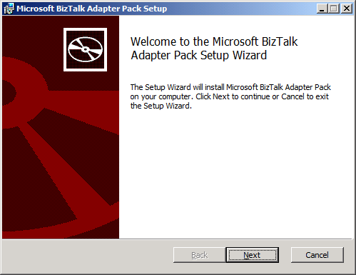
Click ‘Next’

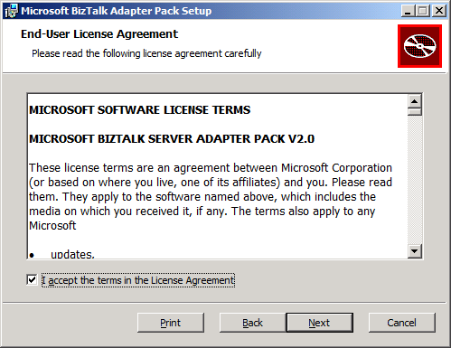
Accept the terms and click ‘Next’

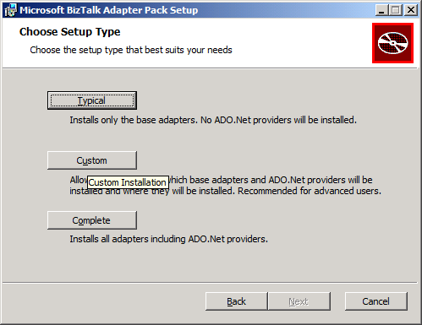
Select ‘Custom’
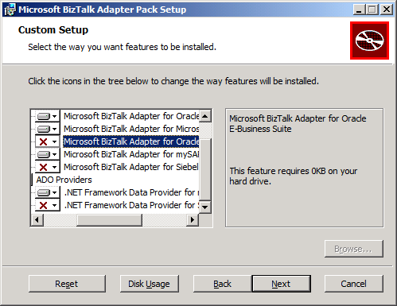
Select the Adapters you need for your environment, make sure you install the Microsoft BizTalk Adapter 3.0 for mySAP Business Suite and the Microsoft BizTalk Adapter 3.0 for SQL Server, click ‘Next’
NOTE: Always install the Microsoft BizTalk Adapter 3.0 for SQL Server and utilize this for SQL Server communication instead of the legacy SQL Adapter which is listed as ‘SQL’ under ‘Adapters’ in the BizTalk Admin Tool.

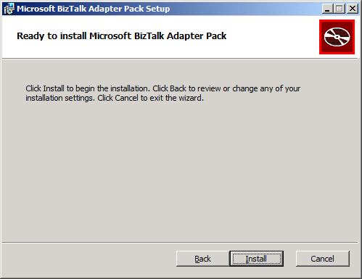
Click ‘Install’

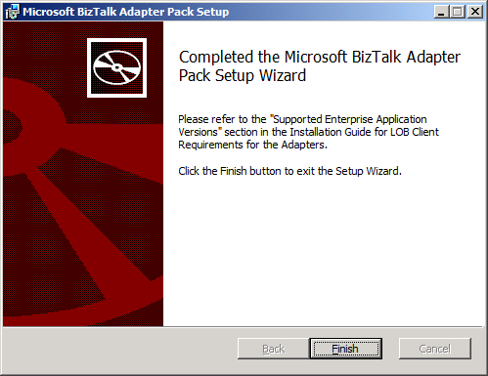
Click ‘Finish’
NOTE: Post Install, the SAP and SQL Adapters need some configuration that is listed in the InstallationGuide.htm, a portion of the InstallationGuide.htm is listed in section 2.12.

Post Install Configuration for BizTalk Adapter Pack 2.0
After Installing the BizTalk Adapter Pack you might need to perform the following tasks after installing the BizTalk Adapter Pack, based on what operations you want to perform using the adapter:
- Invoking transactional RFCs (tRFCs) in an SAP system. If you want to invoke tRFCs in an SAP system, you must run the SQL script, SapAdapter-DbScript-Install.sql. This script is installed as part of the BizTalk Adapter Pack installation.
- Manually registering the bindings. Register the adapter bindings and the .NET Framework Data Providers if the setup wizard failed to do so.
- Using the Data Provider for SAP. You must install the custom RFCs if you chose to install the Data Provider for SAP.

Creating Tables in a SQL Server Database (Only for the SAP Adapter)
To invoke tRFCs in an SAP system you must run the SQL script, SapAdapter-DbScript-Install.sql. This script is installed as part of the BizTalk Adapter Pack installation and creates the database and the database objects in SQL Server. The script is typically installed at <installation drive>:\Program Files\Microsoft BizTalk Adapter Pack.

Registering the Bindings
You only need to perform these steps if the setup wizard fails to register the adapter bindings or .NET Framework Data Providers in the machine.config file.
To register the adapter bindings or the .NET Framework Data Providers
- Navigate to the machine.config file on the computer. For example, on a 32-bit platform, the machine.config is available under <system drive>:\WINDOWS\Microsoft.NET\Framework\<version>\CONFIG.
In the preceding path, <version> is the version of the .NET Framework. For example, for Microsoft .NET Framework 3.5 SP1, the version is v2.0.50727.
- Open the file using a text editor.
- To register the adapter bindings:
  - Search for the element "system.serviceModel" and add the following under it:
  - <client>
  - <endpoint binding="sapBinding" contract="IMetadataExchange" name="sap" />
  - <endpoint binding="siebelBinding" contract="IMetadataExchange" name="siebel" />
  - <endpoint binding="oracleDBBinding" contract="IMetadataExchange" name="oracleDb" />
  - <endpoint binding="oracleEBSBinding" contract="IMetadataExchange" name="oracleEBS" />
  - <endpoint binding="sqlBinding" contract="IMetadataExchange" name="mssql" />
</client>
  - Search for the element "bindingElementExtensions" under system.serviceModel\extensions.
  - Look for the missing adapter binding. Add the following sections under the "bindingElementExtensions" node, depending on the missing adapter binding. You must register all the bindings if the setup wizard fails to register any.
For the SAP adapter, add:
<add name="sapAdapter" type="Microsoft.Adapters.SAP.SAPAdapterExtensionElement,Microsoft.Adapters.SAP, Version=<version>, Culture=neutral, PublicKeyToken=<public key>" />
For the Siebel adapter, add:
<add name="siebelAdapter" type="Microsoft.Adapters.Siebel.SiebelAdapterExtensionElement,Microsoft.Adapters.Siebel, Version=<version>, Culture=neutral, PublicKeyToken=<public key>" />
For the Oracle Database adapter, add:
<add name="oracleDBAdapter" type="Microsoft.Adapters.OracleDB.OracleDBAdapterExtensionElement,Microsoft.Adapters.OracleDB, Version=<version>, Culture=neutral, PublicKeyToken=<public key>" />
For the Oracle E-Business adapter, add:
<add name="OracleEBSAdapter" type="Microsoft.Adapters.OracleEBS.OracleEBSBindingElementExtensionElement, Microsoft.Adapters.OracleEBS, Version=<version>, Culture=neutral, PublicKeyToken=<public key>" />
For the SQL adapter, add:
<add name="sqlAdapter" type="Microsoft.Adapters.Sql.SqlAdapterBindingElementExtensionElement,Microsoft.Adapters.Sql, Version=<version>, Culture=neutral, PublicKeyToken=<public key>" />
  - Search for the element "bindingExtensions" under system.serviceModel\extensions.
  - Look for the missing adapter binding. Add the following sections under the "bindingExtensions" node, depending on the missing adapter binding. You must register all the bindings if the setup wizard fails to register any.
For SAP adapter, add:
<add name="sapBinding" type="Microsoft.Adapters.SAP.SapAdapterBindingSection,Microsoft.Adapters.SAP, Version=<version>, Culture=neutral, PublicKeyToken=<public key>" />
For Siebel adapter, add:
<add name="siebelBinding" type="Microsoft.Adapters.Siebel.SiebelAdapterBindingSection,Microsoft.Adapters.Siebel, Version=<version>, Culture=neutral, PublicKeyToken=<public key>" />
For Oracle Database adapter, add:
<add name="oracleDBBinding" type="Microsoft.Adapters.OracleDB.OracleDBAdapterBindingSection,Microsoft.Adapters.OracleDB, Version=<version>, Culture=neutral, PublicKeyToken=<public key>" />
For Oracle E-Business adapter, add:
<add name="OracleEBSBinding" type="Microsoft.Adapters.OracleEBS.OracleEBSBindingCollectionElement, Microsoft.Adapters.OracleEBS,Microsoft.Adapters.OracleEBS, Version=<version>, Culture=neutral, PublicKeyToken=<public key>" />
For SQL adapter, add:
<add name="sqlBinding" type="Microsoft.Adapters.Sql.SqlAdapterBindingCollectionElement,Microsoft.Adapters.Sql, Version=<version>, Culture=neutral, PublicKeyToken=<public key>" />
Note
For information about how to determine the public key, see Determining the Public Key and Version.
- To register the .NET Framework Data Providers:
  - Search for the element DbProviderFactories under the system.data node.
  - Look for the missing .NET Framework Data Providers. Add the following sections under the DbProviderFactories node, depending on the missing provider. You must register all the providers if the setup wizard fails to register any.
For the Data Provider for SAP, add:
  - <add name="SAPClient Data Provider" invariant="Microsoft.Data.SAPClient"
description=".NET Framework Data Provider for mySAP Business Suite" type="Microsoft.Data.SAPClient.SAPClientFactory,Microsoft.Data.SAPClient, Version=<version>, Culture=neutral, PublicKeyToken=<public key>" />
For the Data Provider for Siebel, add:
<add name="SiebelClient Data Provider" invariant="Microsoft.Data.SiebelClient"
description=".NET Framework Data Provider for Siebel eBusiness Applications"
type="Microsoft.Data.SiebelClient.SiebelProviderFactory,Microsoft.Data.SiebelClient, Version=<version>, Culture=neutral, PublicKeyToken=<public key>" />
- Save and close the machine.config file.

Determining the Public Key and Version
Perform the following steps to determine the public key and version for an adapter or .NET Framework Data Provider.
To determine the public key
- Navigate to the Windows directory, typically C:\WINDOWS\assembly.
- Right-click the DLL for which you want the public key, and then select Properties. The following table lists the name of the DLLs for each adapter and provider.
Adapter/.NET Framework Data Provider | Name of the DLL
SAP adapter | Microsoft.Adapters.SAP
Siebel adapter | Microsoft.Adapters.Siebel
Oracle Database adapter | Microsoft.Adapters.OracleDB
Oracle E-Business adapter | Microsoft.Adapters.OracleEBS
SQL adapter | Microsoft.Adapters.Sql.dll
Data Provider for SAP | Microsoft.Data.SAPClient
Data Provider for Siebel | Microsoft.Data.SiebelClient
- On the General tab, the value against the Public Key Token label specifies the public key for the DLL. Similarly, the value against the Version label specifies the version number for the DLL.
- Copy the public key, and then click Cancel.

Installing the Custom RFCs
You only need to perform this task if you want to use the Data Provider for SAP. For instructions on installing custom RFCs, see the "Installing Custom RFCs for the Data Provider for SAP" topic in the SAP adapter documentation. The document is typically installed at <installation drive>:\Program Files\Microsoft BizTalk Adapter Pack\Documents.
Important
If you are using an earlier version of the custom RFCs provided with the BizTalk Adapter Pack, you must upgrade them to the RFCs provided with this release. You must do so by removing the earlier RFCs and instead installing the RFCs shipped with this release.

Add the Adapters to the BizTalk Admin Tool
Add the Adapters to the ‘Adapters’ section on the BizTalk Admin Tool
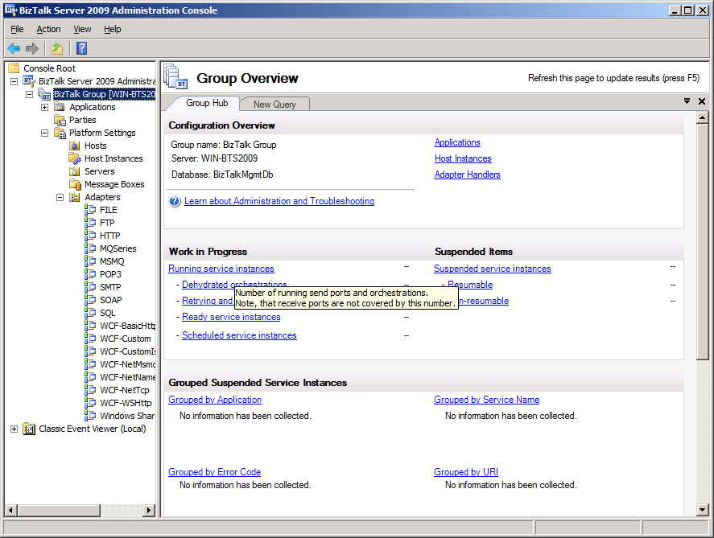
Right-click ‘Adapters’ and click ‘New’
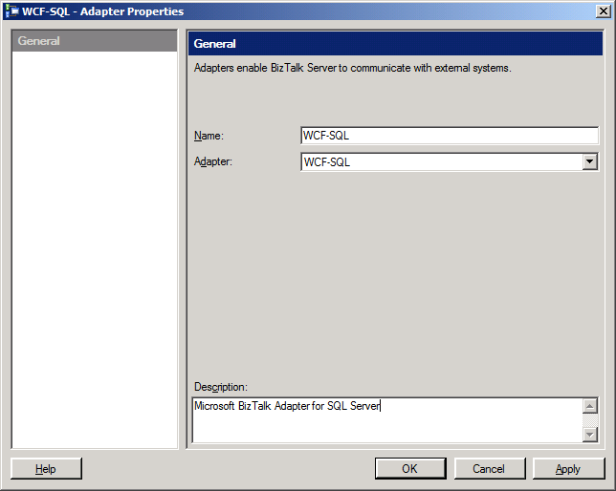
Select ‘WCF-SQL’ from the ‘Adapter’ dropdown and type ‘WCF-SQL’ in the ‘Name’ field, click ‘Apply’.
When you hit ‘Apply’, you get this warning.
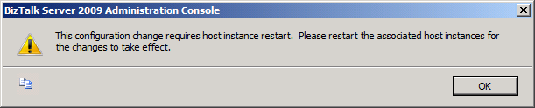
Click ‘OK’ and ignore this. Repeat this same process for the other adapters you installed.
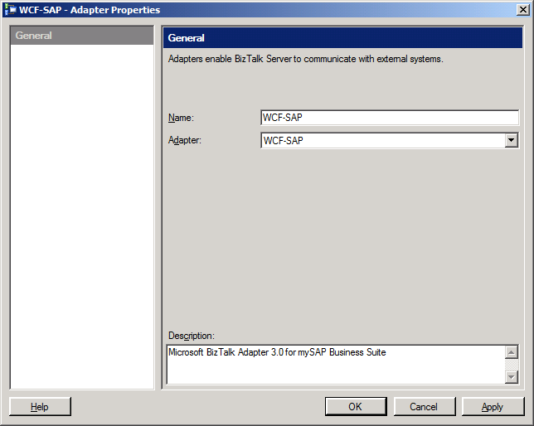
Select ‘WCF-SAP’ from the ‘Adapter’ dropdown and type ‘WCF-SAP’ in the ‘Name’ field, click ‘Apply’

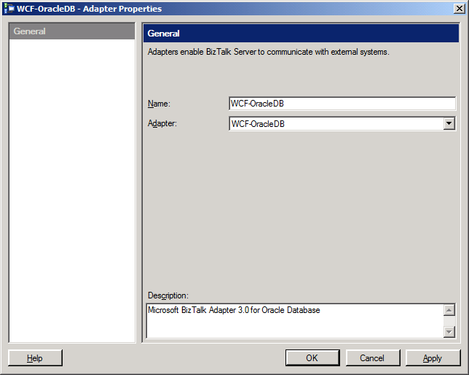
Select ‘WCF-OracleDB’ from the ‘Adapter’ dropdown and type ‘WCF-OracleDB’ in the ‘Name’ field, click ‘Apply’
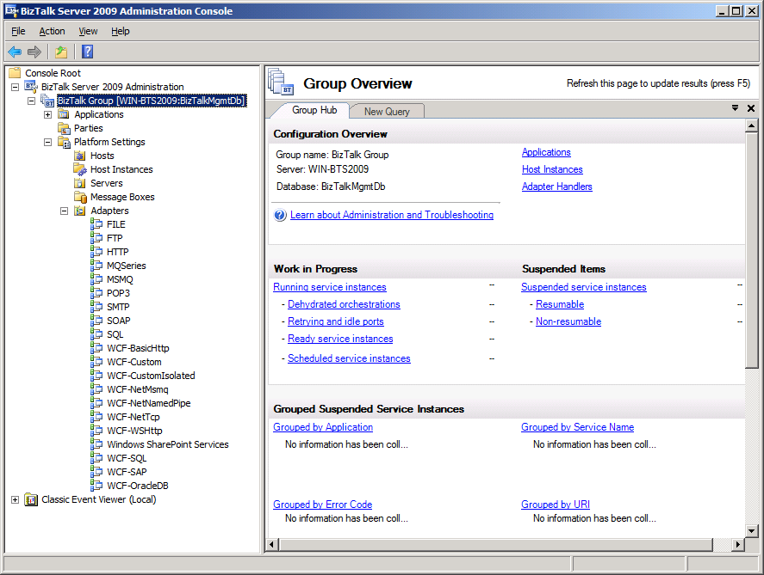
You should now see these adapters in the ‘Adapters’ list, you can now utilize these adapters in your BizTalk ports

Programs and Features Review

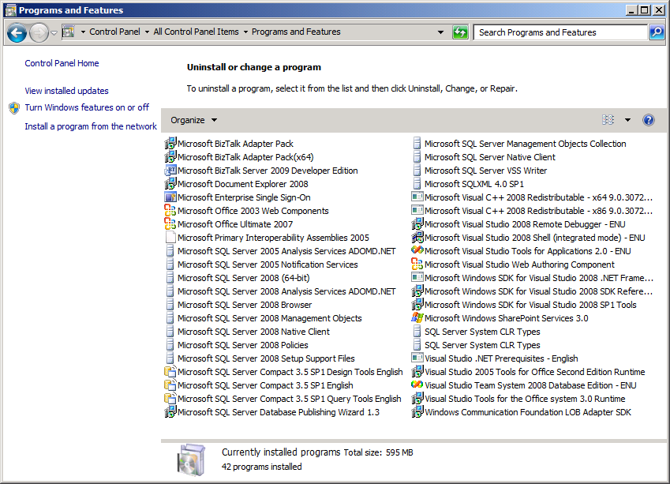
Program and Features view showing programs installed

Test the SAP Microsoft BizTalk Adapter 3.0 for mySAP Business Suite
Deploy a simple SAP project to BizTalk, configure the ports, and then have your SAP BASIS team run a ‘sm59’ transaction. Your BizTalk server should show up as being registered provided you have your Program ID, User Id, Password, and Partner Profile stuff setup.
For our test we will receive an IDOC from one SAP system and send it to another SAP system after mapping it
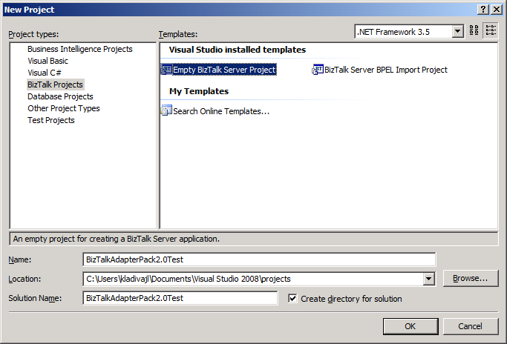
Create a simple BizTalk test project
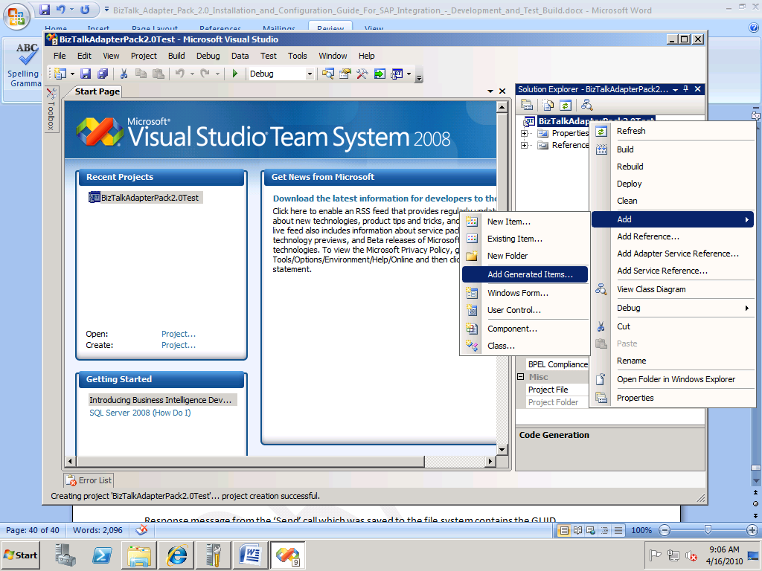
Right-click your project file and click ‘Add’, ‘Add Generated Items…’
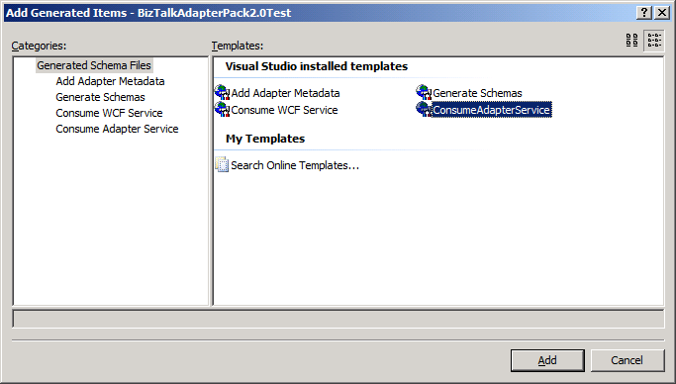
Select ‘ConsumeAdapterService’ and then click ‘Add’.
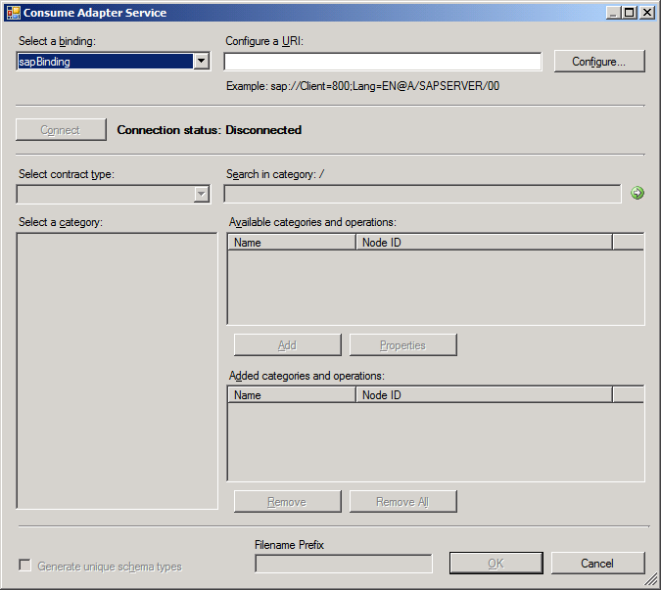
Select ‘sapBinding’ from the ‘Select a Binding’ dropdown, if the ‘Configure…’ button does not become enabled then Visual Studio will not be able to communicate with SAP due to missing SAP DLLs on the BizTalk Server. Check that you copied the 32-bit SAP DLLs to the ‘C:\Windows\SysWOW64’ directory and the 64-bit SAP DLLs to the ‘C:\Windows\system32’ directory
Click the ‘Configure…’ button and fill in the required information on the tabs to connect to your SAP server.
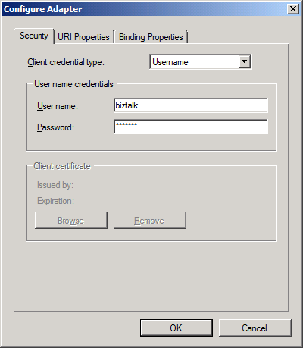
Select your ‘Client credential type’, fill in the required information, and then click on the ‘URI Properties’ tab.
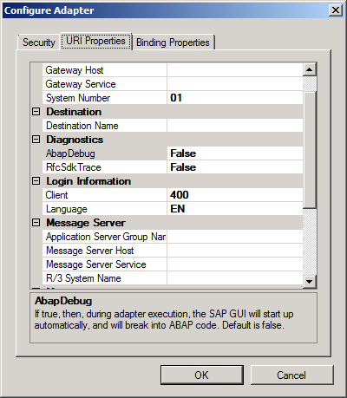
Fill in the required information on the ‘URI Properties’ tab and then click the ‘Binding Properties’ tab.
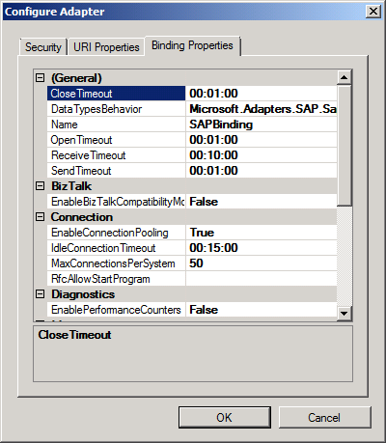
Review the settings and then click ‘OK’ to save the changes you made on the two previous tabs.
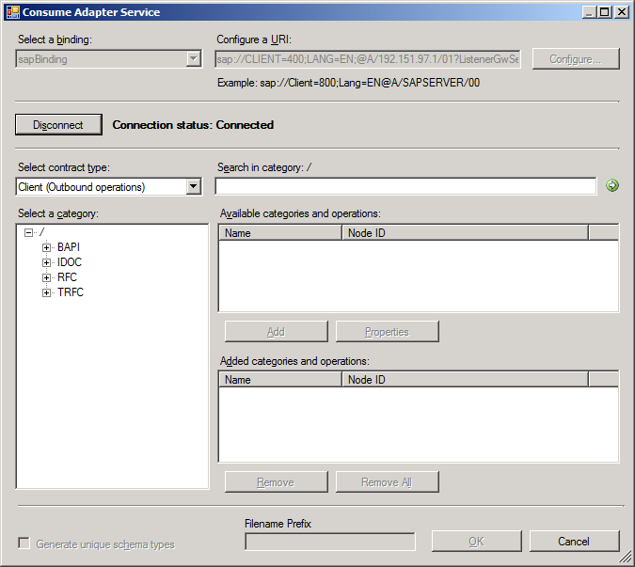
Click the ‘Connect’ button and you should see ‘Connection status: Connected’ if your settings were correct.
Next select a BAPI, IDOC, or RFC and see if you can pull down a schema.
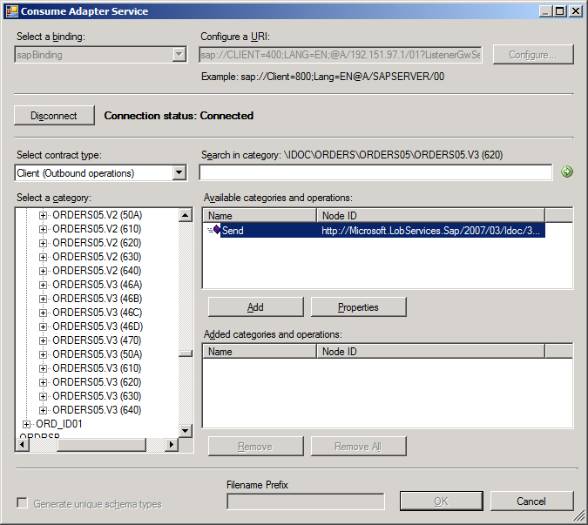
In my case I selected the ORDERS05.V3 (620) IDOC. Next click the ‘Add’ button.
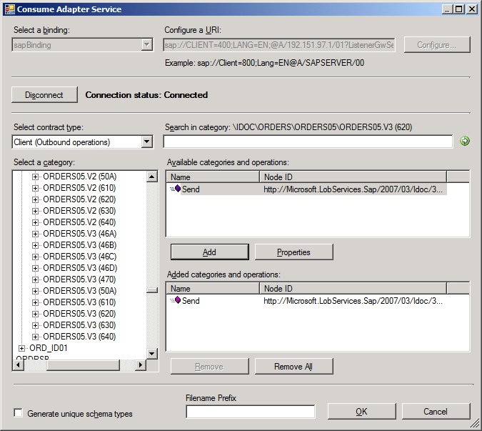
Then click the ‘OK’ button.
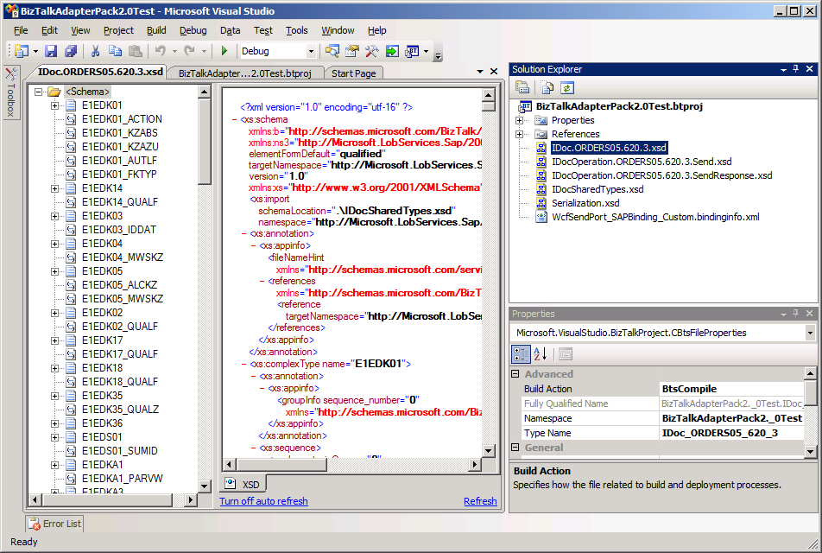
Visual Studio will then pull down the SAP schemas and add them to your BizTalk project. If you can pull down an SAP Schema then your BizTalk Adapter Pack 2.0 configuration is setup correctly. Visual Studio connected via the BizTalk Adapter Pack (x86) bits so you will still need to test the x64 bits when you build up a simple BizTalk project and deploy it and configure it to run under a 64-bit host.

Configure the Microsoft BizTalk Adapter 3.0 for mySAP Business Suite to Utilize tRFC Calls
For tRFC calls you need to run the script below, create a new database for the tables and SPs called ‘SAPTidDb’.
NOTE: You need to grant your service account permissions to the ‘SAPTidDb’ database

You will notice the BizTalk ports have a property for the connection string to this database if you use tRFC calls

