Using the BizTalk Adapter Pack 2.0 with SSIS
BizTalk Adapter Pack 2.0, SQL Server 2008 R2 64-bit, Windows 2008 R2 64-bit
Jay L. Kladiva
Energizer Holdings, Inc.
MCSE, MCSD, MCAD .NET, MCT, MCP + Site Builder
7/2/2010

Table of Contents
1. Document Information 3
1.1. Revision History 3
1.2. Reviewers and Sign-off 3
1.3. References 3
1.4. Installation 4
1.5. Proof of Concept to Validate Installation and Configuration 4

Document Information

Revision History
Revision | Description | Revised By | Revised on
v1.0 | Original Version | Jay Kladiva | 07/2/2010

Reviewers and Sign-off
Name | Role | Sign-off comments

References
Name of Document | Link/Location

Installation
See ‘BizTalk Adapter Pack 2.0 Installation and Configuration Guide for SAP Integration’ whitepaper located on the St. Louis Microsoft Connected Systems Working Group website at;
http://www.microsoftconnectedsystems.net

Proof of Concept to Validate Installation and Configuration
Create a new project by selecting the ‘SQL Server Import and Export Wizard’.

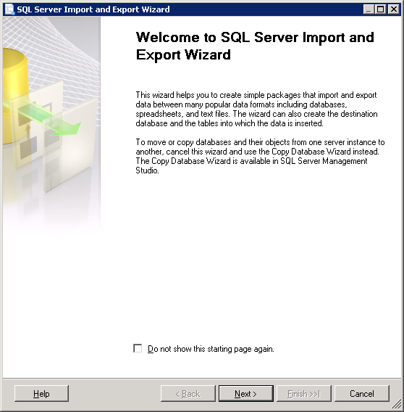
Click ‘Next’
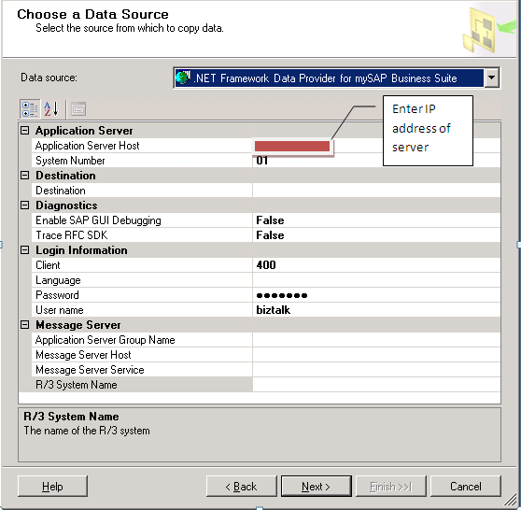
Enter the required information to connect to the QAS ‘Test’ instance of SAP, click ‘Next’
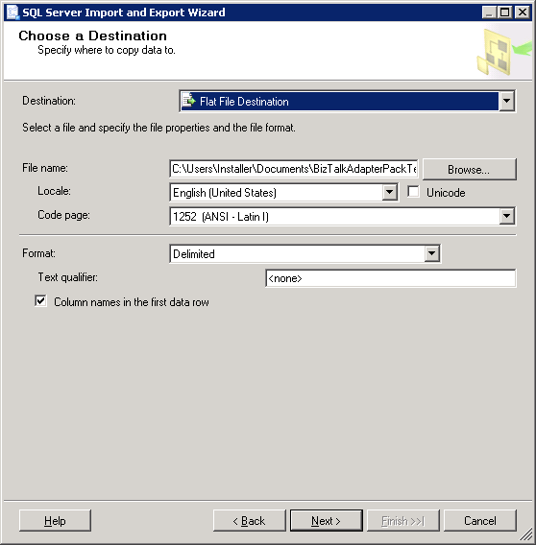
Select ‘Flat File Destination’ as a destination, select a location and file name, then click ‘Next’
NOTE: This is just a simple example to prove the BizTalk Adapter Pack works in SSIS
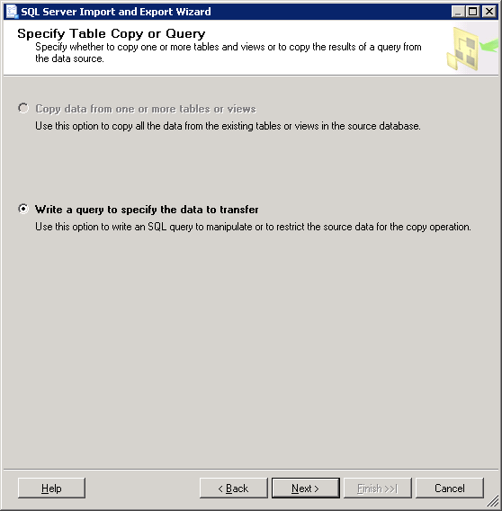
Click ‘Next’
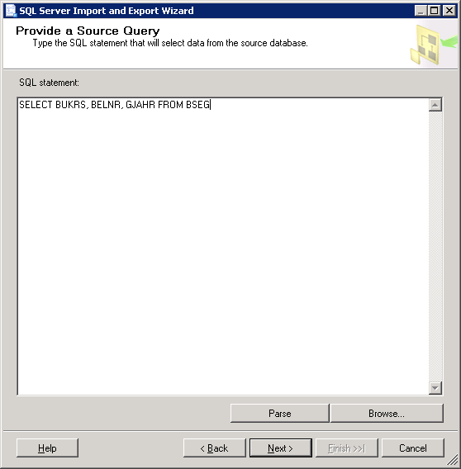
Enter a valid SAP ADO-like query to test the connectivity, click ‘Next’
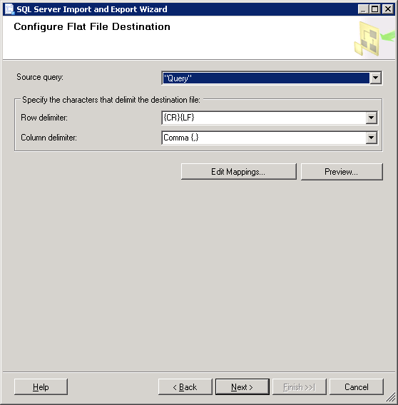
Click the ‘Preview’ button to see if data is retrieved from SAP
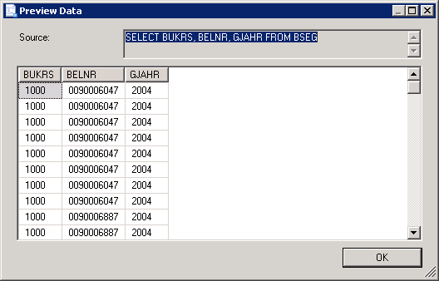
Click ‘OK’
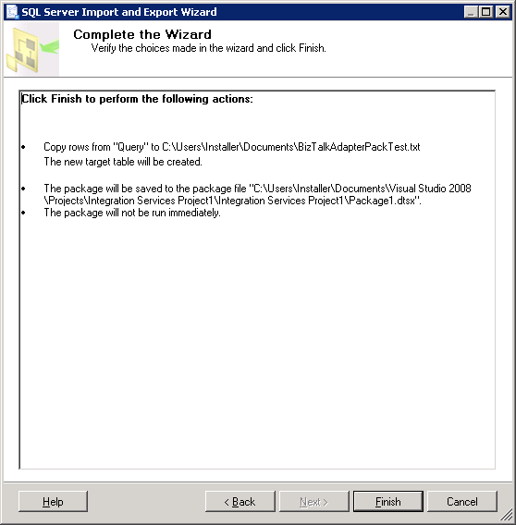
Click ‘Finish’
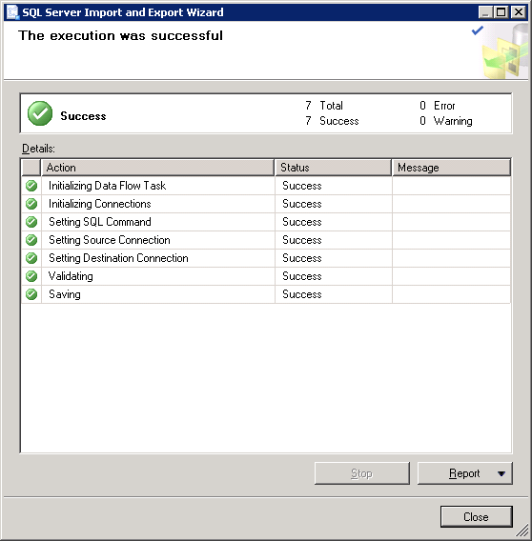
You should see all green checkmarks, click ‘Close’, this validates that the SQL Server 2008 R2 64-bit box can connect to the QAS instance of SAP via the Visual Studio IDE using the 32-bit runtimes and DLLs. In Production the SSIS Packages will run under a 64-bit process. Next schedule your SSIS package as a SQL Job and execute it, it should execute without error.

