BizTalk Adapter Pack 2.0 Installation and Configuration Guide For SAP Integration
Production 64-bit Installation and Configuration Only(No Visual Studio or Dev. Tools)_v1.2
Jay Kladiva
Energizer Holdings, Inc.
MCSE, MCSD, MCAD .NET, MCT, MCP + Site Builder
3/21/2010
This document outlines the complete installation and configuration for the BizTalk Adapter Pack 2.0 for integration scenarios with SAP. This outlines only the production setup for 64-bit which does not include Visual Studio, SDKs, and runtimes that require 32-bit. For this see the ‘ BizTalk Adapter Pack 2.0 64-bit Installation and Configuration Guide For SAP Integration Development Installation and Configuration_v1.2)’ guide. This contains the required 32-bit and 64-bit installation and configuration so that you can development your solutions using Visual Studio and the WCF SDK running 32-bit and deploy it to the same machine and run it utilizing only 64-bit components, so essentially your BizTalk Development box serves two roles; BizTalk Development and BizTalk Production.

Table of Contents
1. Document Information 4
1.1. Revision History 4
1.2. Reviewers and Sign-off 4
1.3. References 4
2. BizTalk Adapter Pack 2.0 64-bit Installation & Configuration Guide 5
2.1. Pre-requisites 5
2.2. Validate That the .NET Framework 3.5 SP1(x64) is Installed 5
2.3. RFCSDK(Unicode)(64-bit) 5
2.4. R3DLLINS 6
2.5. Visual C++ 2008 (64-bit) Setup 6
2.6. WCF LOB Adapter SDK (64-bit) 8
2.7. BizTalk Adapter Pack 2.0 (64-bit) 13
2.8. Post Install Configuration for BizTalk Adapter Pack 2.0 (64-bit) 18
2.9. BizTalk Adapter Pack 2.0 (32-bit) 22
2.10. Add the Adapters to the BizTalk Admin Tool 29
2.11. Programs and Features Review 33
2.12. Test the SAP Microsoft BizTalk Adapter 3.0 for mySAP Business Suite 34
2.13. Configure the Microsoft BizTalk Adapter 3.0 for mySAP Business Suite to Utilize tRFC Calls 36

Document Information

Revision History
Revision | Description | Revised By | Revised on
v0.9 | Original Version | Jay Kladiva | 03/21/2010
v1.1 |  | Jay Kladiva | 03/30/2010
v1.2 |  | Jay Kladiva | 04/14/2010

Reviewers and Sign-off
Name | Role | Sign-off comments

References
Name of Document | Link/Location

BizTalk Adapter Pack 2.0 64-bit Installation & Configuration Guide

Pre-requisites
In order to utilize the BizTalk Adapter Pack 2.0 from within BizTalk you must have BizTalk 2009 or BizTalk 2006 R2 installed and configured, see BizTalk 2009 Installation and Configuration Guide at;
http://www.microsoftconnectedsystems.net/listing.aspx?categoryid=2

Validate That the .NET Framework 3.5 SP1(x64) is Installed
Validate the .NET Framework 3.5 SP1(x64) is installed

RFCSDK(Unicode)(64-bit)
Install the appropriate version of the RFCSDK. Always install the Unicode version of the RFCSDK even if your SAP system is Non-Unicode.
Download RFCSDK 7.0 (Unicode)(64-bit) and save the DLLS off to a folder on your BizTalk Server
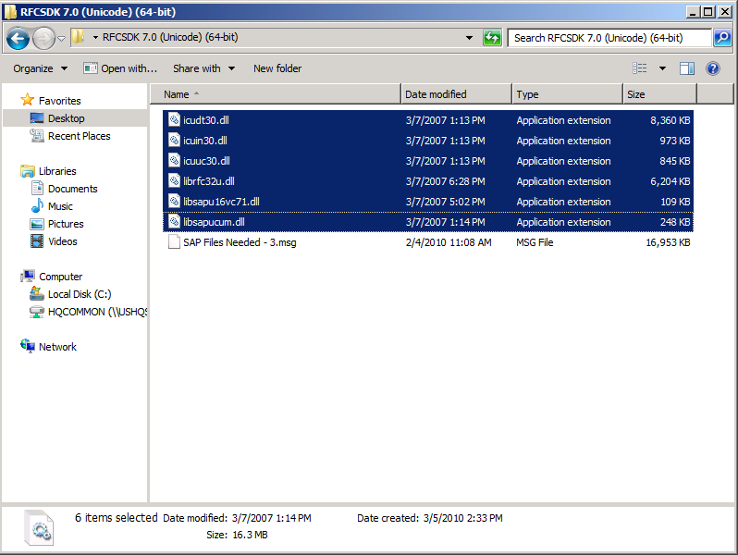
Copy the 6 DLLs from the SAP Software Download Center to the ‘C:\Windows\system32’ directory
NOTE: SAP GUI should not be installed, if it is installed on your BizTalk Server then you must remove it

R3DLLINS
Copy the 4 DLLS from the ‘ntpatch’ directory from the R3DLLINS.EXE program to the ‘C:\Windows\system32’ directory

Visual C++ 2008 (64-bit) Setup
Install the Visual C++ 2008 (64-bit) Setup
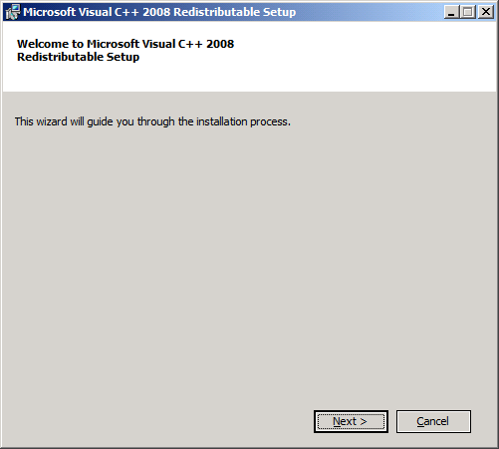
Click ‘Next’
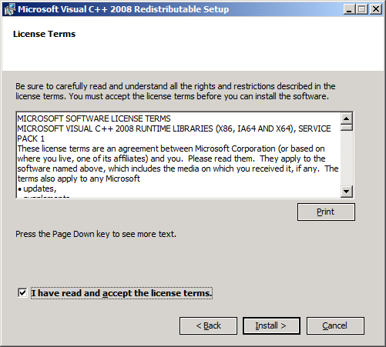
Accept the terms and click ‘Install’
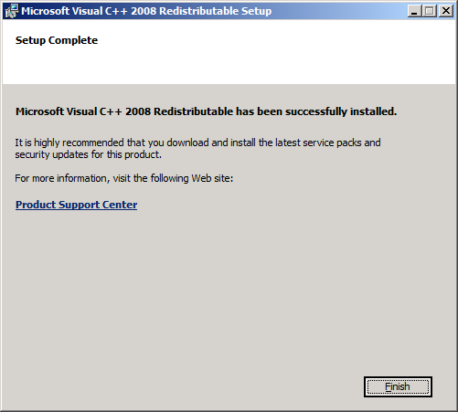
Click ‘Finish’

WCF LOB Adapter SDK (64-bit)
Install the WCF LOB Adapter SDK (64-bit)
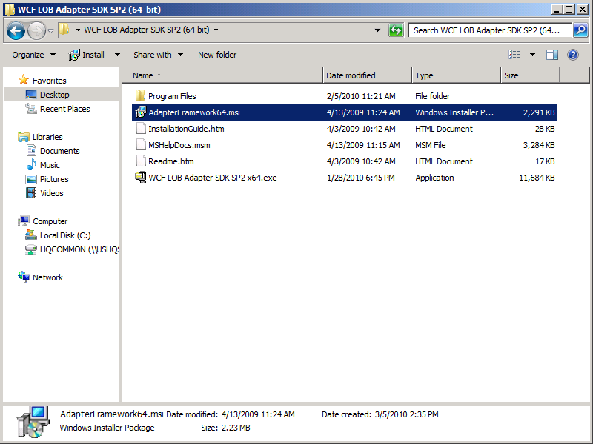
Execute the AdapterFramework64.msi
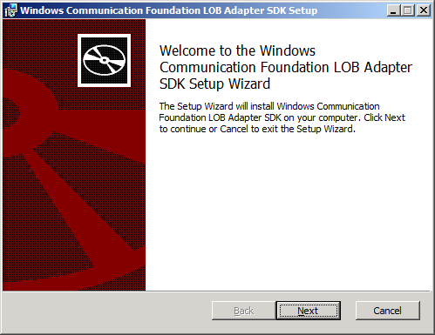
Click ‘Next’

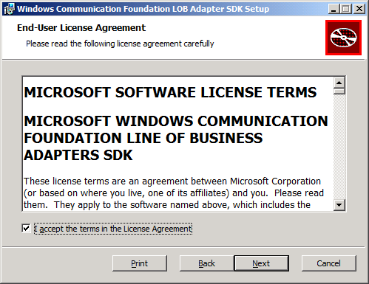
Accept the terms and click ‘Next’

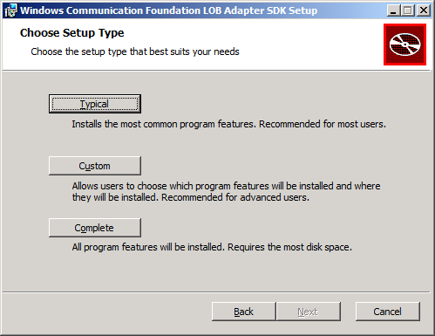
Click ‘Custom’
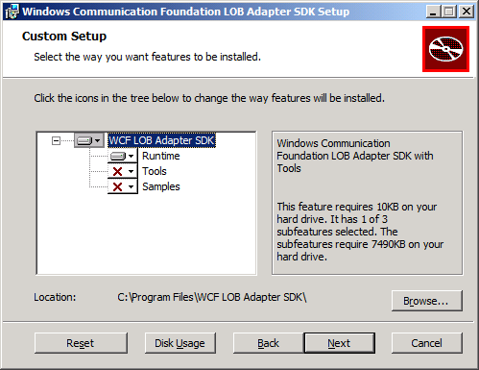
Only install the ‘Runtime’ on production, click ‘Next’

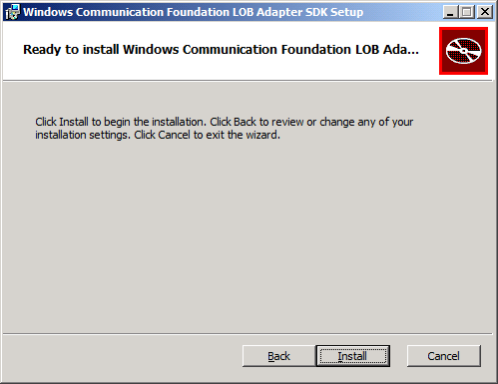
Click ‘Install’

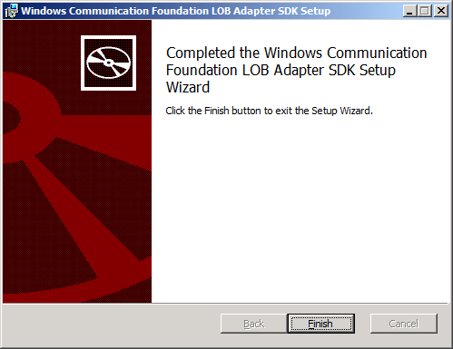
Click ‘Finish’

BizTalk Adapter Pack 2.0 (64-bit)
Install the BizTalk Adapter Pack 2.0 (64-bit)
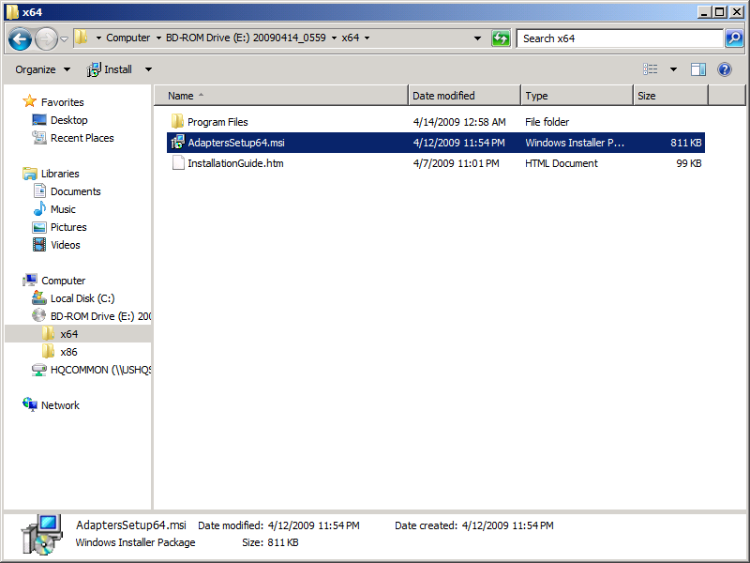
Execute the AdapterSetup64.msi
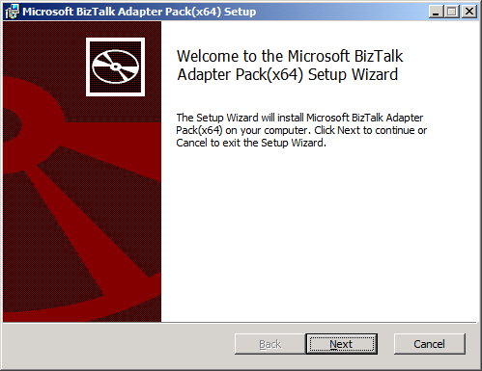
Click ‘Next’

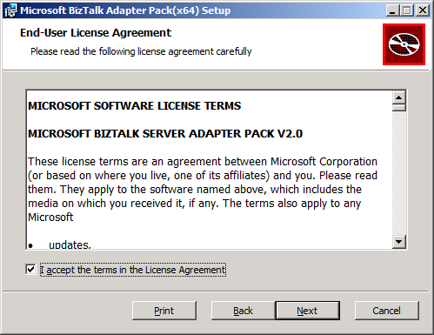
Accept the terms and click ‘Next’

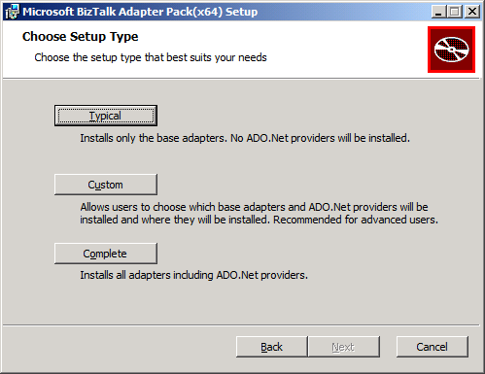
Click ‘Custom’
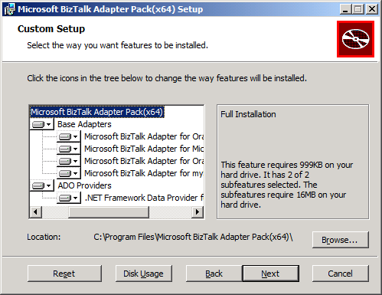
Choose the SAP Adapter and any others you need, click ‘Next’

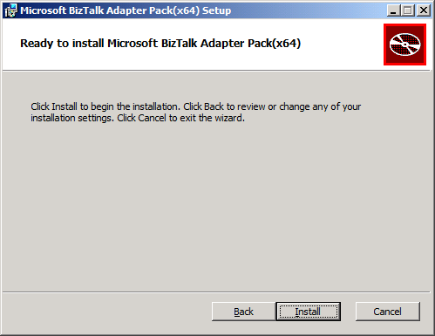
Click ‘Install’

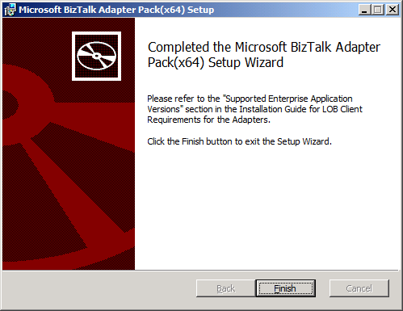
Click ‘Finish’
NOTE: Post Install, the SAP and SQL Adapters need some configuration that is listed in the InstallationGuide.htm

Post Install Configuration for BizTalk Adapter Pack 2.0 (64-bit)
After Installing the BizTalk Adapter Pack you might need to perform the following tasks after installing the BizTalk Adapter Pack, based on what operations you want to perform using the adapter:
- Invoking transactional RFCs (tRFCs) in an SAP system. If you want to invoke tRFCs in an SAP system, you must run the SQL script, SapAdapter-DbScript-Install.sql. This script is installed as part of the BizTalk Adapter Pack installation.
- Manually registering the bindings. Register the adapter bindings and the .NET Framework Data Providers if the setup wizard failed to do so.
- Using the Data Provider for SAP. You must install the custom RFCs if you chose to install the Data Provider for SAP.

Creating Tables in a SQL Server Database (Only for the SAP Adapter)
To invoke tRFCs in an SAP system you must run the SQL script, SapAdapter-DbScript-Install.sql. This script is installed as part of the BizTalk Adapter Pack installation and creates the database and the database objects in SQL Server. The script is typically installed at <installation drive>:\Program Files\Microsoft BizTalk Adapter Pack.

Registering the Bindings
You only need to perform these steps if the setup wizard fails to register the adapter bindings or .NET Framework Data Providers in the machine.config file.
To register the adapter bindings or the .NET Framework Data Providers
- Navigate to the machine.config file on the computer. For example, on a 32-bit platform, the machine.config is available under <system drive>:\WINDOWS\Microsoft.NET\Framework\<version>\CONFIG.
In the preceding path, <version> is the version of the .NET Framework. For example, for Microsoft .NET Framework 3.5 SP1, the version is v2.0.50727.
- Open the file using a text editor.
- To register the adapter bindings:
  - Search for the element "system.serviceModel" and add the following under it:
  - <client>
  - <endpoint binding="sapBinding" contract="IMetadataExchange" name="sap" />
  - <endpoint binding="siebelBinding" contract="IMetadataExchange" name="siebel" />
  - <endpoint binding="oracleDBBinding" contract="IMetadataExchange" name="oracleDb" />
  - <endpoint binding="oracleEBSBinding" contract="IMetadataExchange" name="oracleEBS" />
  - <endpoint binding="sqlBinding" contract="IMetadataExchange" name="mssql" />
</client>
  - Search for the element "bindingElementExtensions" under system.serviceModel\extensions.
  - Look for the missing adapter binding. Add the following sections under the "bindingElementExtensions" node, depending on the missing adapter binding. You must register all the bindings if the setup wizard fails to register any.
For the SAP adapter, add:
<add name="sapAdapter" type="Microsoft.Adapters.SAP.SAPAdapterExtensionElement,Microsoft.Adapters.SAP, Version=<version>, Culture=neutral, PublicKeyToken=<public key>" />
For the Siebel adapter, add:
<add name="siebelAdapter" type="Microsoft.Adapters.Siebel.SiebelAdapterExtensionElement,Microsoft.Adapters.Siebel, Version=<version>, Culture=neutral, PublicKeyToken=<public key>" />
For the Oracle Database adapter, add:
<add name="oracleDBAdapter" type="Microsoft.Adapters.OracleDB.OracleDBAdapterExtensionElement,Microsoft.Adapters.OracleDB, Version=<version>, Culture=neutral, PublicKeyToken=<public key>" />
For the Oracle E-Business adapter, add:
<add name="OracleEBSAdapter" type="Microsoft.Adapters.OracleEBS.OracleEBSBindingElementExtensionElement, Microsoft.Adapters.OracleEBS, Version=<version>, Culture=neutral, PublicKeyToken=<public key>" />
For the SQL adapter, add:
<add name="sqlAdapter" type="Microsoft.Adapters.Sql.SqlAdapterBindingElementExtensionElement,Microsoft.Adapters.Sql, Version=<version>, Culture=neutral, PublicKeyToken=<public key>" />
  - Search for the element "bindingExtensions" under system.serviceModel\extensions.
  - Look for the missing adapter binding. Add the following sections under the "bindingExtensions" node, depending on the missing adapter binding. You must register all the bindings if the setup wizard fails to register any.
For SAP adapter, add:
<add name="sapBinding" type="Microsoft.Adapters.SAP.SapAdapterBindingSection,Microsoft.Adapters.SAP, Version=<version>, Culture=neutral, PublicKeyToken=<public key>" />
For Siebel adapter, add:
<add name="siebelBinding" type="Microsoft.Adapters.Siebel.SiebelAdapterBindingSection,Microsoft.Adapters.Siebel, Version=<version>, Culture=neutral, PublicKeyToken=<public key>" />
For Oracle Database adapter, add:
<add name="oracleDBBinding" type="Microsoft.Adapters.OracleDB.OracleDBAdapterBindingSection,Microsoft.Adapters.OracleDB, Version=<version>, Culture=neutral, PublicKeyToken=<public key>" />
For Oracle E-Business adapter, add:
<add name="OracleEBSBinding" type="Microsoft.Adapters.OracleEBS.OracleEBSBindingCollectionElement, Microsoft.Adapters.OracleEBS,Microsoft.Adapters.OracleEBS, Version=<version>, Culture=neutral, PublicKeyToken=<public key>" />
For SQL adapter, add:
<add name="sqlBinding" type="Microsoft.Adapters.Sql.SqlAdapterBindingCollectionElement,Microsoft.Adapters.Sql, Version=<version>, Culture=neutral, PublicKeyToken=<public key>" />
Note
For information about how to determine the public key, see Determining the Public Key and Version.
- To register the .NET Framework Data Providers:
  - Search for the element DbProviderFactories under the system.data node.
  - Look for the missing .NET Framework Data Providers. Add the following sections under the DbProviderFactories node, depending on the missing provider. You must register all the providers if the setup wizard fails to register any.
For the Data Provider for SAP, add:
  - <add name="SAPClient Data Provider" invariant="Microsoft.Data.SAPClient"
description=".NET Framework Data Provider for mySAP Business Suite" type="Microsoft.Data.SAPClient.SAPClientFactory,Microsoft.Data.SAPClient, Version=<version>, Culture=neutral, PublicKeyToken=<public key>" />
For the Data Provider for Siebel, add:
<add name="SiebelClient Data Provider" invariant="Microsoft.Data.SiebelClient"
description=".NET Framework Data Provider for Siebel eBusiness Applications"
type="Microsoft.Data.SiebelClient.SiebelProviderFactory,Microsoft.Data.SiebelClient, Version=<version>, Culture=neutral, PublicKeyToken=<public key>" />
- Save and close the machine.config file.

Determining the Public Key and Version
Perform the following steps to determine the public key and version for an adapter or .NET Framework Data Provider.
To determine the public key
- Navigate to the Windows directory, typically C:\WINDOWS\assembly.
- Right-click the DLL for which you want the public key, and then select Properties. The following table lists the name of the DLLs for each adapter and provider.
Adapter/.NET Framework Data Provider | Name of the DLL
SAP adapter | Microsoft.Adapters.SAP
Siebel adapter | Microsoft.Adapters.Siebel
Oracle Database adapter | Microsoft.Adapters.OracleDB
Oracle E-Business adapter | Microsoft.Adapters.OracleEBS
SQL adapter | Microsoft.Adapters.Sql.dll
Data Provider for SAP | Microsoft.Data.SAPClient
Data Provider for Siebel | Microsoft.Data.SiebelClient
- On the General tab, the value against the Public Key Token label specifies the public key for the DLL. Similarly, the value against the Version label specifies the version number for the DLL.
- Copy the public key, and then click Cancel.

Installing the Custom RFCs
You only need to perform this task if you want to use the Data Provider for SAP. For instructions on installing custom RFCs, see the "Installing Custom RFCs for the Data Provider for SAP" topic in the SAP adapter documentation. The document is typically installed at <installation drive>:\Program Files\Microsoft BizTalk Adapter Pack\Documents.
Important
If you are using an earlier version of the custom RFCs provided with the BizTalk Adapter Pack, you must upgrade them to the RFCs provided with this release. You must do so by removing the earlier RFCs and instead installing the RFCs shipped with this release.

BizTalk Adapter Pack 2.0 (32-bit)
Install the 32-bit BAP 2.0
NOTE: BizTalk Admin tool runs under a 32-bit process, so you have to install the 32-bit BizTalk Adapter Pack 2.0 to configure your Send Ports, Receive Ports, and to add Adapters
Link: http://msdn.microsoft.com/en-us/library/cc185262(BTS.10).aspx

Invalid binding error while configuring SAP adapter ports in BizTalk Server Administration Console on a 64-bit installation
Problem
When you try to configure a port for the adapter in BizTalk Server Administration console, you get the following error:

"Unable to create binding configuration element for editing. Check the values of the BindingType and BindingConfiguration properties.
(Microsoft.Biztalk.Adapter.Wcf.Converters.CreateBindingException) Unable to get binding type for binding extension "sapBinding".
Verify the binding extension is registered in machine.config."
Cause
The SAP adapter is a WCF custom binding, which is registered under System.ServiceModel in the machine.config file. A 64-bit platform has two machine.config files, one used by the 32-bit applications and the other used by the 64-bit applications. So, when you install the 64-bit version of the BizTalk Adapter Pack, the setup wizard registers the bindings in the 64-bit version of the machine.config file. However, BizTalk Server Administration console runs as a 32-bit process and hence when you configure a port for the adapter, it checks for the bindings in the 32-bit version of the machine.config file and fails giving an error.
Resolution
- Install both the 32-bit and 64-bit versions of the BizTalk Adapter Pack on a 64-bit WCF LOB Adapter SDK installation.
Important
You must only have a 64-bit WCF LOB Adapter SDK installation. Side-by-side installation of 32-bit and 64-bit WCF LOB Adapter SDK on a single computer is not supported.
- Add both the 32-bit and 64-bit versions of the client DLLs for the SAP adapter (such as librfc32u.dll) to the PATH variable. The 32-bit version of the DLLs must be added to C:\Windows\SysWow64 folder. The 64-bit version of the DLLs must be added to C:\Windows\System32 folder.
Important
If the adapter (32 or 64-bit) is running on a computer that has a 64-bit operating system, and you are using the adapter to write an application, you should mark the application to the same type (32 or 64-bit) as the adapter. Also, the version of the RFC SDK (32 or 64-bit) must be same as the version of the adapter (32 or 64-bit).
For example, if a 32-bit adapter is running on a computer with a 64-bit operating system, the adapter client application must be marked as 32-bit.
- For more information about the SAP client DLLs, refer to “What client libraries must be present on the system where the SAP adapter is installed?” in the Frequently Asked Questions.

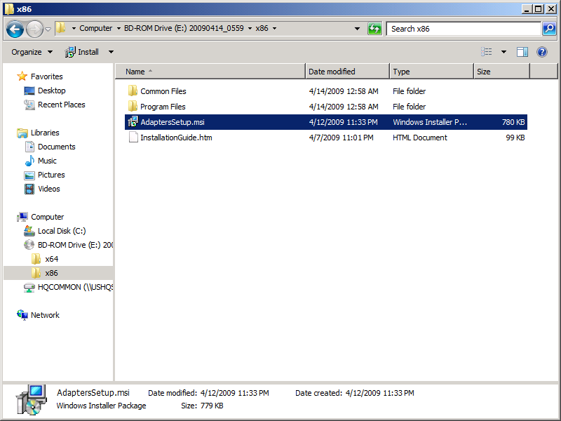
Execute the ‘ApaptersSetup.msi
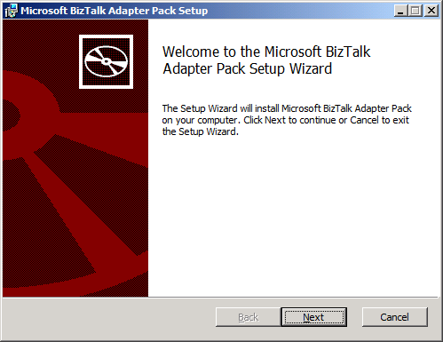
Click ‘Next’

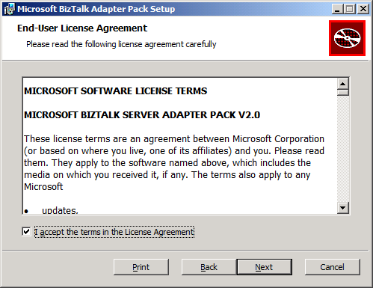
Accept the terms and click ‘Next’

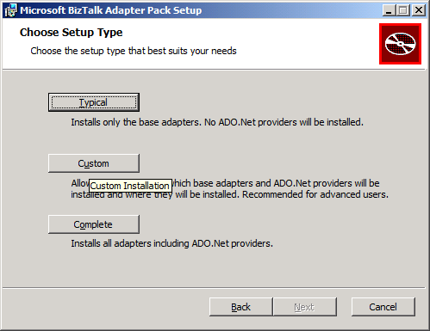
Select ‘Custom’
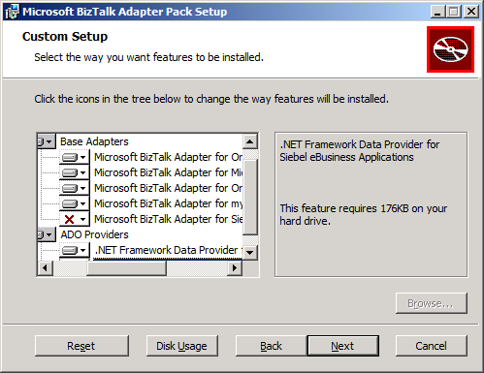
Select the Adapters you need for your environment, make sure you install the Microsoft BizTalk Adapter 3.0 for mySAP Business Suite and the Microsoft BizTalk Adapter 3.0 for SQL Server, click ‘Next’
NOTE: Always install the Microsoft BizTalk Adapter 3.0 for SQL Server and utilize this for SQL Server communication instead of the legacy SQL Adapter which is listed as ‘SQL’ under ‘Adapters’ in the BizTalk Admin Tool.

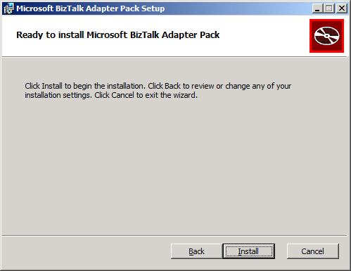
Click ‘Install’

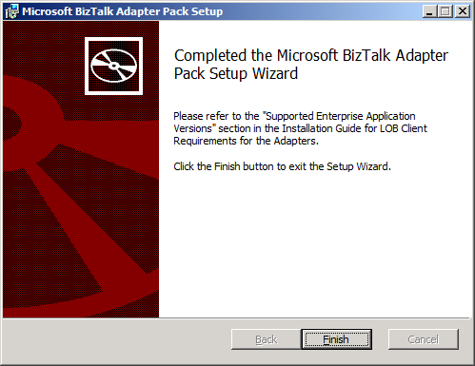
Click ‘Finish’

Add the Adapters to the BizTalk Admin Tool
Add the Adapters to the ‘Adapters’ section on the BizTalk Admin Tool
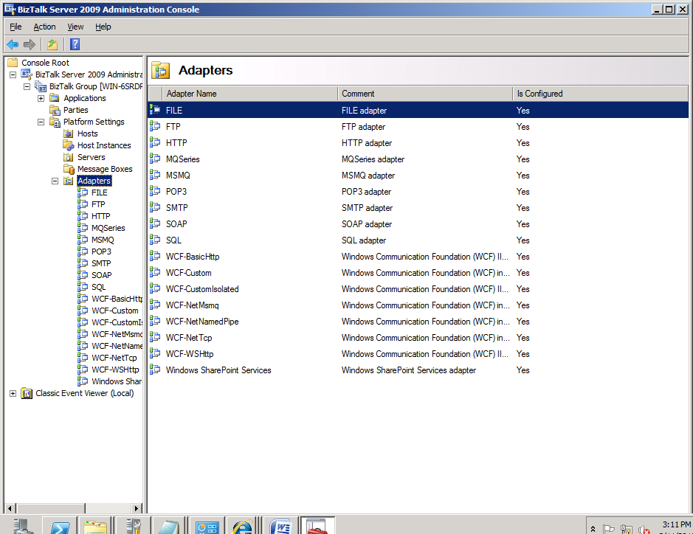
Right-click ‘Adapters’ and click ‘New’
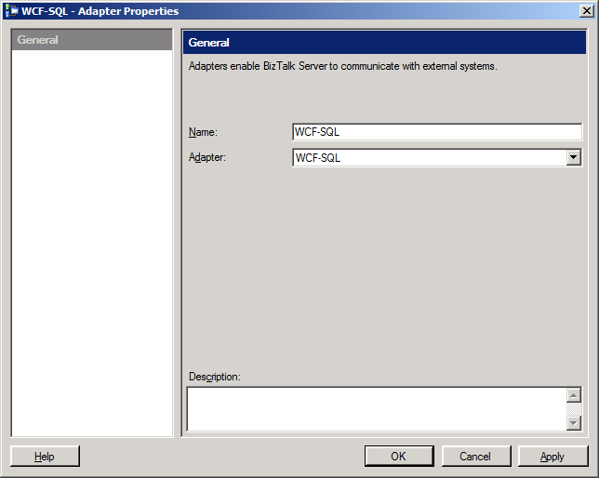
Select ‘WCF-SQL’ from the ‘Adapter’ dropdown and type ‘WCF-SQL’ in the ‘Name’ field, click ‘Apply’.
When you hit ‘Apply’, you get this warning.
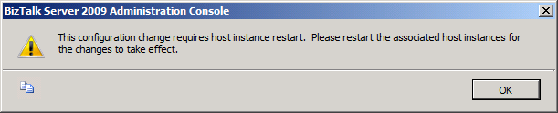
Click ‘OK’ and ignore this. Repeat this same process for the other adapters you installed.
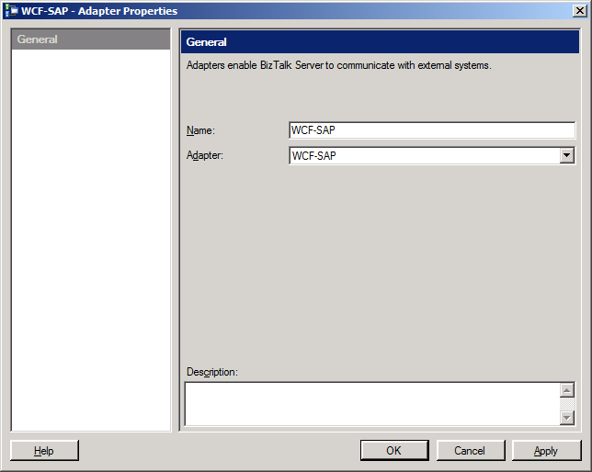
Select ‘WCF-SAP’ from the ‘Adapter’ dropdown and type ‘WCF-SAP’ in the ‘Name’ field, click ‘Apply’

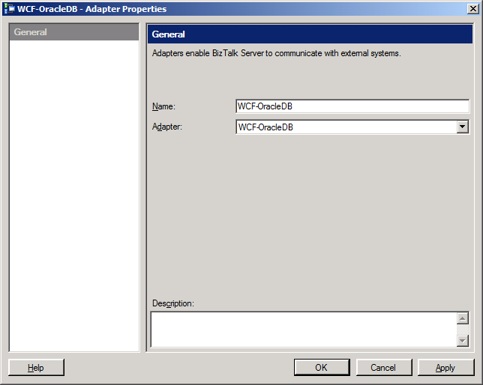
Select ‘WCF-OracleDB’ from the ‘Adapter’ dropdown and type ‘WCF-OracleDB’ in the ‘Name’ field, click ‘Apply’

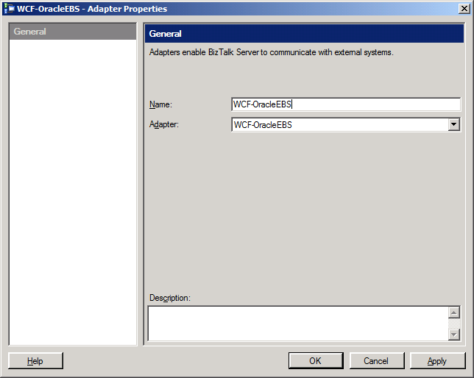
Select ‘WCF-OracleEBS’ from the ‘Adapter’ dropdown and type ‘WCF-OracleEBS’ in the ‘Name’ field, click ‘Apply’

Programs and Features Review

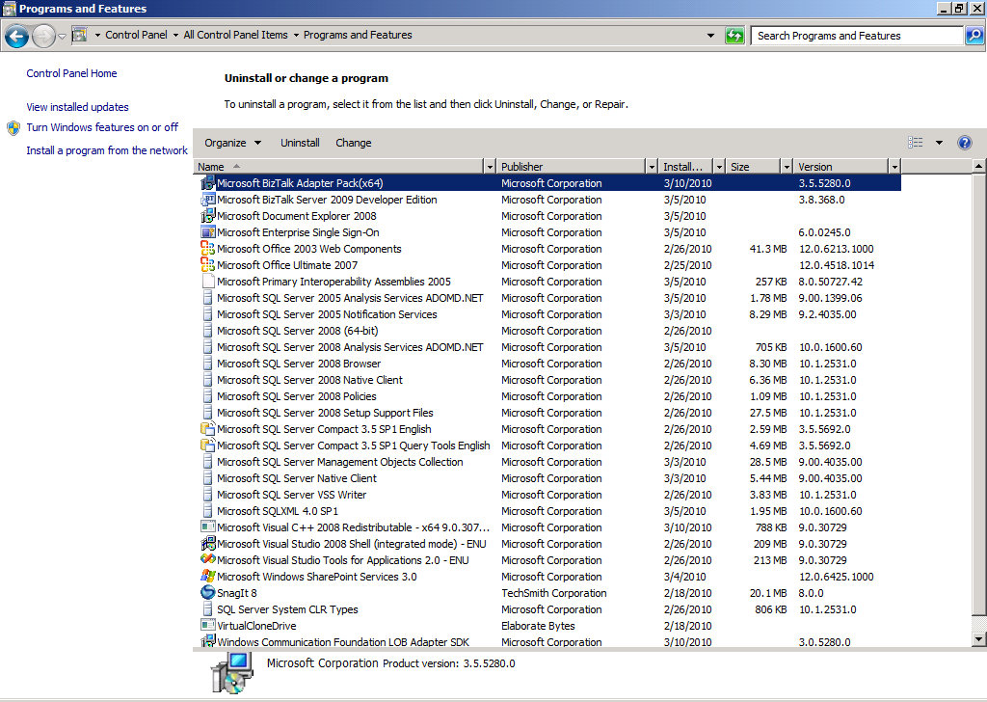
Program and Features view showing programs installed

Test the SAP Microsoft BizTalk Adapter 3.0 for mySAP Business Suite
Deploy a simple SAP project to BizTalk, configure the ports, and then have your SAP BASIS team run a ‘sm59’ transaction. Your BizTalk server should show up as being registered provided you have your Program ID, User Id, Password, and Partner Profile stuff setup.
For our test we will receive an IDOC from one SAP system and send it to another SAP system after mapping it
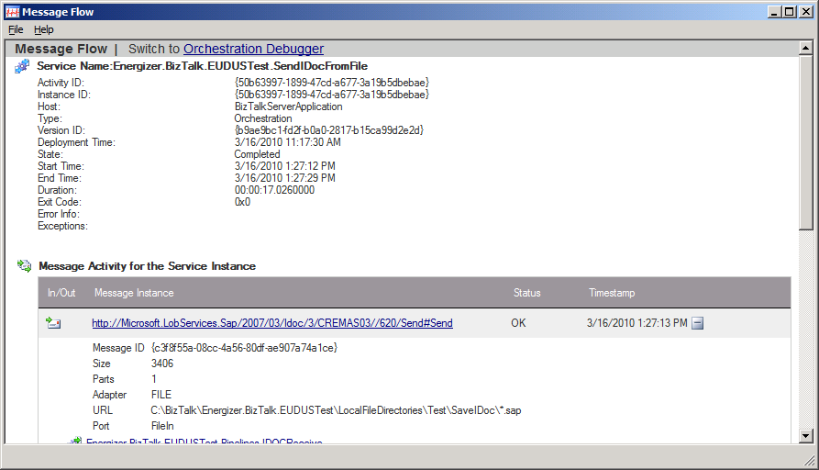
Send CREMAS03 IDOC from one SAP system to BizTalk, BizTalk receives the IDOC and dumps it to the file system, BizTalk Receive Port picks it up and applies a map and then sends to another SAP system via the Microsoft BizTalk Adapter 3.0 for mySAP Business Suite, BizTalk gets the response back from SAP from the Solicit-Response call and then the saves the response message to the file system.
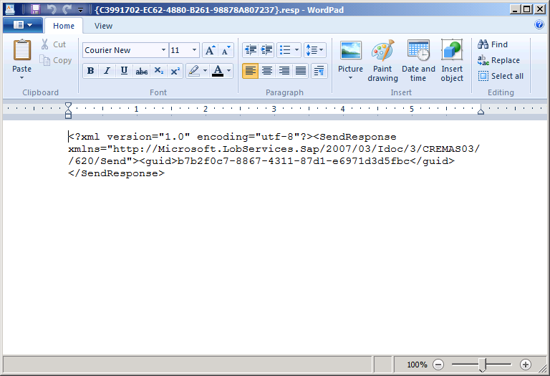
Response message from the ‘Send’ call which was saved to the file system contains the GUID.

Configure the Microsoft BizTalk Adapter 3.0 for mySAP Business Suite to Utilize tRFC Calls
For tRFC calls you need to run the script below, create a new database for the tables and SPs called ‘SAPTidDb’.
NOTE: You need to grant your service account permissions to the ‘SAPTidDb’ database

You will notice the BizTalk ports have a property for the connection string to this database if you use tRFC calls

