BizTalk 2010 Installation and Configuration Guide - Development and Test Build
BizTalk 2010 64-bit, SQL Server 2008 R2 64-bit, Windows 2008 R2 64-bit
Jay L. Kladiva
Energizer Holdings, Inc.
MCSE, MCSD, MCAD .NET, MCT, MCP + Site Builder
7/20/2010
This is a complete Installation and Configuration guide for BizTalk 2010 that documents all the steps necessary from start to finish to setup a BizTalk Server environment. This was built on a Hyper-V R2 that only contained one .vhd file so everything is installed on the C:\ drive. Ideally you would usually want to install BizTalk Server on one machine and SQL Server on another machine. The steps would be the same as outlined in this document except you would install SQL Server on a remote server as listed in Section 2.6. All other software and configuration is done on your primary BizTalk Server. If you plan to have multiple BizTalk Server in your BizTalk Server Group, first build out your first BizTalk Server, then follow the same steps to build the next BizTalk Server excluding installing SQL Server, SQL Notifications, and setting up domain accounts. When you get to Step 2.15 on the Enterprise SSO and BizTalk Group sections select ‘Join a BizTalk Server……’ instead of ‘Create New…….’ which will have your secondary BizTalk Server join the existing BizTalk Server Group and will allow it to pull the settings which are stored in the BizTalk databases to configure this server. The rest should be self-explanatory. If you install BizTalk on more than one BizTalk Server then I recommend moving your Master Secret Server to the remote SQL Server. If BizTalk losses connectivity to the SQL Server it will fail and this eliminates the issue of having the non-primary BizTalk Servers fail due to failure of the primary BizTalk Server because it acts as the Master Secret Server as well. The secondary BizTalk Servers act as backup Master Secret Servers and cache the secret but if the servers reboot and the Master Secret Server is not available then all the secondary BizTalk Servers will be rendered useless. Finally, I recommend having separate domain accounts for Development/Test and Production. All non-Production servers should use domain accounts with the ‘_T’ appended on the end of the account name. This will keep you from locking up your production service accounts by having a BizTalk Developer fat finger a password and then deploying a BizTalk application to the Development server and then enabling the hosts.

Table of Contents
1. Document Information 4
1.1. Revision History 4
1.2. Reviewers and Sign-off 4
1.3. References 4
2. BizTalk 2010 64-bit Installation & Configuration Guide 5
2.1. Pre-requisites 5
2.2. Pre-Installation 7
2.3. Add and Configure the ‘Web Server (IIS)’ and ‘Application Server’ Roles 7
2.4. Install Microsoft Office 2010 29
2.5. Install Visual Studio 2010 Ultimate Edition 32
2.6. Install SQL Server 2008 R2 64-bit 44
2.7. Install SQL Notifications Services 70
2.8. SharePoint Foundation 2010 82
2.9. Disable the Shared Memory Protocol, Enable TCP/IP and Named Pipes 106
2.10. Join the Local Administrators Group 108
2.11. Configure the Application Event Log 108
2.12. BizTalk Server 2010 64-bit Installation 109
2.13. Verify Your BizTalk Server 2010 Installation 118
2.14. Setup Domain Accounts For BizTalk Server 2010 119
2.15. Configure BizTalk Server 2010 121
2.16. Enable DTC on the Local Host Server 122
2.17. Configure BizTalk Server SQL Jobs 124
2.18. Backing Up Custom BizTalk Databases 132
2.19. Optional Step – Install the /n software BizTalk Adapters 3.5 Community Edition 132

Document Information

Revision History
Revision | Description | Revised By | Revised on
v1.0 | Original Version | Jay Kladiva | 06/30/2010
v1.1 | Finished Install | Jay Kladiva | 07/20/2010

Reviewers and Sign-off
Name | Role | Sign-off comments

References
Name of Document | Link/Location

BizTalk 2010 64-bit Installation & Configuration Guide

Pre-requisites
Install Windows Server 2008 R2. Next, install the hotfixes and patches via Windows Update.
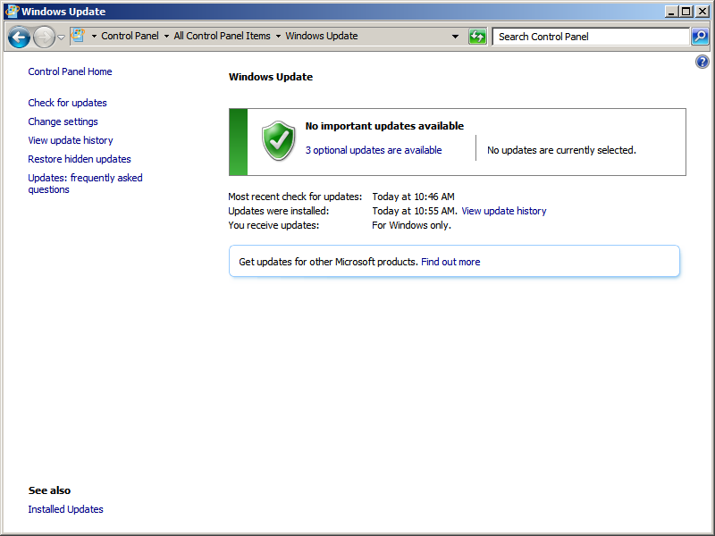

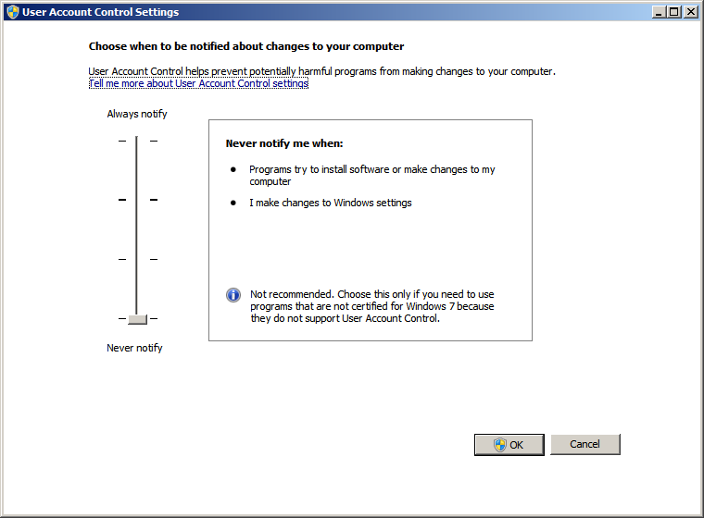
Turn off UAC
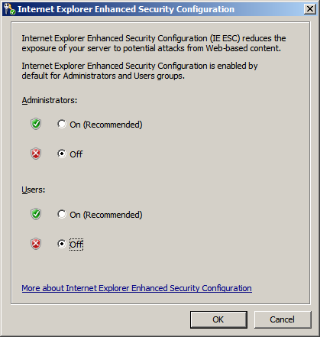
Set IE ESC to ‘Off’ for both settings

Pre-Installation
Install the following programs to aid in installing the BizTalk platform:
- Install VirtualCloneDrive, WinRAR or some program to allow you to work with DVD .iso images
- Control Panel, ‘Folder Options’, ‘View’, remove checkmark for ‘Hide extensions for known file types’
- Install Microsoft Word 2010 for documenting the install

Add and Configure the ‘Web Server (IIS)’ and ‘Application Server’ Roles

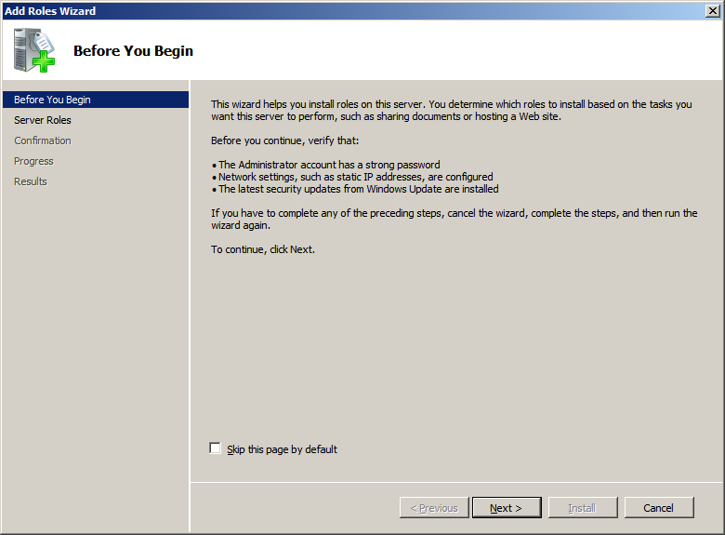
Click ‘Next’
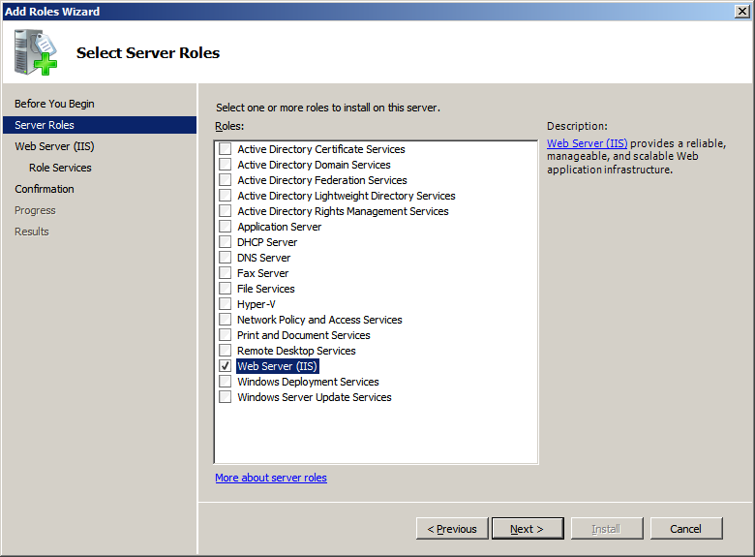
Check the ‘Web Server (IIS)’ role and click ‘Next’
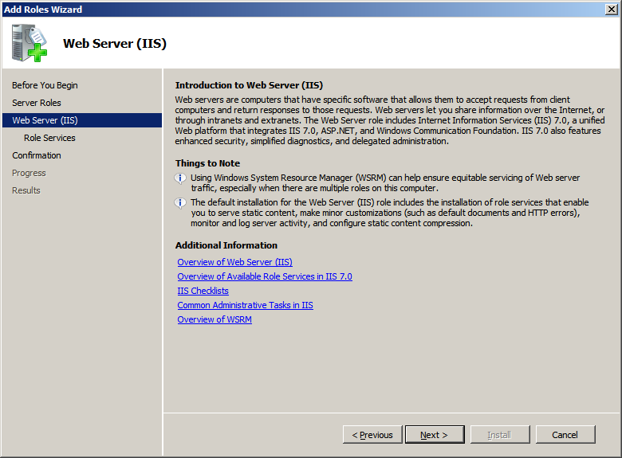
Click ‘Next’
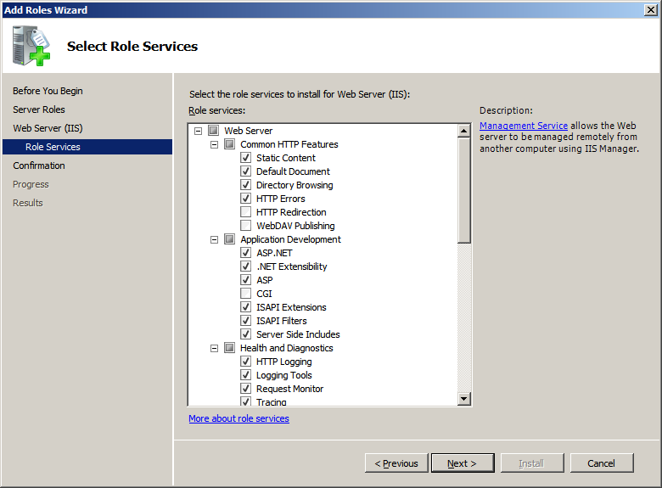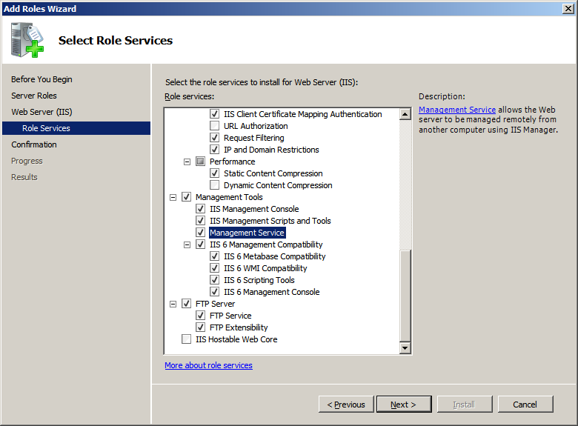
Click ‘Next’

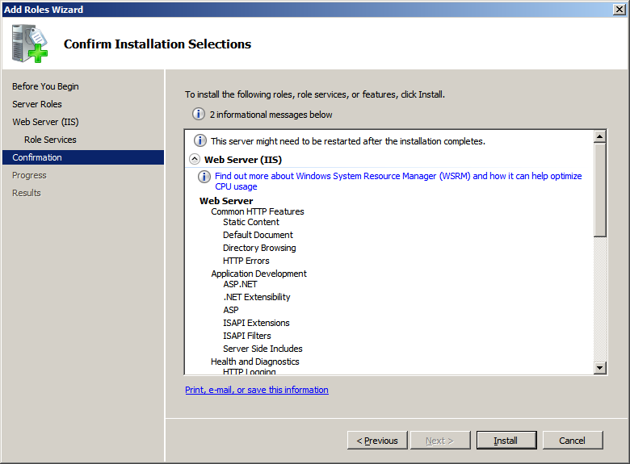
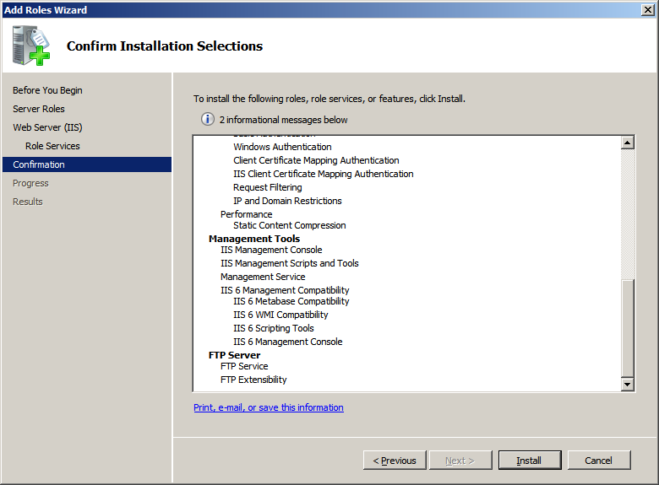
Review the informational messages and click ‘Install’

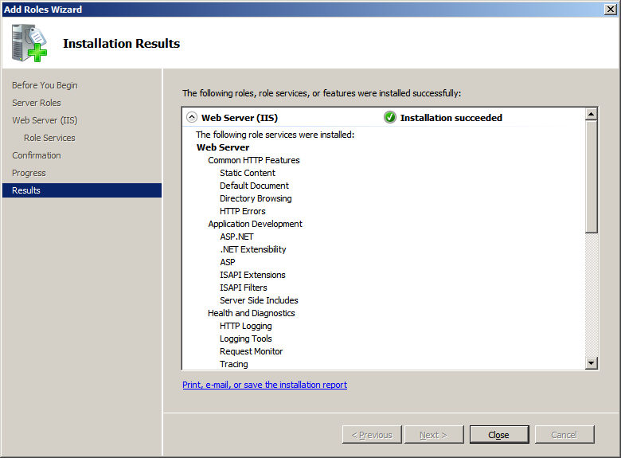
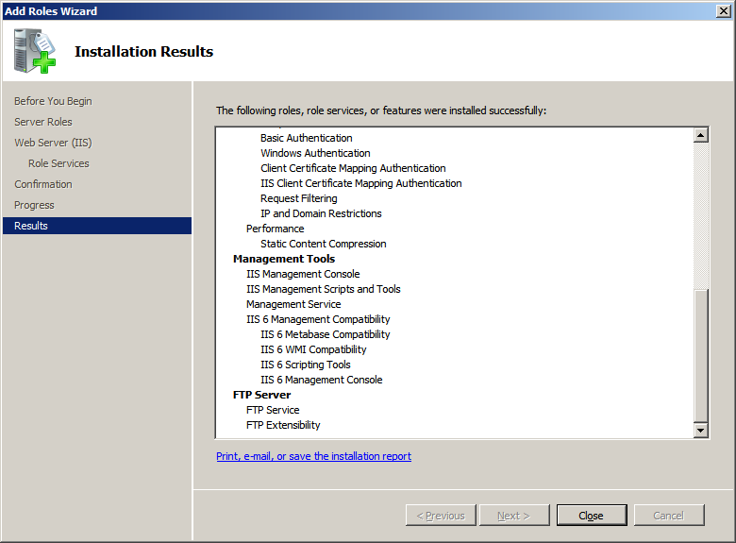
You should not see any errors, click ‘Close’
Next, add the ‘Application Server’ Role
Click ‘Next’
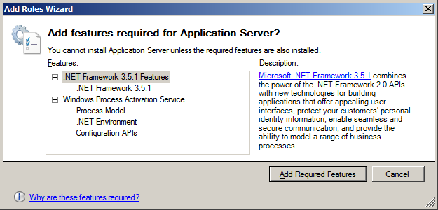
On the popup window click ‘Add Required Features’
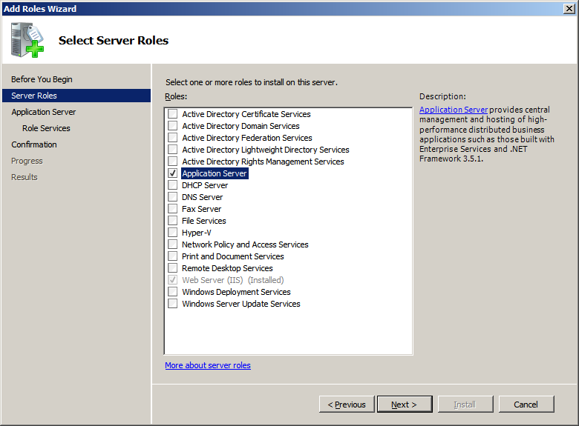
Check the ‘Application Server’ role and then click ‘Next’

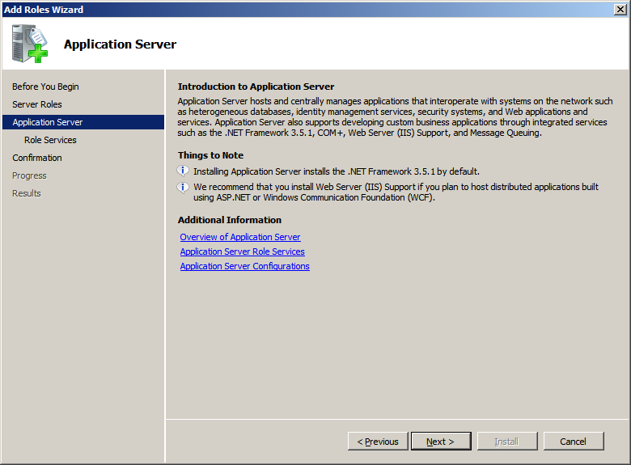
Click ‘Next’

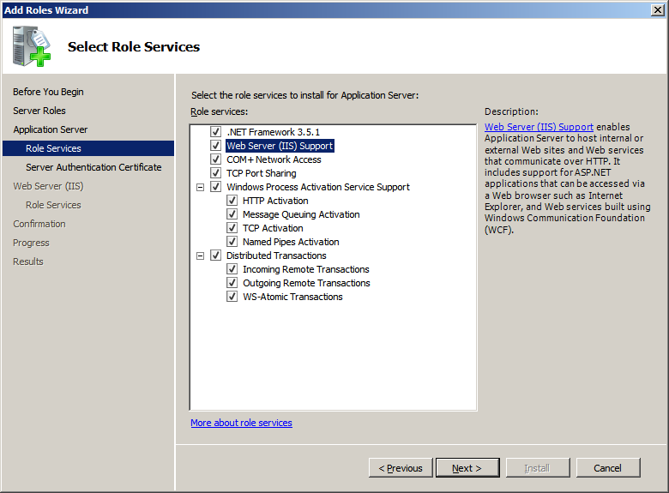
Check all the boxes and click ‘Next’

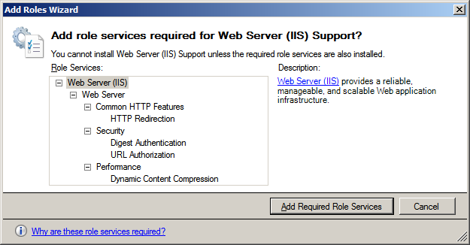
On the popup window click ‘Add Required Role Services’

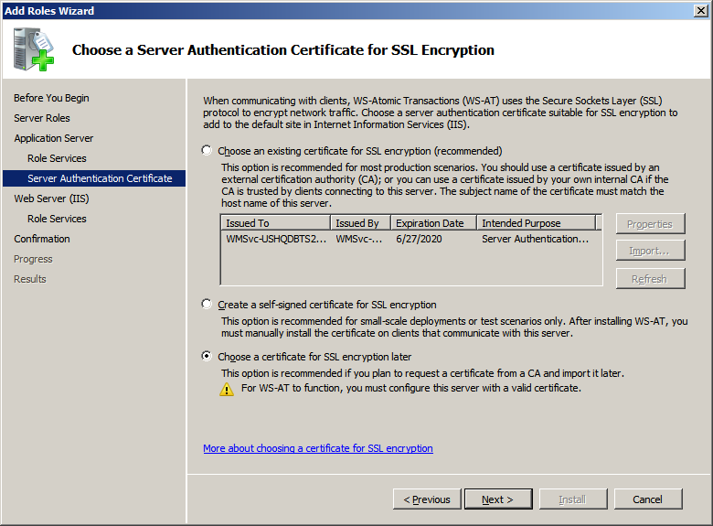
Select the ‘Choose a certificate for SSL encryption later’ option and click ‘Next’
Next, do to the options selected in the ‘Application Server’ role the ‘Web Server (IIS)’ role needs to be updated
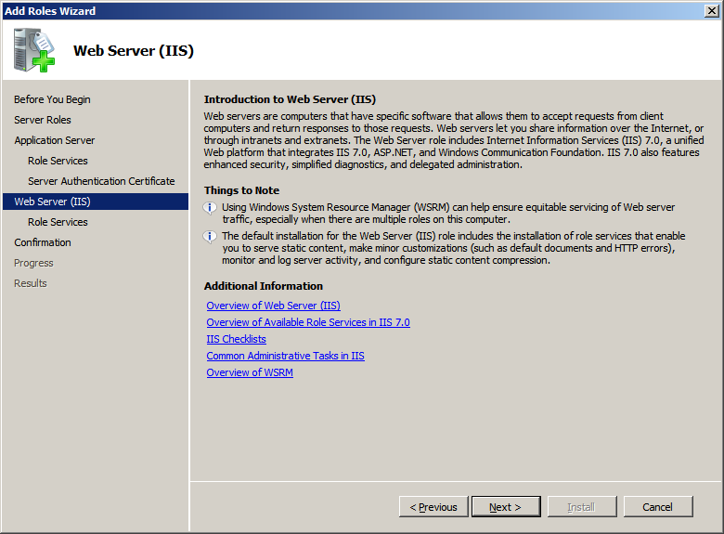
Click ‘Next’
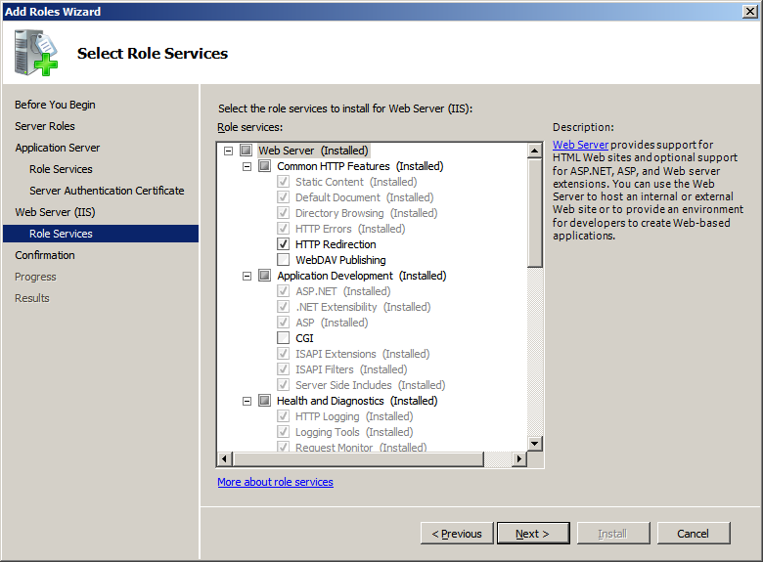
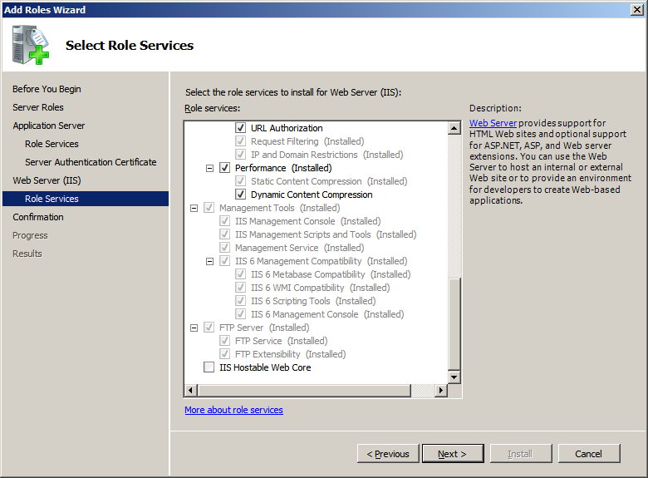
Click ‘Next’

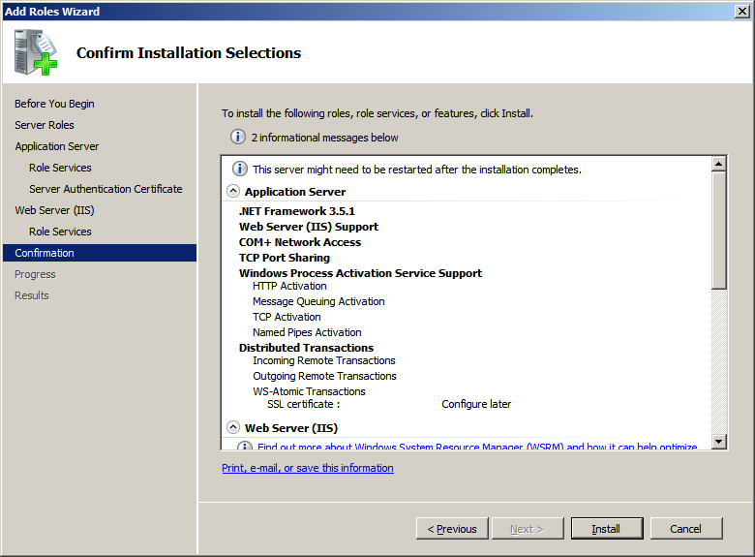
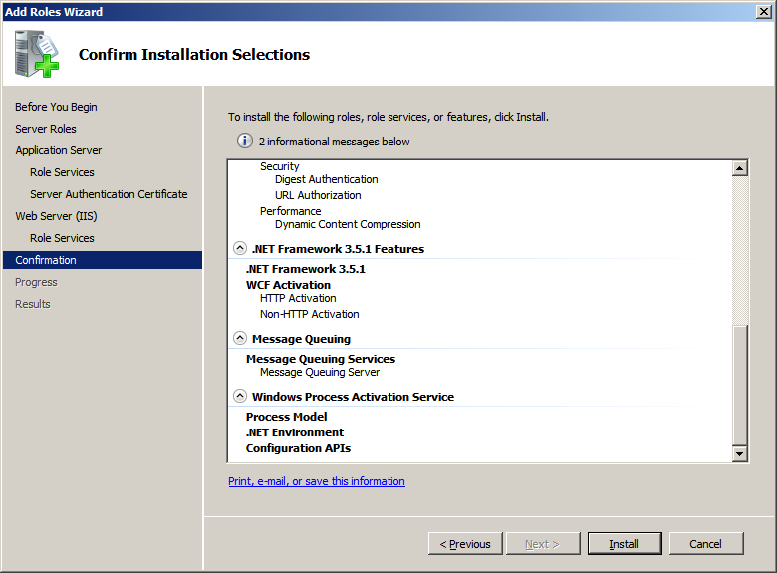
Click ‘Install’
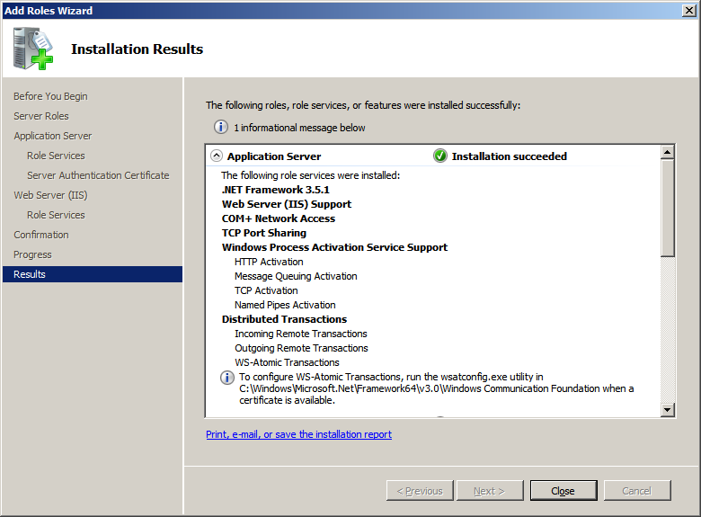
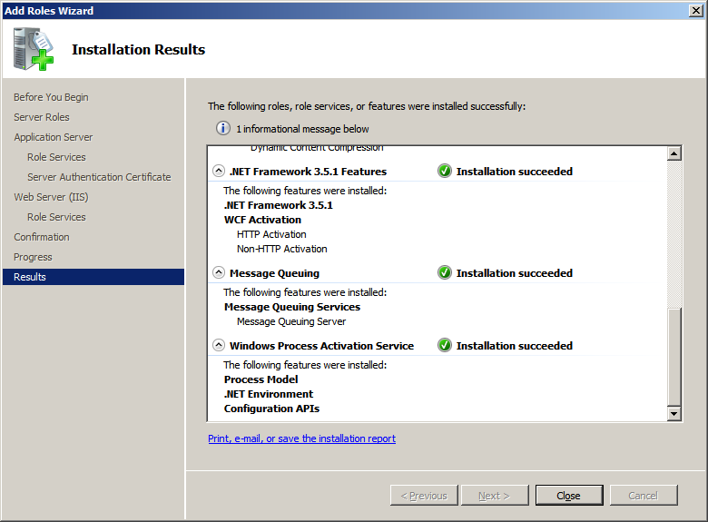
Review any messages, above the information message is ‘ To configure WS-Atomic Transactions, run the wsatconfig.exe utility in C:\Windows\Microsoft.Net\Framework64\v3.0\Windows Communication Foundation when a certificate is available.’ This adds a tab on the MS-DTC to allow you to configure WS-AT. Click ‘Close’.

Install Microsoft Office 2010
Install Microsoft Office 2010 and select Excel and InfoPath. If you doing BizTalk work you probably want to leverage InfoPath to enable 3rd Party form submission and SharePoint integration
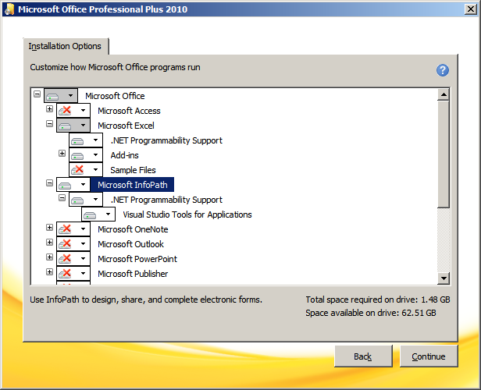
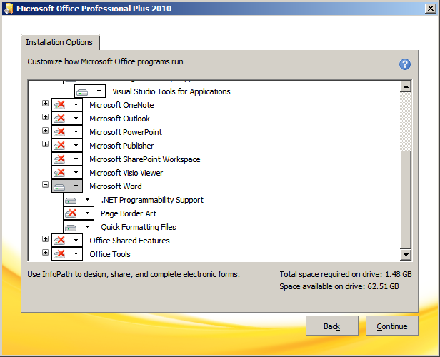
Click ‘Continue’, I had already installed Microsoft Word to allow me to document the installation process

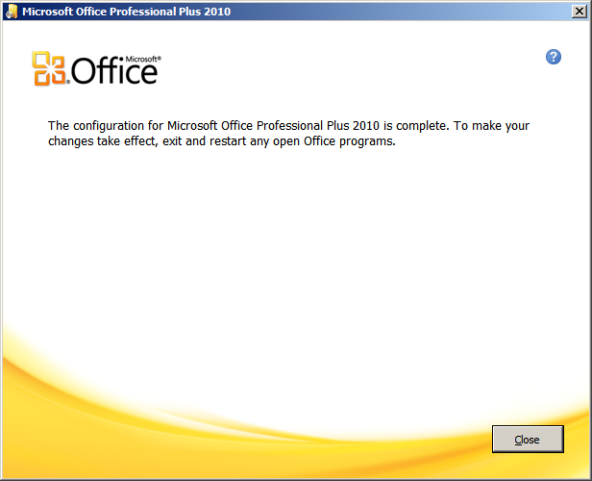
Click ‘Close’

Install Visual Studio 2010 Ultimate Edition

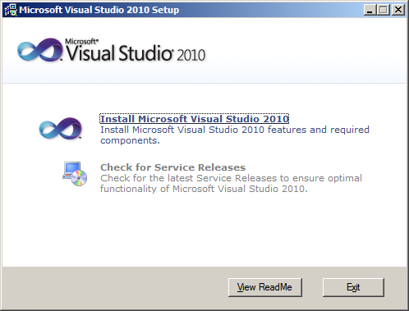
Click ‘Install Microsoft Visual Studio 2010’.
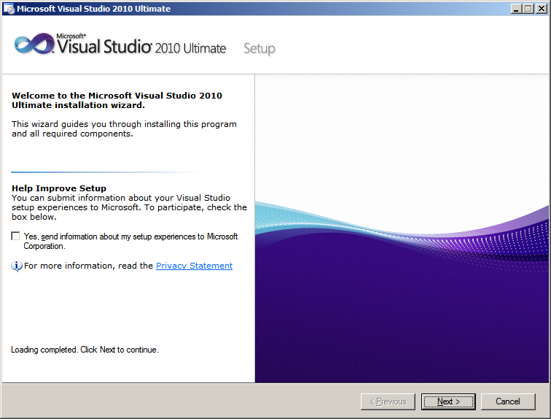
Click ‘Next’
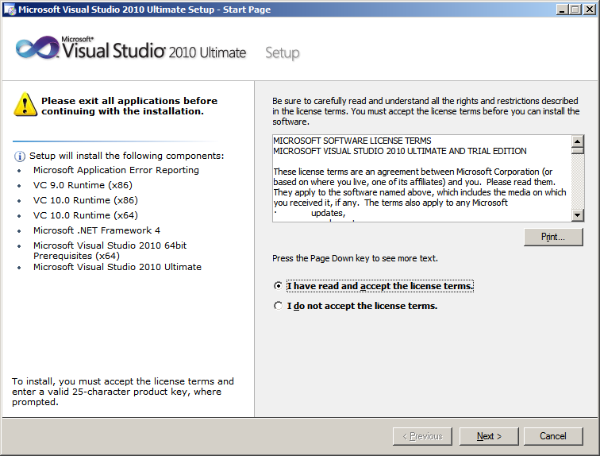
Accept the license terms and click ‘Next’
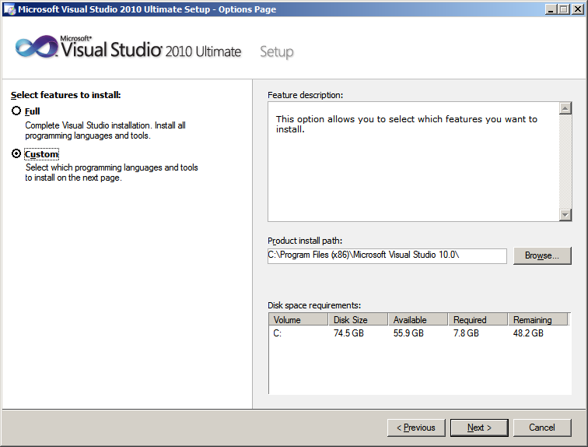
Select ‘Custom’ and click ‘Next’
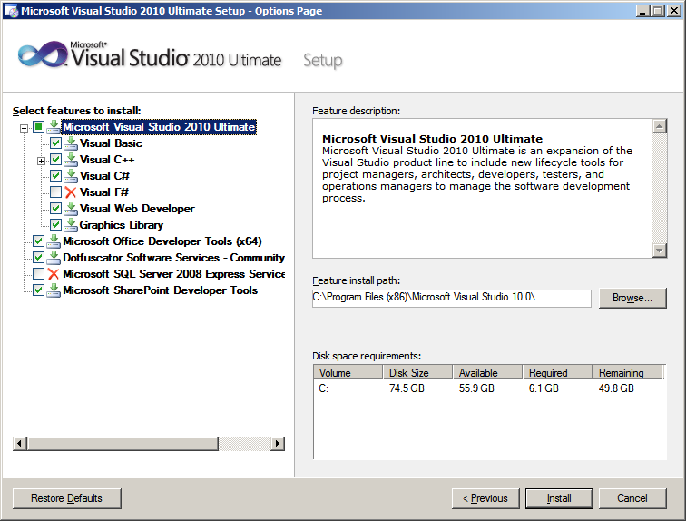
Uncheck ‘Visual F#’, ‘Microsoft SQL Server 2008 Express Service’, and then click ‘Install’
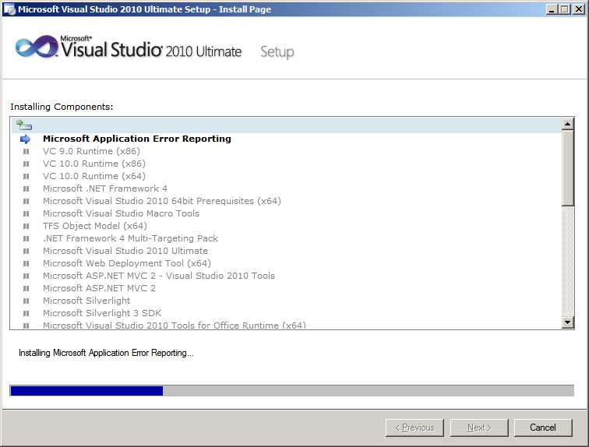
Go get a coffee, this will take a while.....

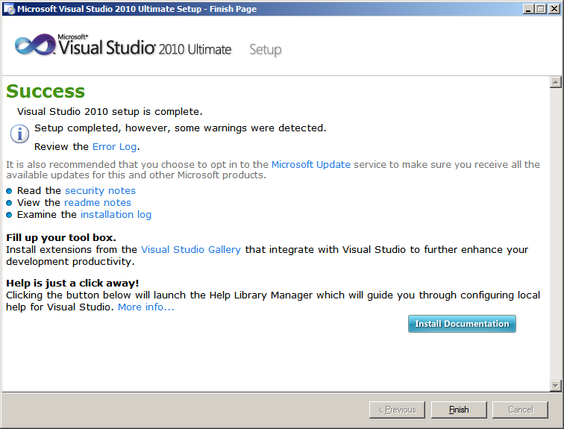
Click ‘Finish’

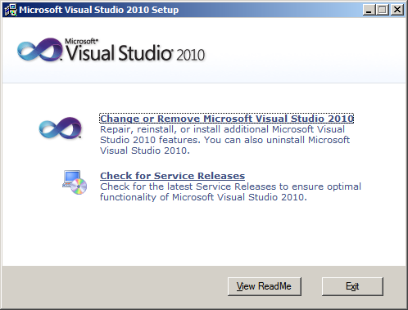
Click ‘Check for Service Releases’
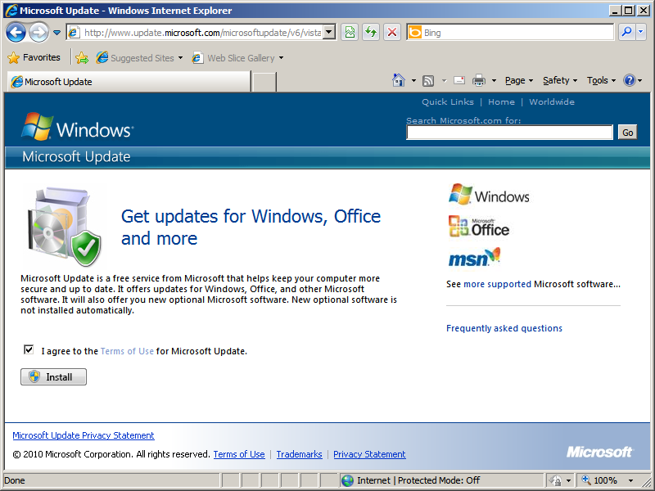
Click ‘Install’
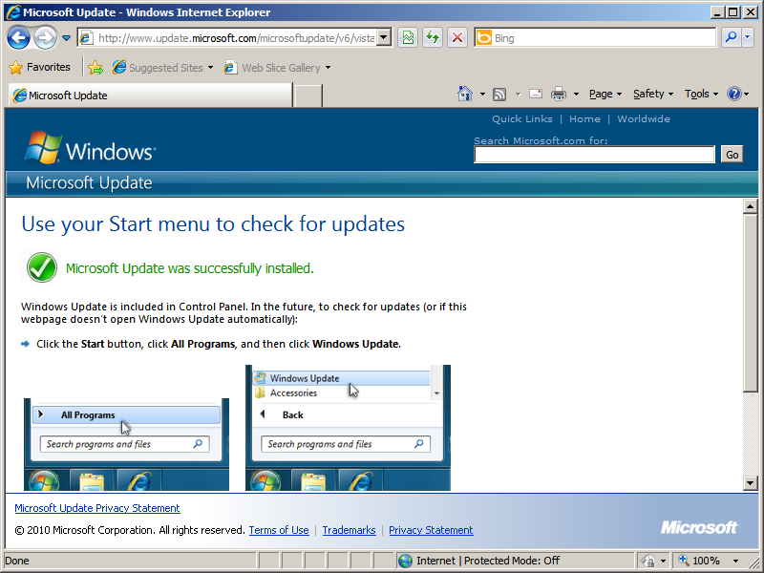
Close the browser
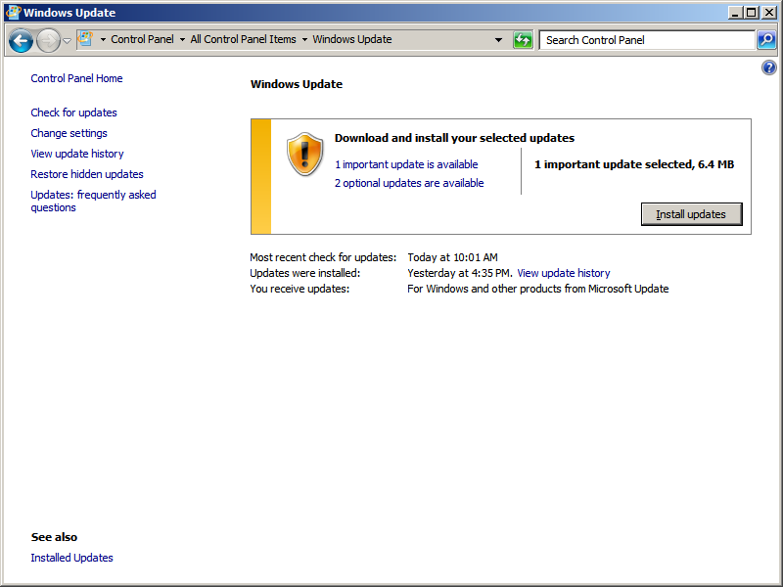
Install any important updates
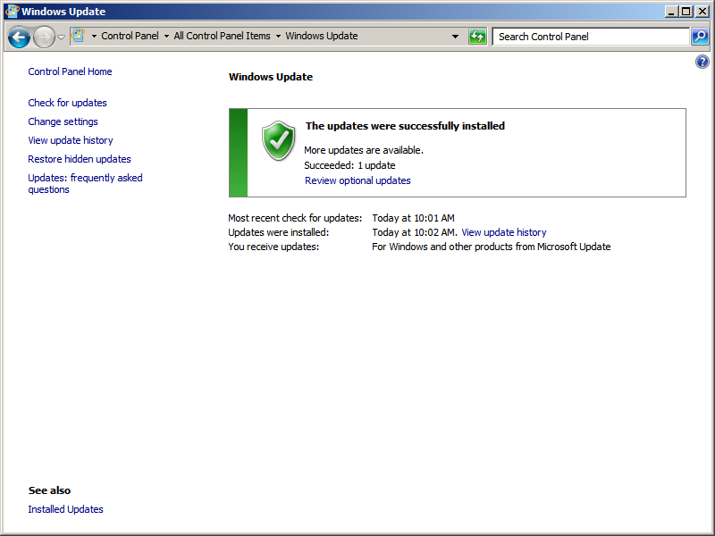
Close the Windows Update window

Install SQL Server 2008 R2 64-bit
Install SQL Server 2008 R2 64-bit
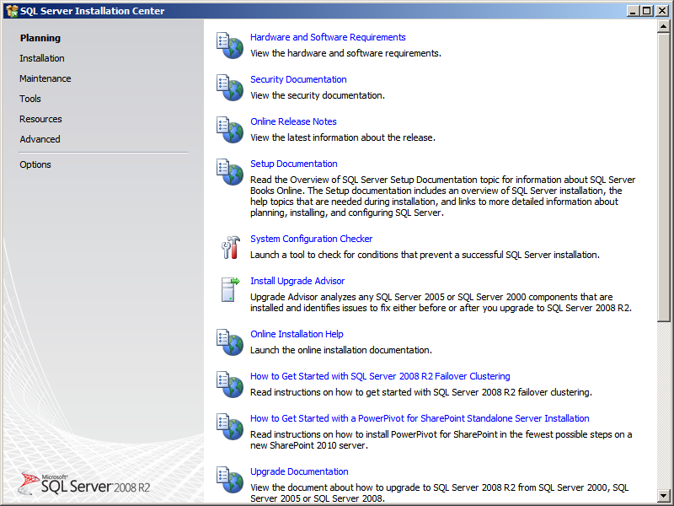
Click the ‘Installation’ link

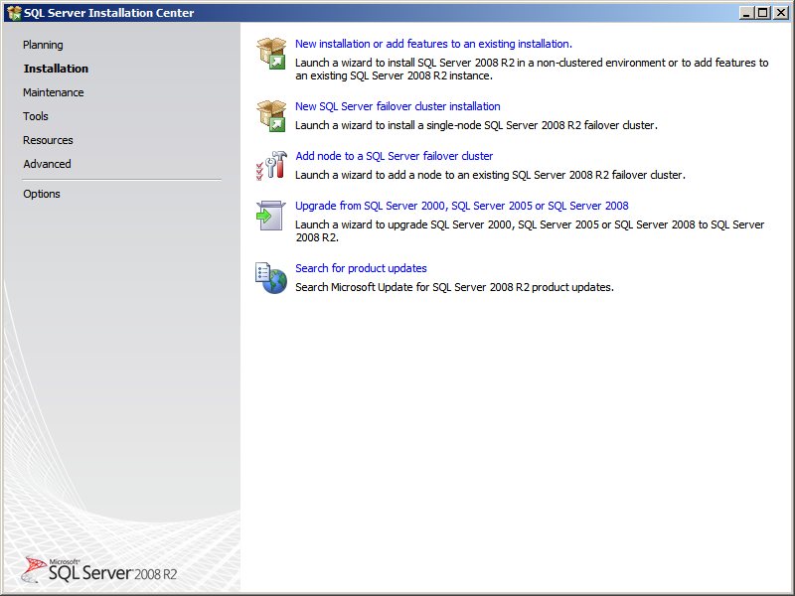
Click on ‘New SQL Server stand-alone installation or add features to an existing installation’ link
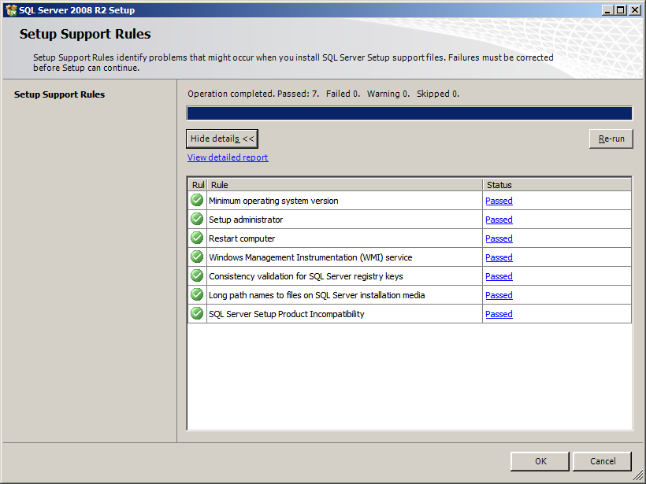
You want all green check boxes, click ‘OK’
Next you will see the ‘Product Key’ screen, enter your product key, in my case I installed SQL Server 2008 R2 Developer Edition which is pre-pidded, click ‘Next’
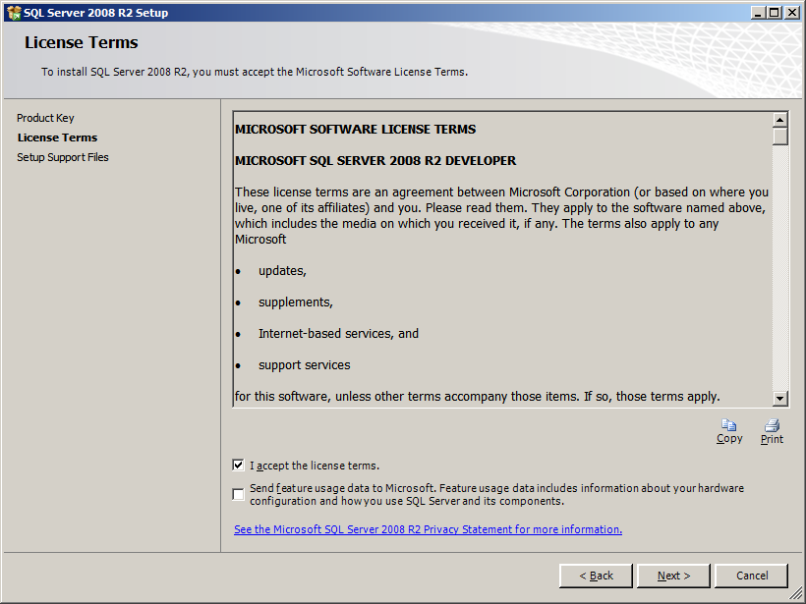
Accept the terms and click ‘Next’
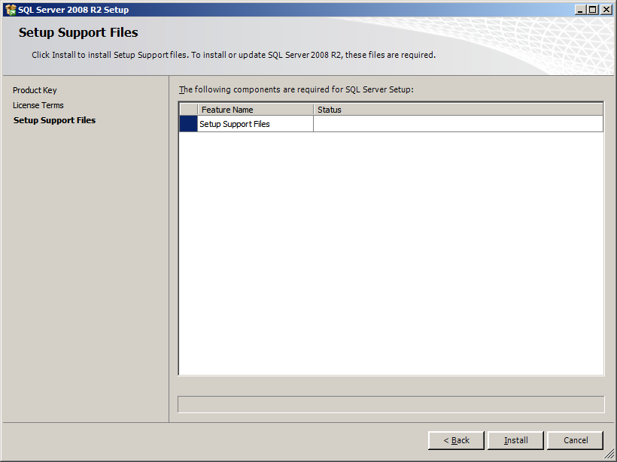
Click ‘Install’
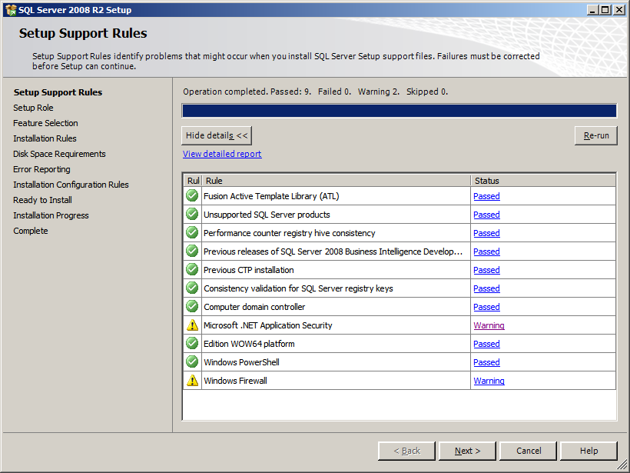
I had two warnings which are listed below, click ‘Next’

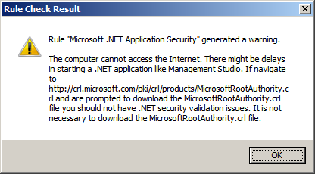
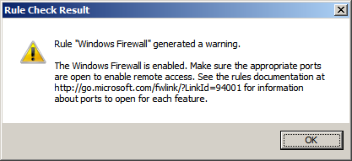

To fix Windows Firewall warning I opened up TCP port 1433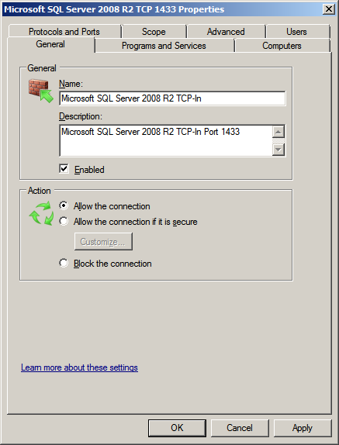
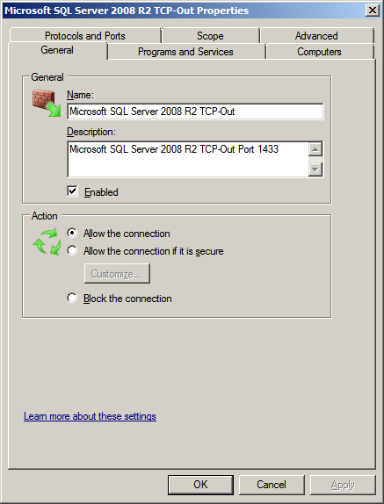

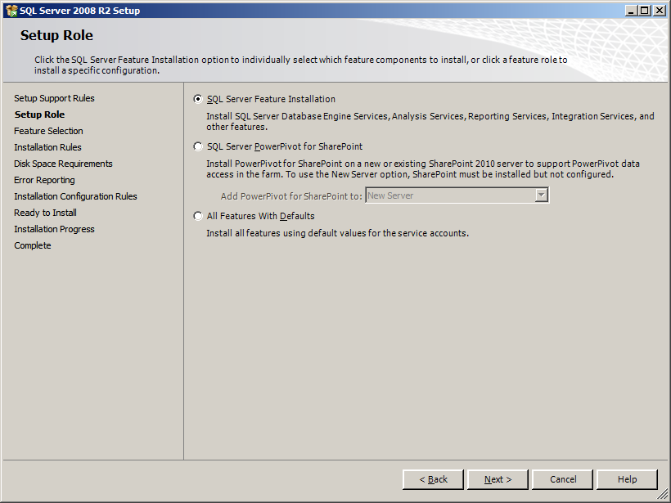
Select ‘SQL Server Feature Installation’ and click ‘Next’

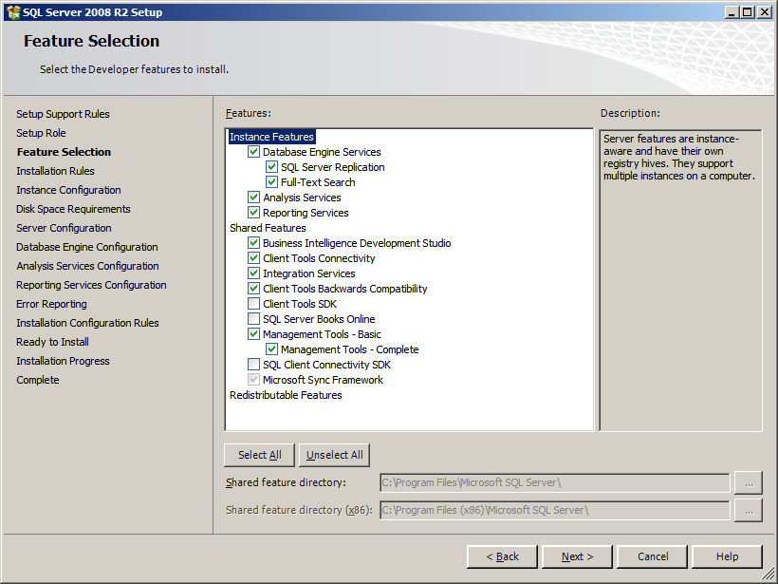
Select the options above and click ‘Next’

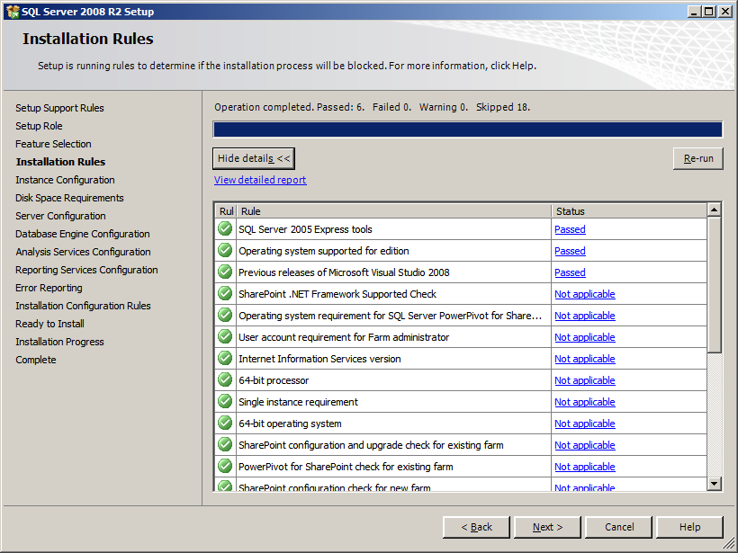
You should not see any errors, click ‘Next’
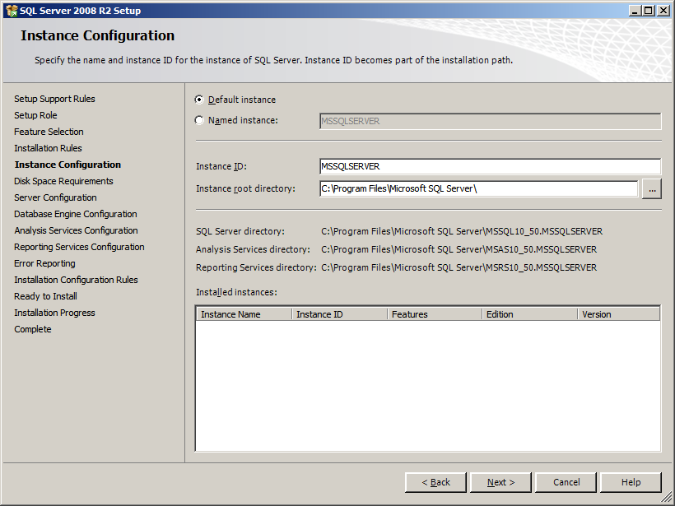
Select ‘Default instance’ and then click ‘Next’
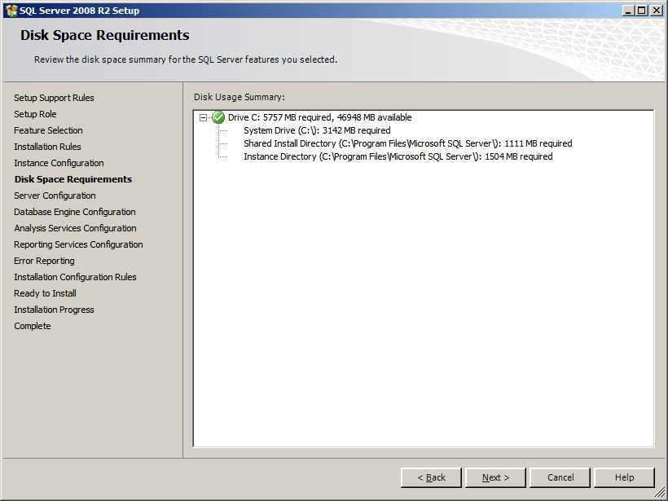
Click ‘Next’

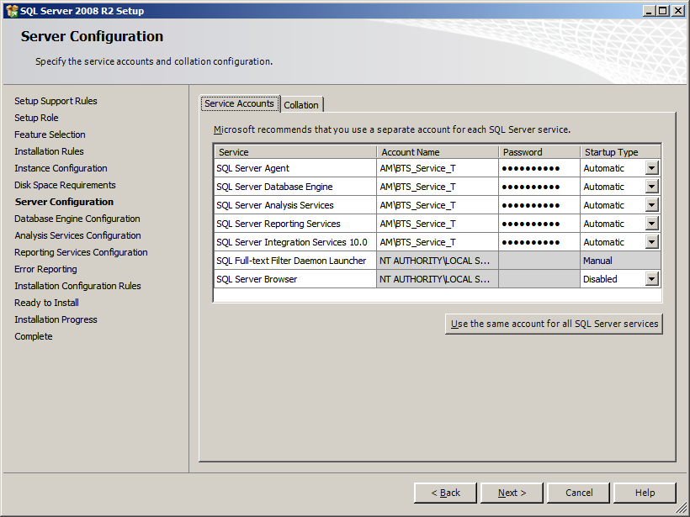
Click the ‘Use the same account for all SQL Server services’ button, fill in the ‘Account Name’ and ‘Password’ fields, and set ‘SQL Server Agent’ to ‘Automatic’. Next, click the ‘Collation’ tab
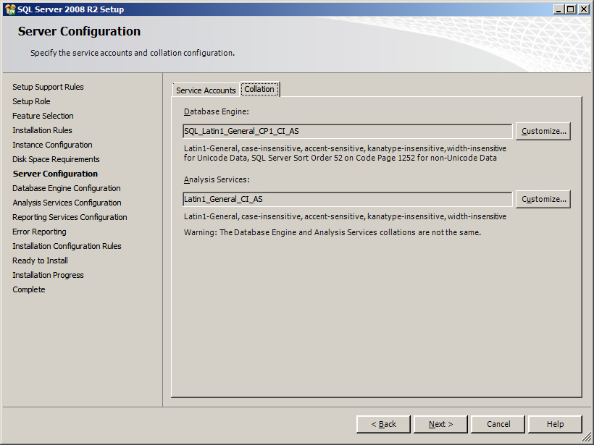
Leave the defaults and click ‘Next’

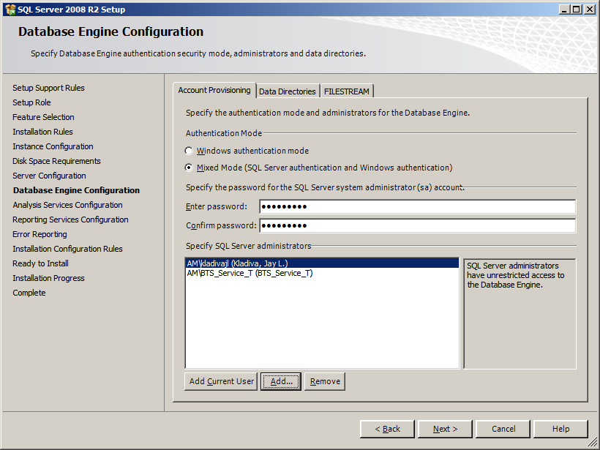
Select ‘Mixed Mode’, enter a password for ‘sa’, and then add your domain account to the ‘Specify SQL Server administrators’ list by click the ‘Add Current User’ button. Then click on the ‘Data Directories’ tab
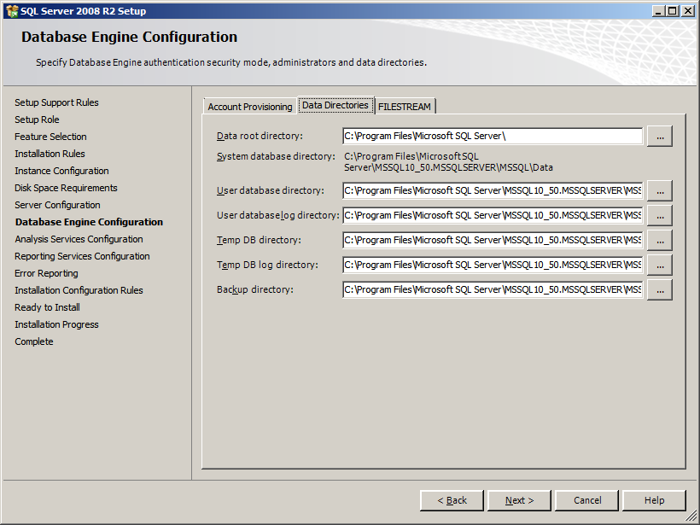
Review and click on the next tab, I only have 1 .vhd so all my stuff is on the C:\ drive
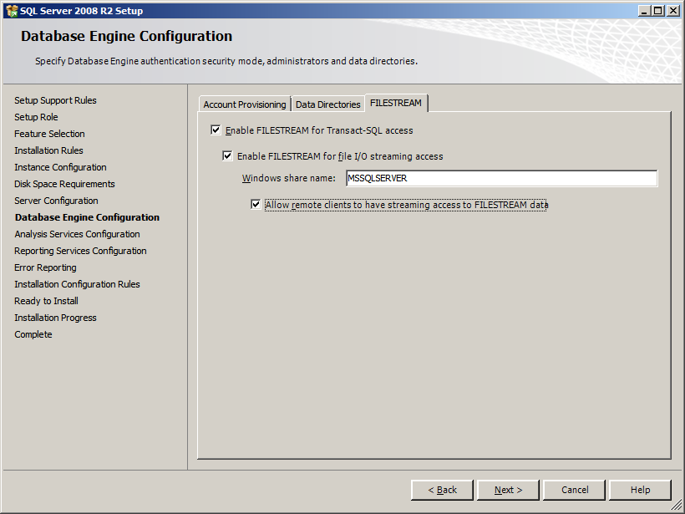
I enabled FILESTREAM to demo the capability, click ‘Next’

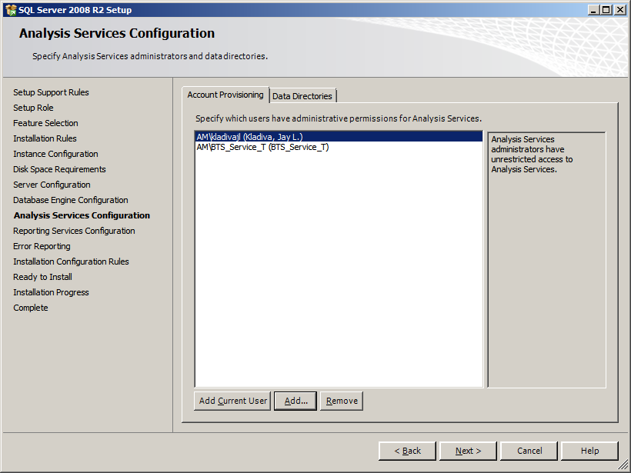
Click the ‘Add Current User’ button and then click the next tab
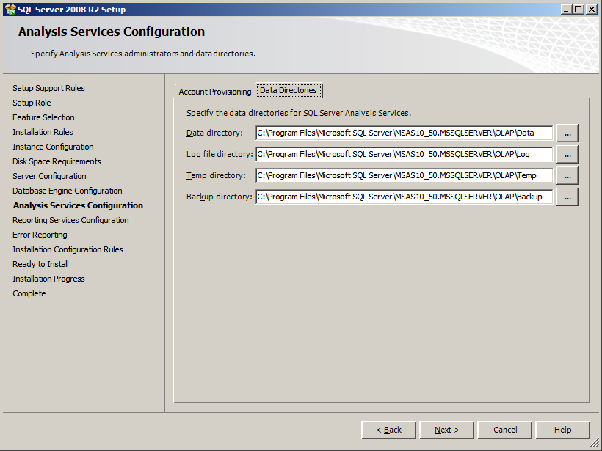
Click ‘Next’

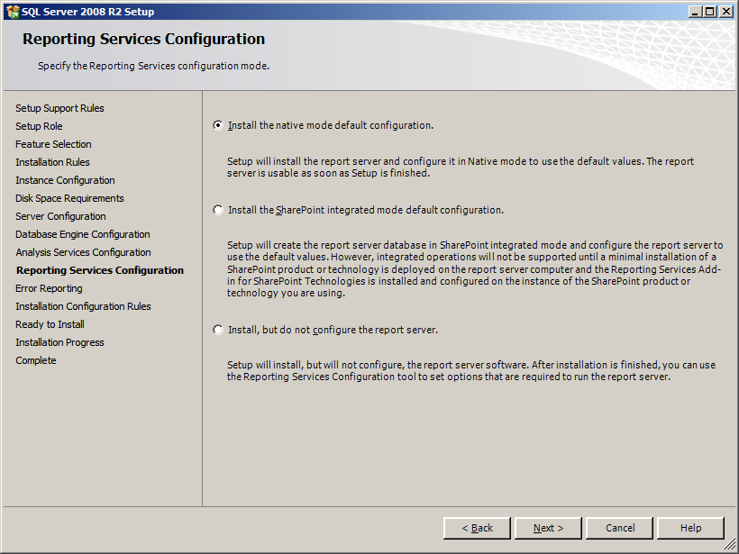
Select ‘Install the native mode default configuration’ option and then click ‘Next’

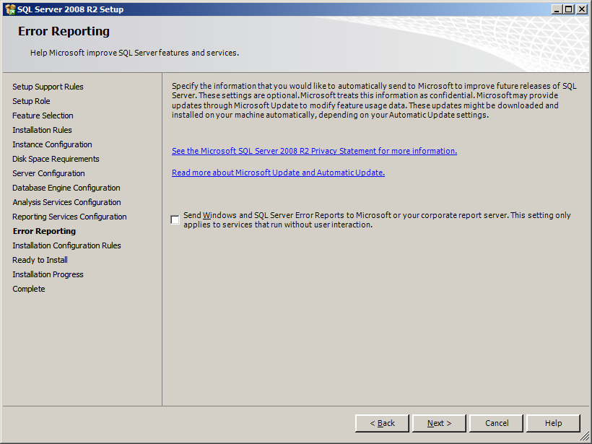
Uncheck the check box and then click ‘Next’

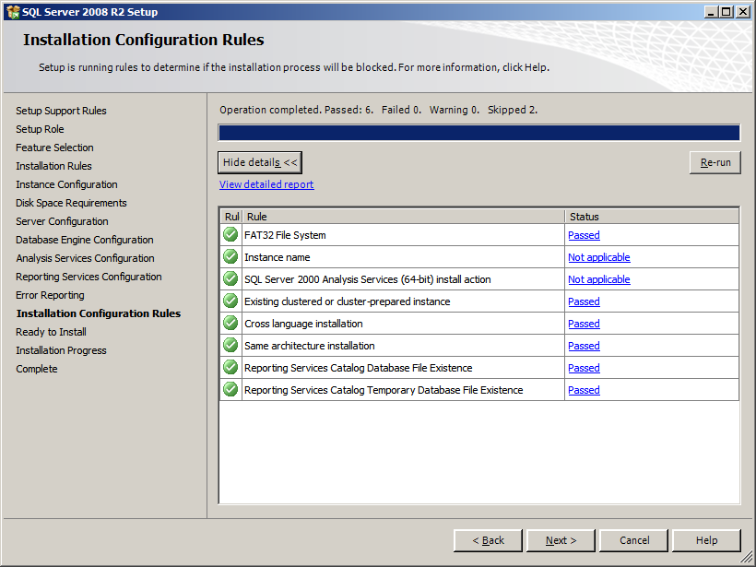
Click ‘Next’

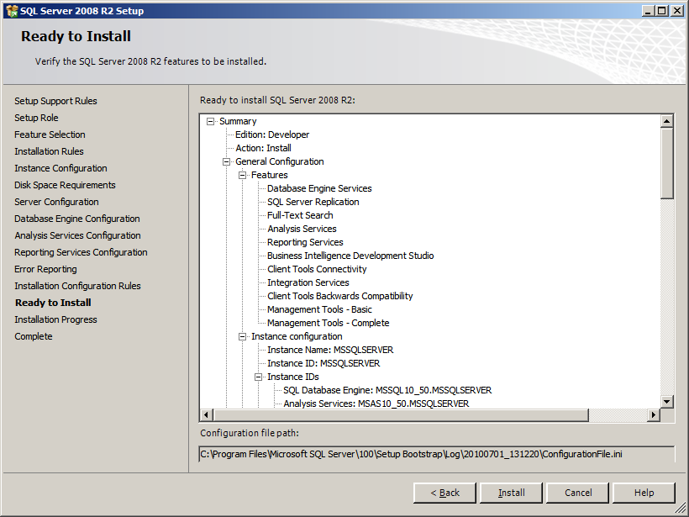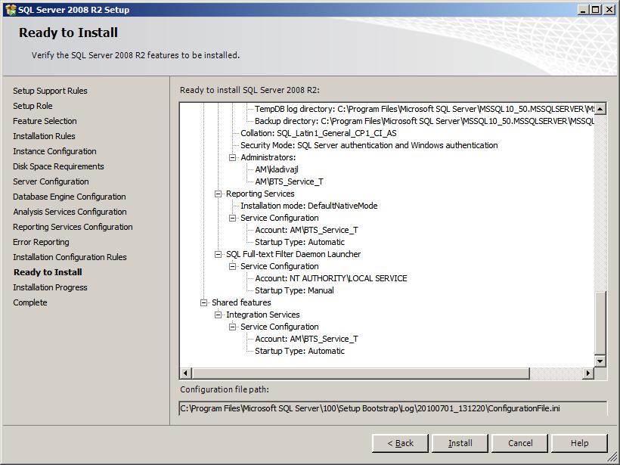
Click ‘Install’

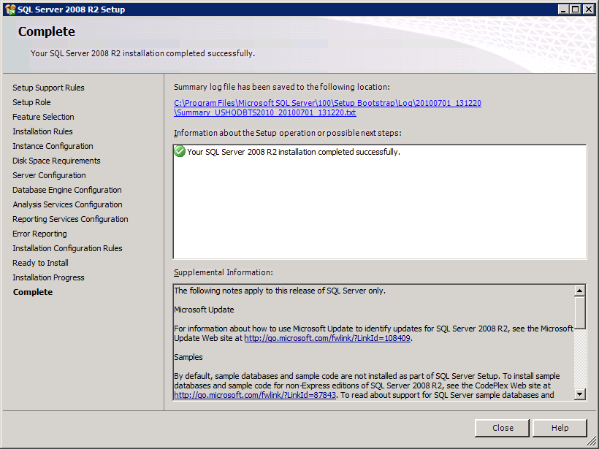
You should see a green checkmark, click ‘Close’

Install SQL Notifications Services
This feature is required for BAM alerts. SQL Notification Services is not included in SQL Server 2008 R2, you must download the install packages from the Microsoft Download Center listed under the ‘Feature Pack for Microsoft SQL Server 2005 – December 2008 which you can find here;
http://www.microsoft.com/downloads/details.aspx?FamilyID=536fd7d5-013f-49bc-9fc7-77dede4bb075&displaylang=en
Scroll down to the bottom of the page to the ‘Files In Download’ section and download these packages;
Microsoft SQL Server Native Client X64 Package (sqlncli_x64.msi)
Microsoft SQL Server 2005 Management Objects Collection X64 Package (SQLServer2005_XMO_x64.msi)
Microsoft SQL Server 2005 Notification Services Client Components X64 Package (SQLServer2005_NS_x64.msi)
Once you have downloaded and saved off the 3 MSI packages, install the SQL Server Native Client
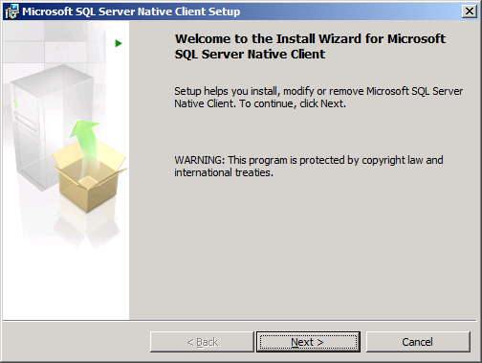
Click ‘Next’

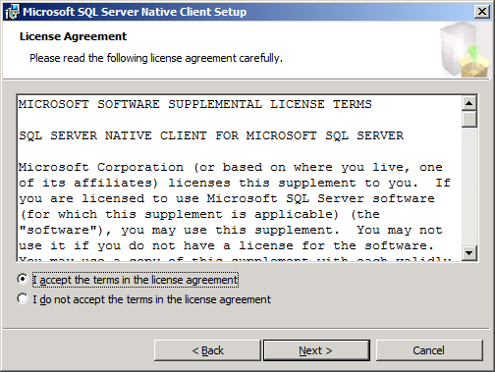
Accept the terms and click ‘Next’
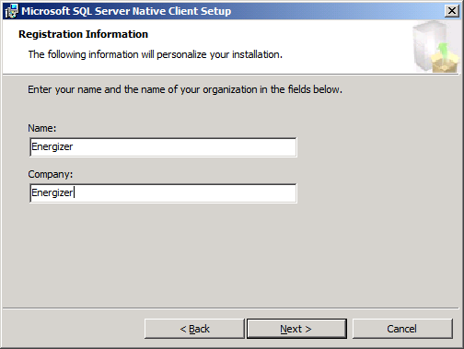
Fill out the form and click ‘Next’
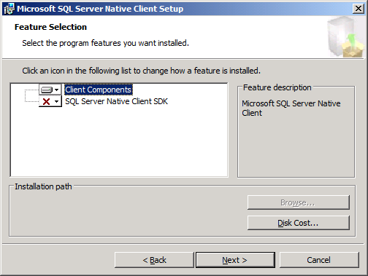
Install only the ‘Client Components’ and click ‘Next’

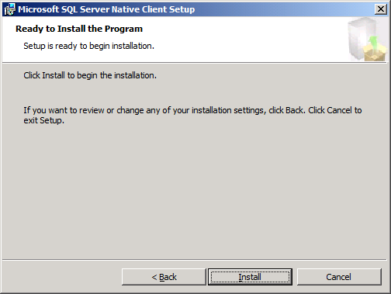
Click ‘Install’

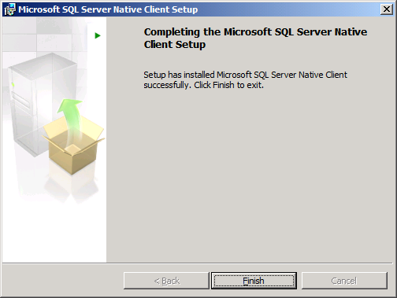
You should see a message that it installed successfully, click ‘Finish’
Next install the Microsoft SQL Server 2005 Management Objects Collection by kicking off the
SQLServer2005_XMO_x64.msi
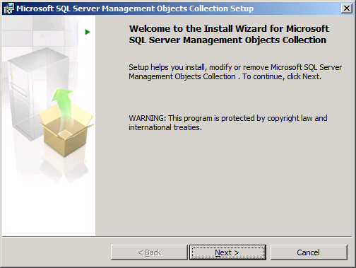
Click ‘Next’

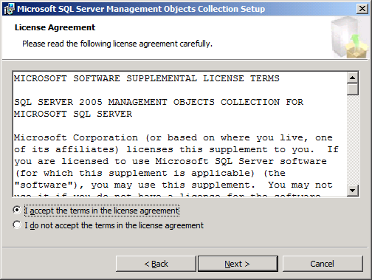
Accept the terms and click ‘Next’

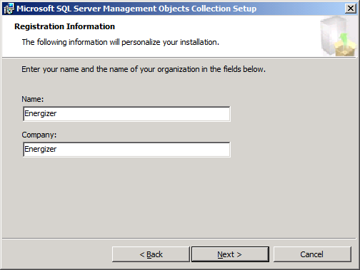
Fill out the form and click ‘Next’

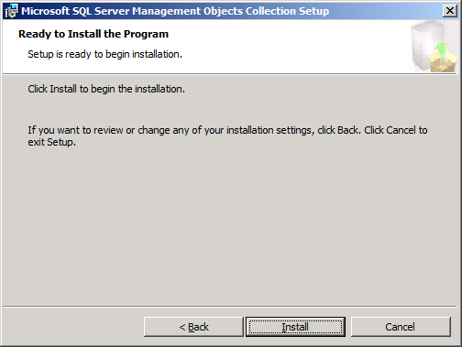
Click ‘Install’

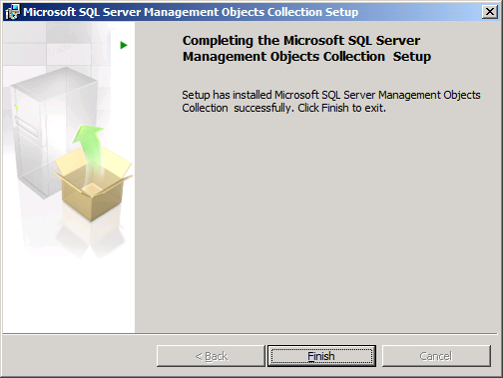
You should see a message stating the install was successful, click ‘Finish’
Next install the Microsoft SQL Server 2005 Notification Services Client Components by kicking off the SQLServer2005_NS_x64.msi package

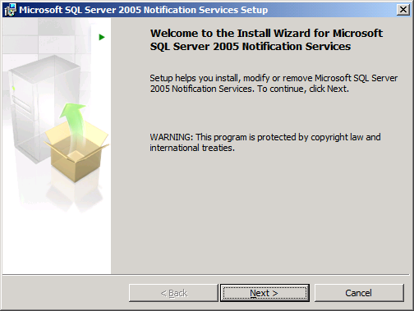
Click ‘Next’
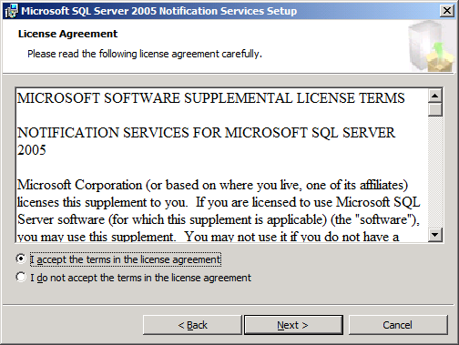
Accept the terms and click ‘Next’

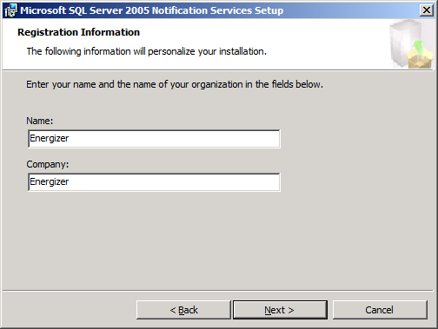
Fill out the form and click ‘Next’

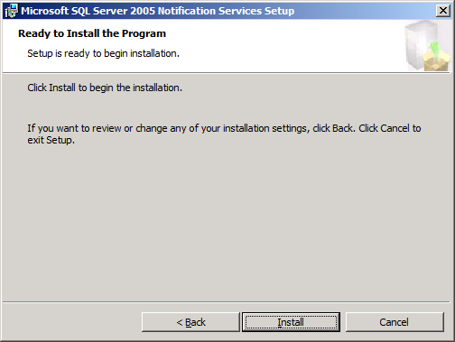
Click ‘Install’

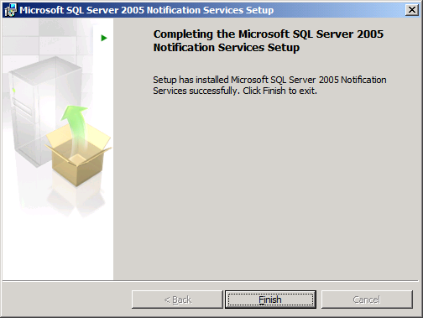
You should see a message stating the install was successful, click ‘Finish’

SharePoint Foundation 2010
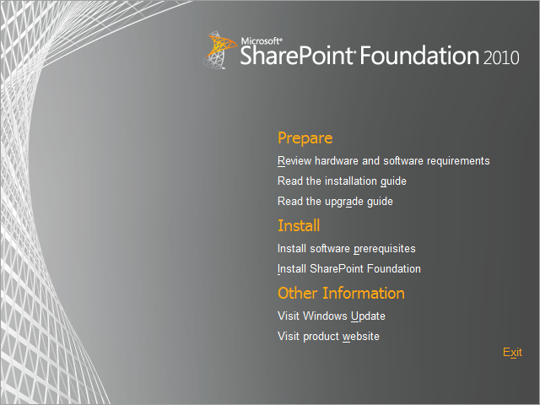
Click ‘Install software prerequisites’
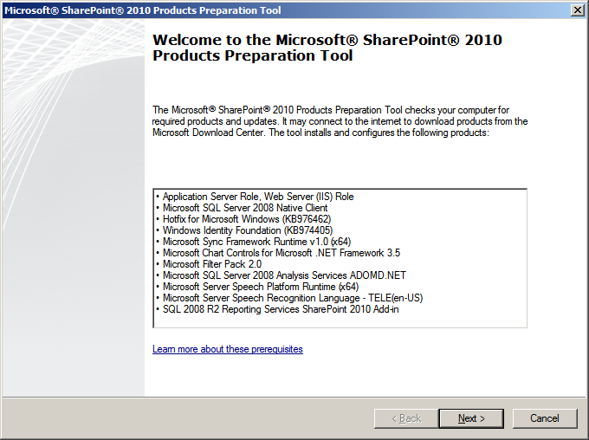
Click ‘Next’
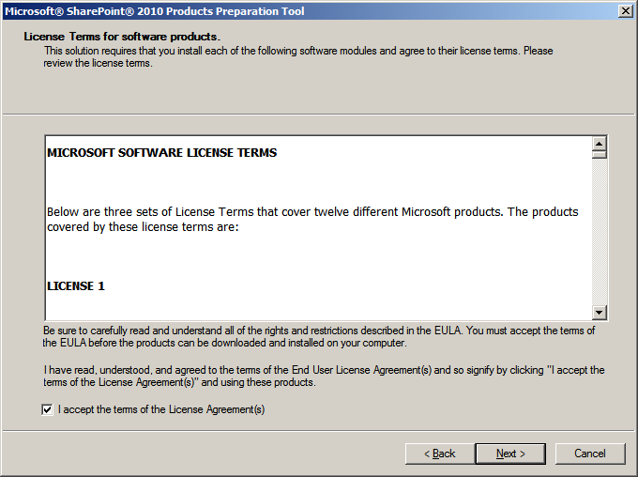
Accept the terms and click ‘Next’
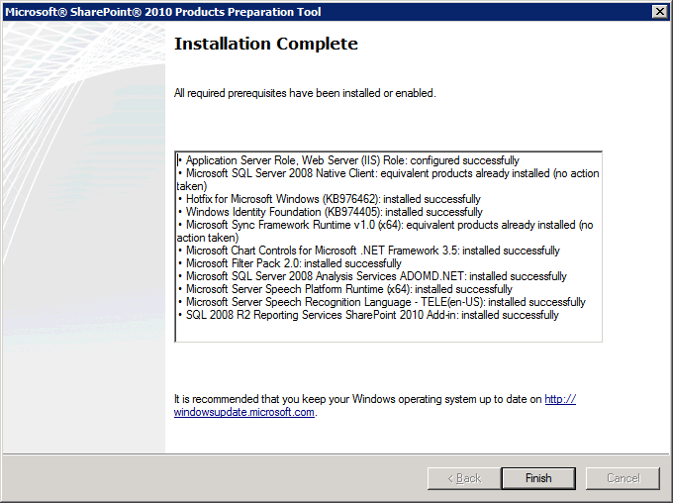
Click ‘Finish’

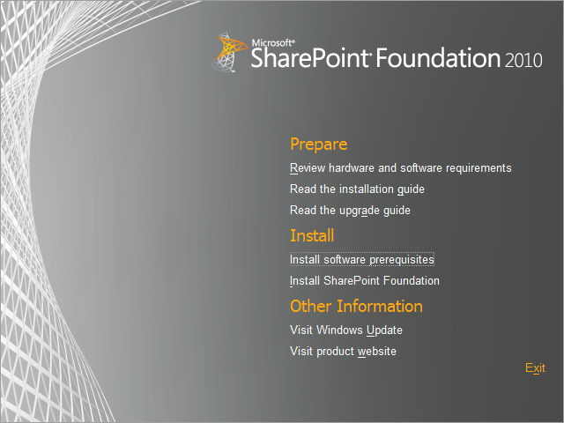
Click ‘Install SharePoint Foundation’
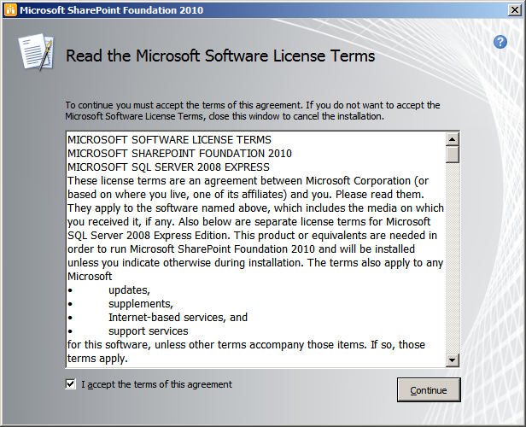
Accept the terms and click ‘Continue’

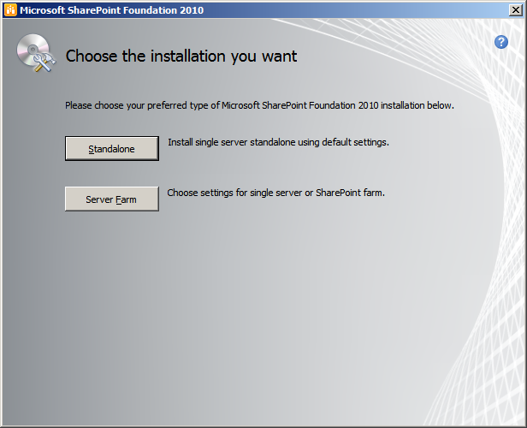
Click ‘Server Farm’
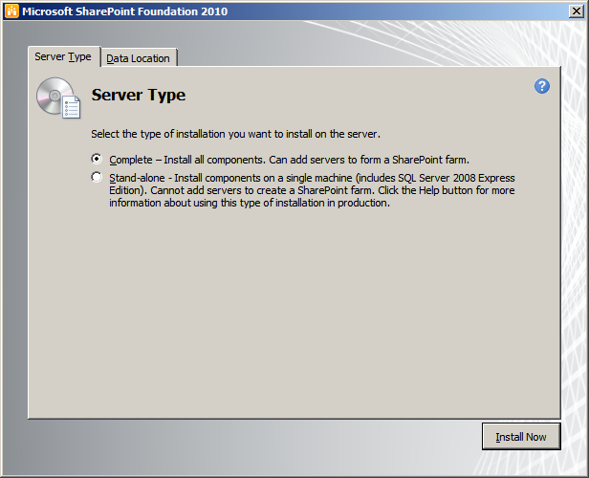
Select ‘Complete’
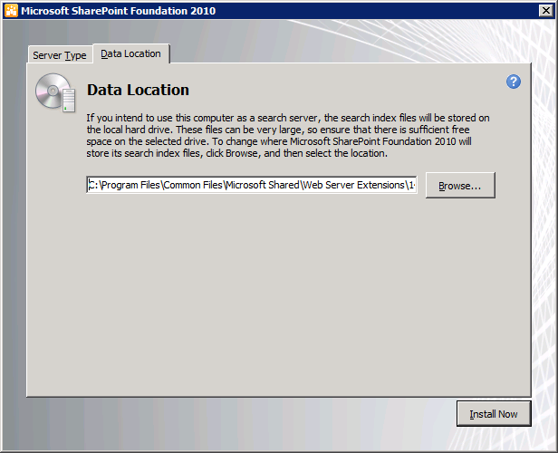
Click ‘Install Now’

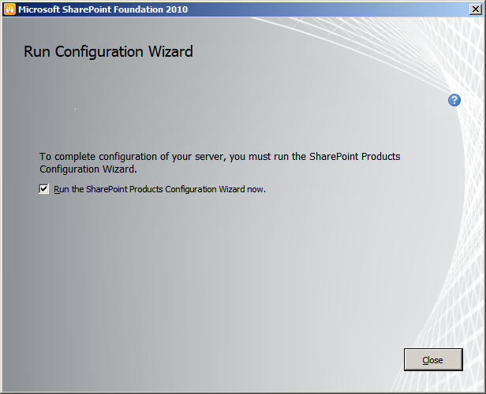
Click ‘Close’
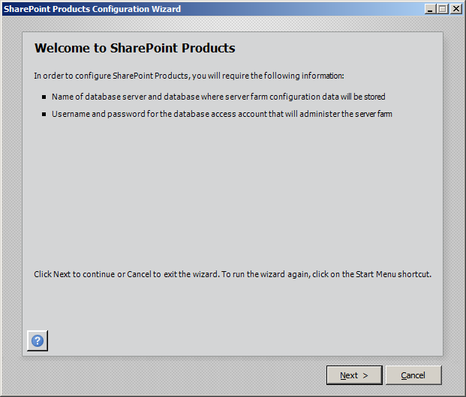
Click ‘Next’, you will see the popup listed below;

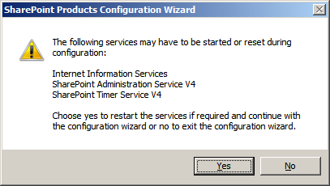
Click ‘Yes’

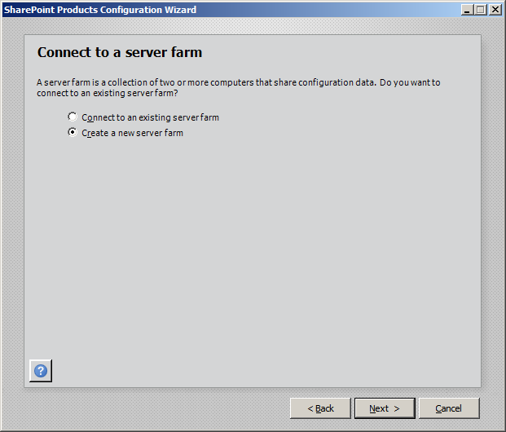
Select ‘Create a new server farm’, then click ‘Next’
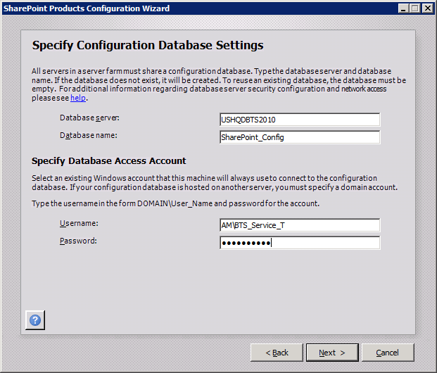
Add the server name of your BizTalk SQL Server, in this case it is the local server, specify your database access account, then click ‘Next’
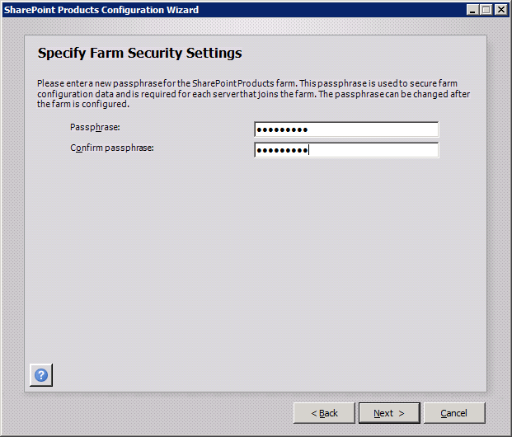
Enter your ‘Passphrase’ and then click ‘Next’

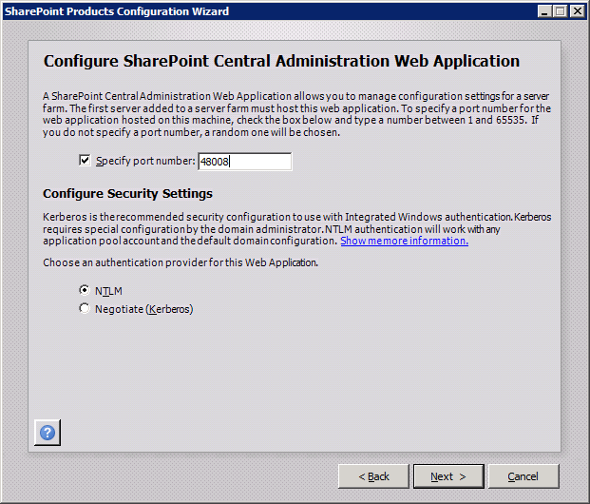
Accept the default port and click ‘NTLM’, then click ‘Next’

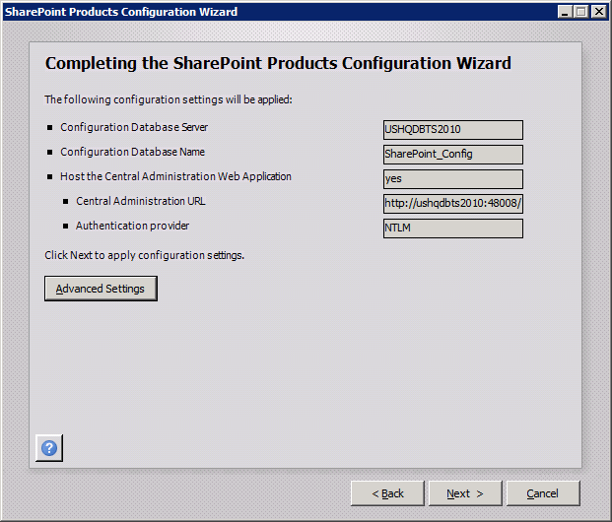
Review and then click ‘Next’

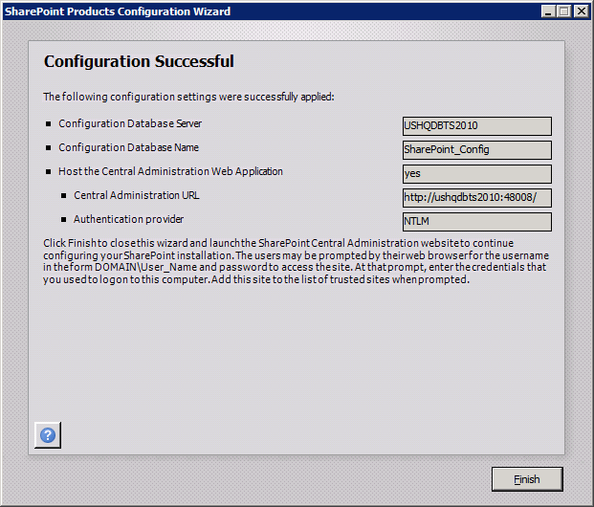
Click ‘Finish’
NOTE: If you have issues, this is a good blog entry;
Common Microsoft SharePoint Server 2010 Installation Issues and Resolutions
http://blogs.technet.com/b/wbaer/archive/2009/12/11/common-microsoft-sharepoint-server-2010-installation-issues-and-resolutions.aspx

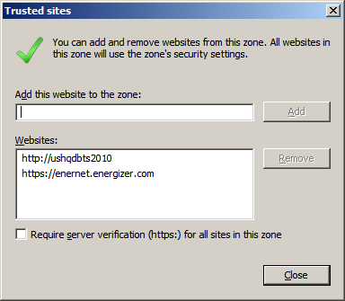
Add SharePoint Central Admin to your list of ‘Trusted sites’

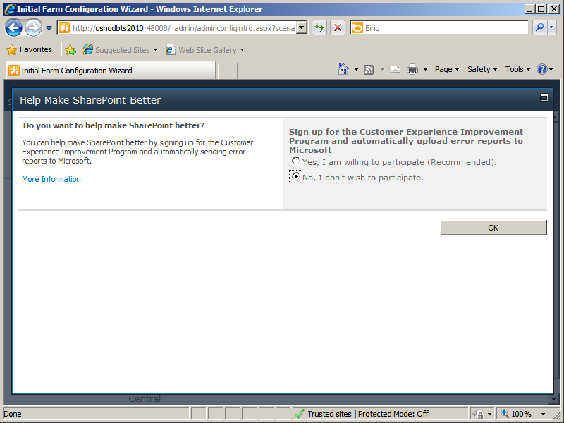
Select ‘No, I don’t wish to participate’ and then click ‘OK’

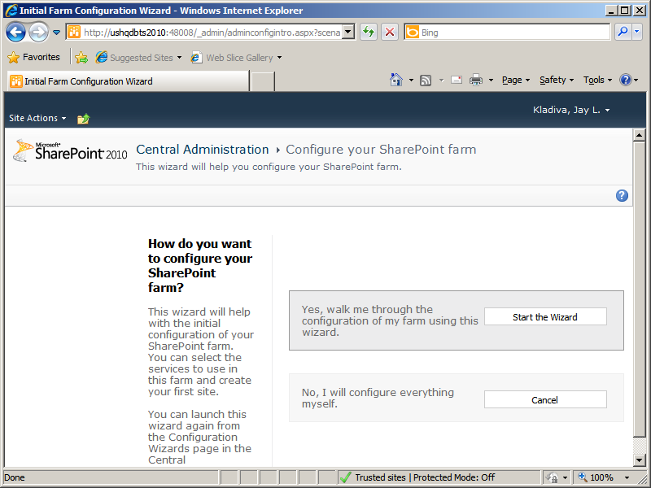
Click ‘Start the Wizard’

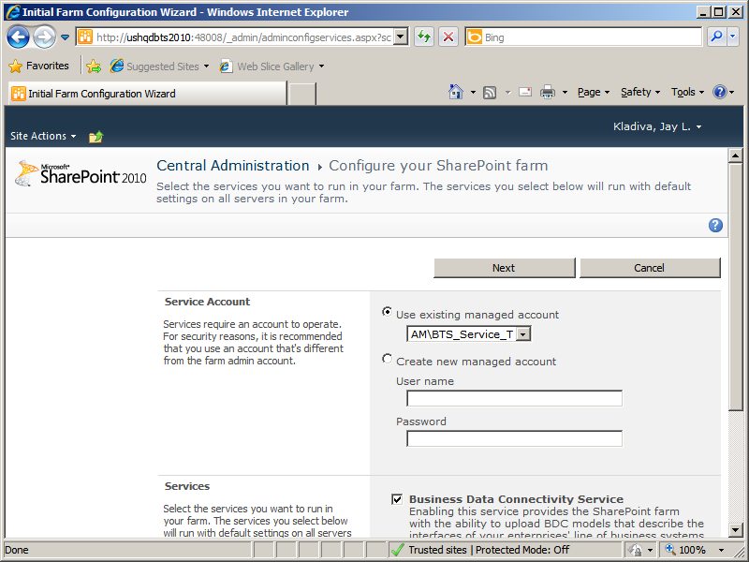
Fill out the form and click ‘Next’

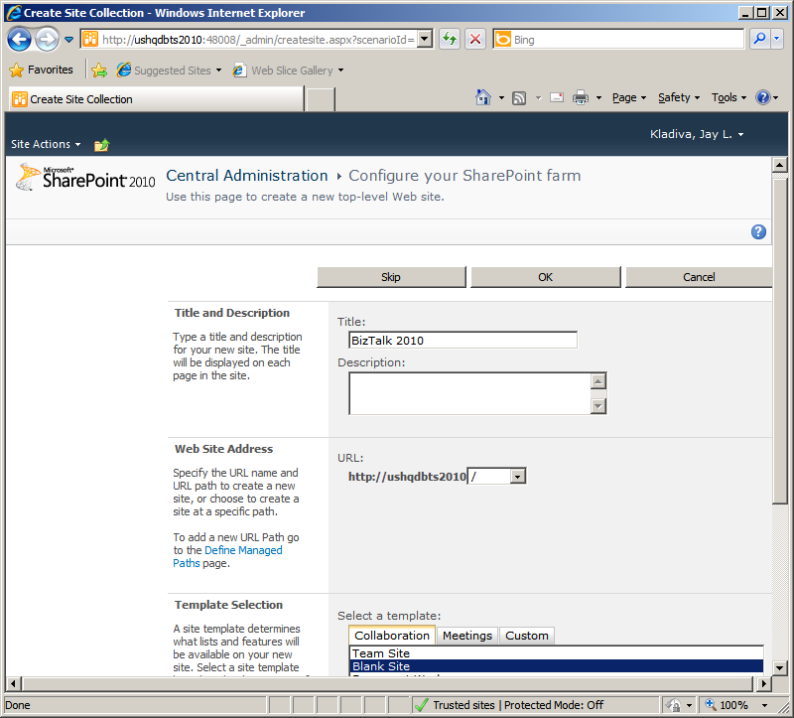
Give a ‘Title’ to your new top-level Web site and then click ‘OK’
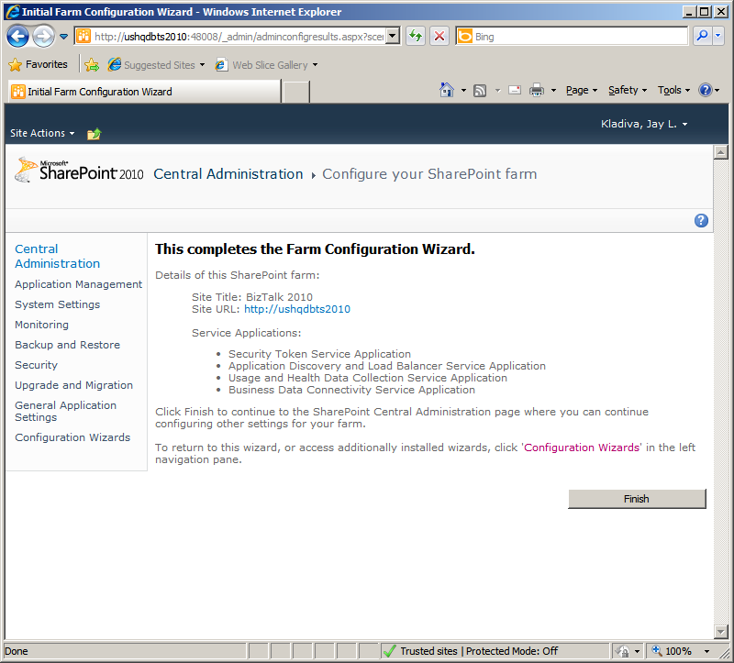
Click ‘Finish’

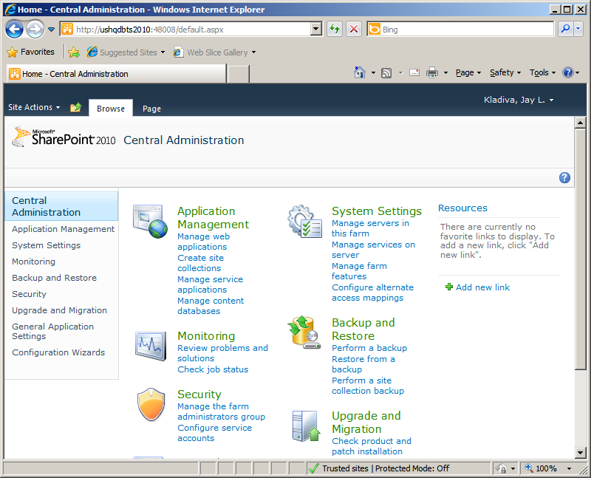
SharePoint 2010 Central Admin home page
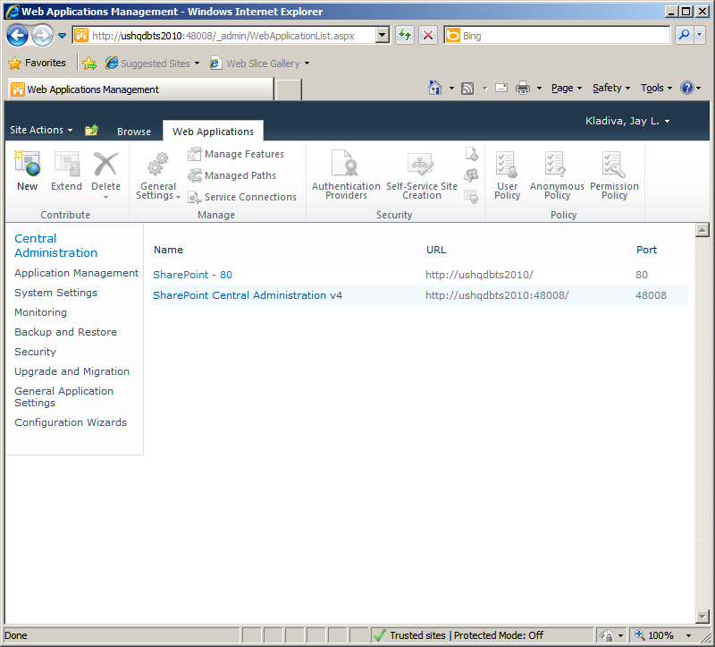
You should have 2 Web Applications(SharePoint – 80 and SharePoint Central Administration v4)

Disable the Shared Memory Protocol, Enable TCP/IP and Named Pipes
Click ‘Start’, ‘All Programs’, click ‘Microsoft SQL Server 2008 R2’, click ‘Configuration Tools’, then click ‘SQL Server Configuration Manager’
In the SQL Server Configuration Manager, click on the ‘SQL Server Network Configuration’ node and expand it, under ‘Protocols for MSSQLSERVER’ right-click the ‘Shared Memory’ protocol and disable it. Right-click the TCP/IP protocol and enable it and repeat the process for Named Pipes.
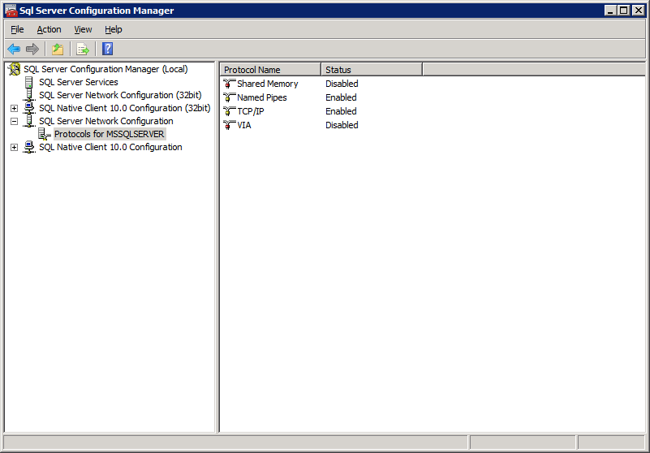
Repeat the same for the SQL Native Client 10.0 Configuration (32bit) node
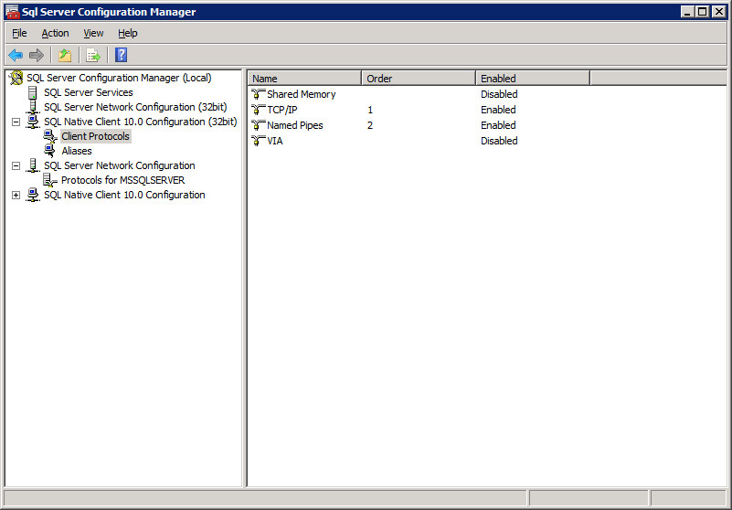
Next, click on ‘SQL Server Services’, right-click ‘SQL Server Services’ and click ‘Stop’, then ‘Start’ to make the settings take effect.
Close the SQL Server Configuration Manager

Join the Local Administrators Group
BizTalk requires you to be a Local Administrator to install and configure BizTalk.
Click ‘Start’, ‘Control Panel’, ‘Administrator Tools’, ‘Computer Management’, ‘Local Users and Groups, ‘Groups’, …..add you user account to the ‘Administrators’ group

Configure the Application Event Log
BizTalk logs its events to the Windows Application Event Log. Depending on the features you plan to install for BizTalk and the current size of the Application Event Log your installation might fail if the log exceeds its size limit. Also in production you always want a rolling list of the latest events and do not want your Application Event Log to become massive in size
Click ‘Start’, ‘Control Panel’, ‘Administrative Tools’, Event Viewer’, expand ‘Windows Logs’, and right-click ‘Application’, then click ‘Properties’, set the ‘Maximum log size’ to a reasonable number and select ‘Overwrite events as needed’.
Click ‘OK’ and close the Event Viewer
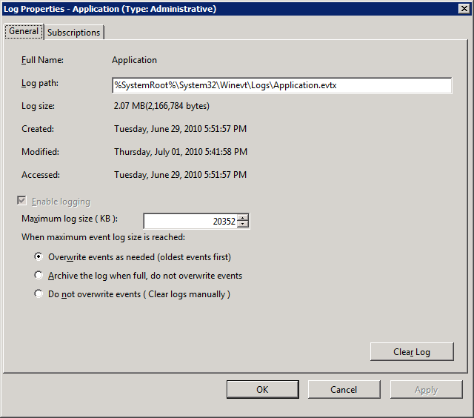

BizTalk Server 2010 64-bit Installation
Download the BizTalk 2010 Beta from the microsoft.com site here;
http://www.microsoft.com/downloads/details.aspx?FamilyID=0f852e77-f792-4784-b2d4-95113d40db64&displaylang=en
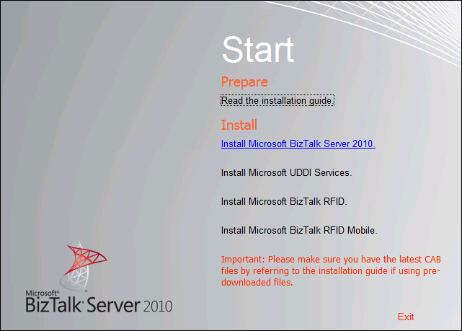
Click the ‘Install Microsoft BizTalk Server 2010’ link

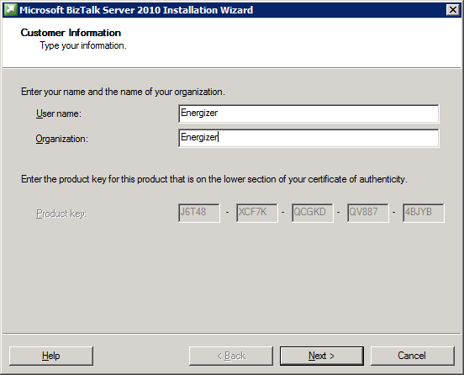
Fill out the form and click ‘Next’

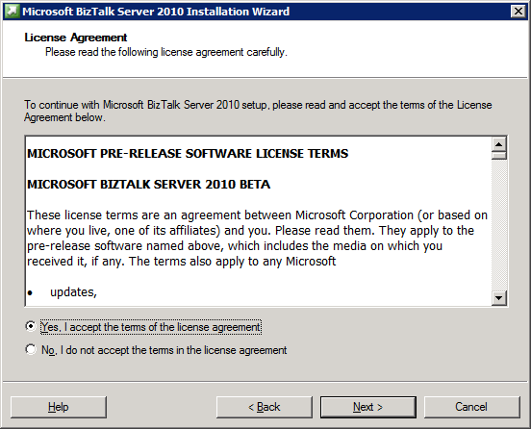
Accept the terms and click ‘Next’
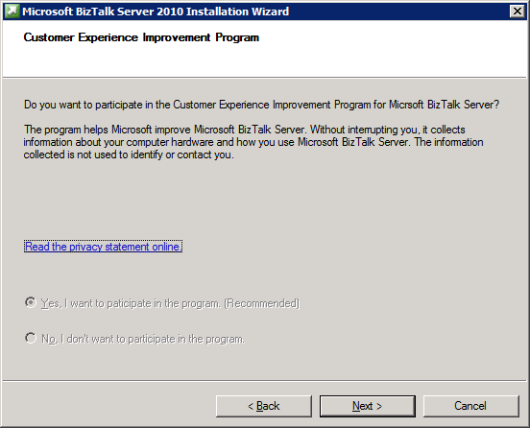
Click ‘Next’
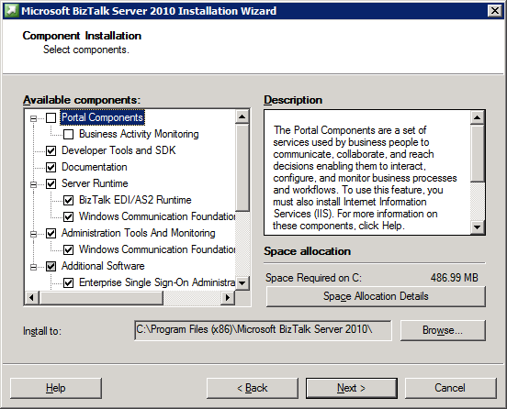
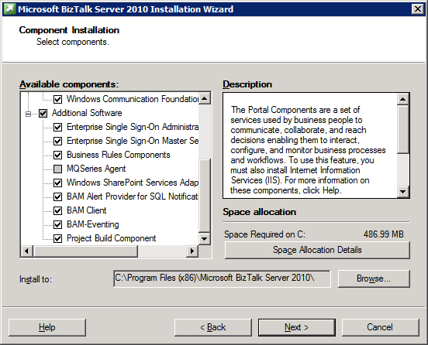
Select all the options except ‘Portal Components’, ‘Business Activity Monitoring’, and ‘MQ Series Agent’. The BAM Portal can only run in 32-bit mode, installing the other BAM components gives you the BAM API and BAM databases to store events, then you can create your own portal in SharePoint, ASP.NET, etc. to display BAM information to your business. Click, ‘Next’

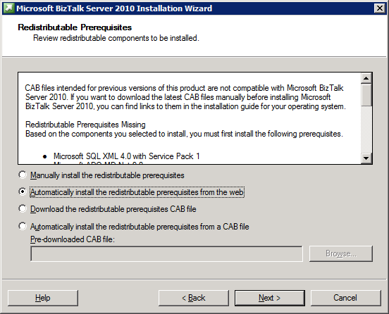
Select, ‘Automatically install the redistributable prerequisites from the web’ and click ‘Next’
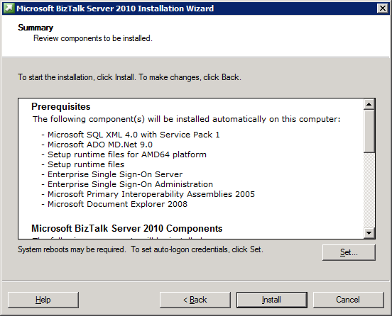
Review and click ‘Install’

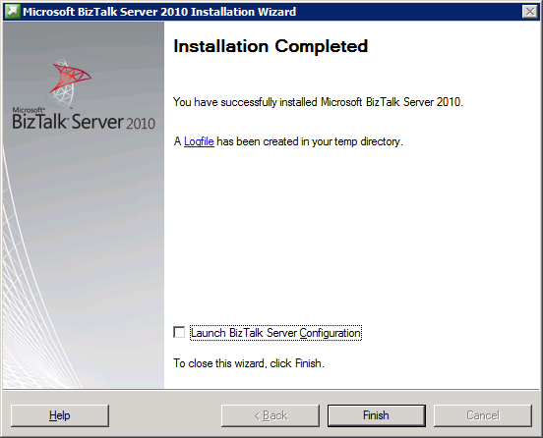
You should see a message that BizTalk was installed successfully, click on the ‘Logfile’ link to review the log if any errors were encountered. Clear the check box and click ‘Finish’, BizTalk is now installed but not configured.

Verify Your BizTalk Server 2010 Installation
Microsoft lists this step in their Installation guide.
Click ‘Start’, ‘Run’, type ‘regedit’, press ‘Enter’, then browse to the HKEY_LOCAL_MACHINE\SOFTWARE\Microsoft\BizTalk Server\3.0 key
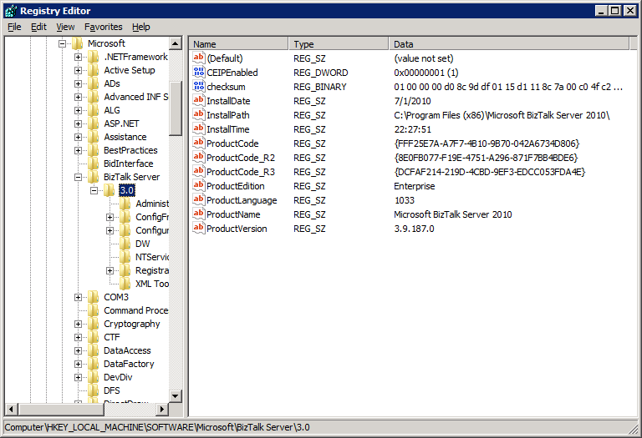
If the key exists then your setup succeeded. Also nice to know where this key is so you can view what version of BizTalk you installed by looking at the ‘ProductEdition’ node, now you are now ready to configure BizTalk Server 2010 via the ‘BizTalk Server Configuration Wizard’.

Setup Domain Accounts For BizTalk Server 2010
You need to setup some domain accounts for the various pieces of BizTalk Server 2010. Ideally you should have separate accounts for your production environment then your development/test environments. If you share these accounts between development and production then you could make a mistake with your password in the bindings and lock up this account in production causing a host to fail.
Production BizTalk Environment
Domain User Accounts
<DOMAIN>\BTS_Service
<DOMAIN>\SSO_Service
<DOMAIN>\BTS_Host_Ins
<DOMAIN>\BTS_Iso_Host_Ins

Domain Group Accounts
<DOMAIN>\SSO_Admins
<DOMAIN>\BTS_Server_Admins
<DOMAIN>\BTS_Server_Oper
<DOMAIN>\BTS_App_Users
<DOMAIN>\BTS_Iso_Host_Users
<DOMAIN>\SPS_Enabled_Hosts

Dev/Test BizTalk Environment
Domain User Accounts
<DOMAIN>\BTS_Service_T
<DOMAIN>\SSO_Service_T
<DOMAIN>\BTS_Host_Ins_T
<DOMAIN>\BTS_Iso_Host_Ins_T

Domain Group Accounts
<DOMAIN>\SSO_Admins_T
<DOMAIN>\BTS_Server_Admins_T
<DOMAIN>\BTS_Server_Oper_T
<DOMAIN>\BTS_App_Users_T
<DOMAIN>\BTS_Iso_Host_Users_T
<DOMAIN>\SPS_Enabled_Hosts_T

TODO: Need to list permissions needed for the Domain Users and Domain Groups listed above

Configure BizTalk Server 2010
Click ‘Start’, click ‘All Programs’ click ‘Microsoft BizTalk Server 2010’, right-click BizTalk Server Configuration and then click ‘Run as Administrator’
Normally you would select ‘Custom configuration’ and provide different User and Group Accounts on all the screens but since I’m just evaluating the BizTalk 2010 Beta I choose ‘Basic configuration’ in the interests of saving time.
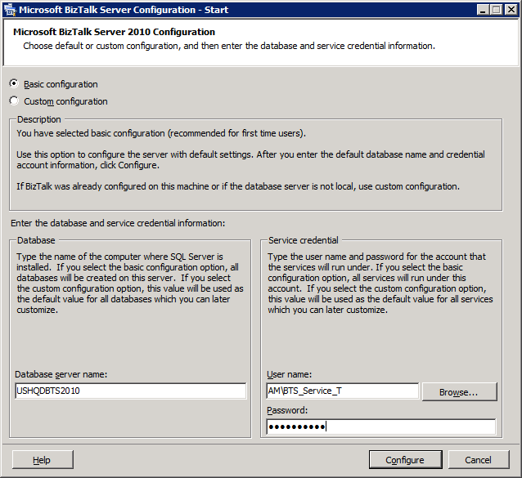
Click ‘Configure’

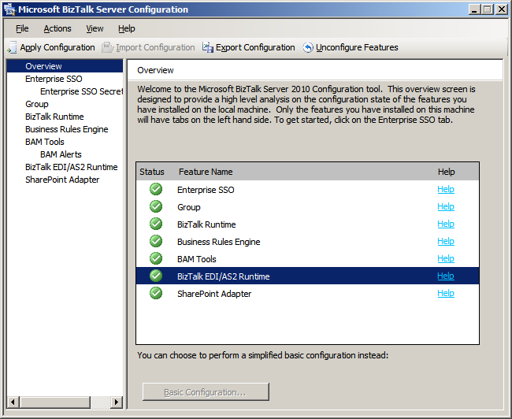
BizTalk is now configured, your screen should have all green checkmarks, close the BizTalk Configuration Tool, the BizTalk Server is now installed and configured

Enable DTC on the Local Host Server
BizTalk requires the Microsoft Distributed Transaction Coordinator (MS DTC) to be enabled
Configure MSDTC on BizTalk and SQL Servers:
Click ‘Start’, ‘Run’, type ‘dcomcnfg’, and hit the ‘Enter’ key
Under ‘Component Services’, ‘My Computer’, ‘Distributed Transaction Coordinator’, right-click ‘Local DTC’ and select ‘Properties’, click the ‘Security’ tab.
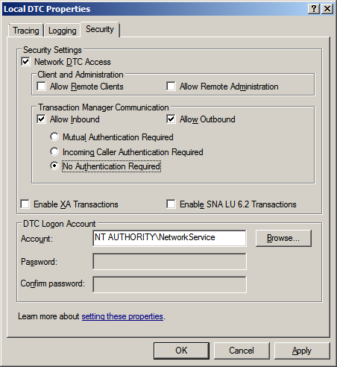
Ensure that the ‘Network DTC Access’, ‘Allow Inbound’, ‘Allow Outbound’, and ‘No Authentication Required’ options are selected and all others are cleared.
Click ‘OK’
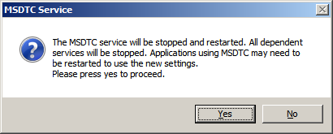
Click ‘Yes’
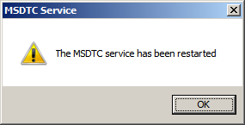
Click ‘OK’ and close the ‘Component Services’

Under ‘Administrative Tools’, ‘Services’, right-click ‘COM+ System Application’ and select ‘Restart’, then do this for the ‘Distributed Transaction Coordinator’, and then the ‘SQL Server (MSSQLSERVER)’ service.

Configure BizTalk Server SQL Jobs
All of the BizTalk jobs are not configured and enabled upon installation. You must configure and enabled these.
All the BizTalk jobs will have an owner of the user that installed BizTalk. Ideally you would want to change the owner to ‘sa’ from your user account on all BizTalk jobs.
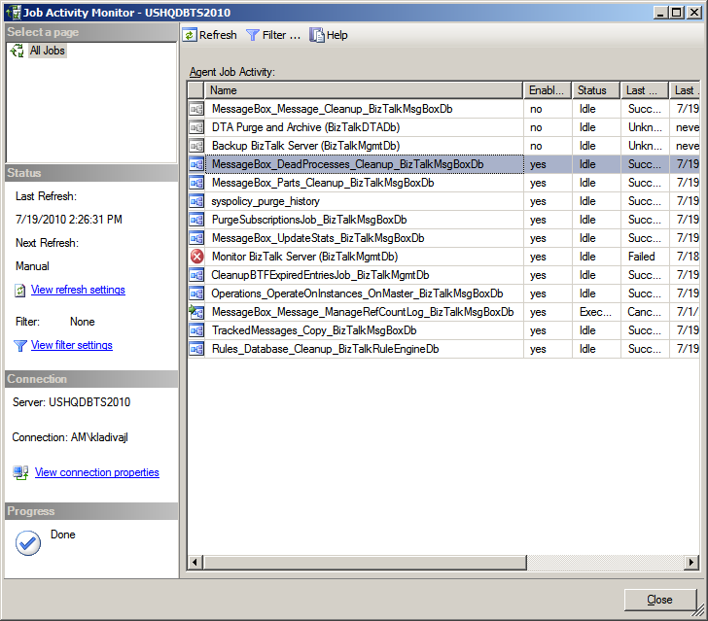
View of the BizTalk job status. As you can see 3 jobs are disabled out of the box. Two BizTalk jobs need to be configured and enabled.

DTA Purge and Archive Job
The original script after installing BizTalk looks like this:
exec dtasp_BackupAndPurgeTrackingDatabase
0, --@nLiveHours tinyint, --Any completed instance older than the live hours +live days
1, --@nLiveDays tinyint = 0, --will be deleted along with all associated data
30, --@nHardDeleteDays tinyint = 0, --all data older than this will be deleted.
null, --@nvcFolder nvarchar(1024) = null, --folder for backup files
null, --@nvcValidatingServer sysname = null,
0 --@fForceBackup int = 0 --
Review the parameters and change them:
declare @dtLastBackup datetime set @dtLastBackup = GetUTCDate()
exec dtasp_PurgeTrackingDatabase 0, 60, 90, @dtLastBackup
NOTE: You have two options, run the dtasp_PurgeTrackingDatabase or dtasp_BackupAndPurgeTrackingDatabase stored proc. We don’t archive to a remote SQL Server so we implemented dtasp_PurgeTrackingDatabase. If you want keep your tracking data for a period of a year, it would be best to archive this off to a remote SQL Server using the dtasp_BackupAndPurgeTrackingDatabase stored proc.
Enable the job and check the job to make sure it ran successfully after the defined interval

Backup BizTalk Server
This is a critical job that must be setup and configured. It consists of 4 steps.
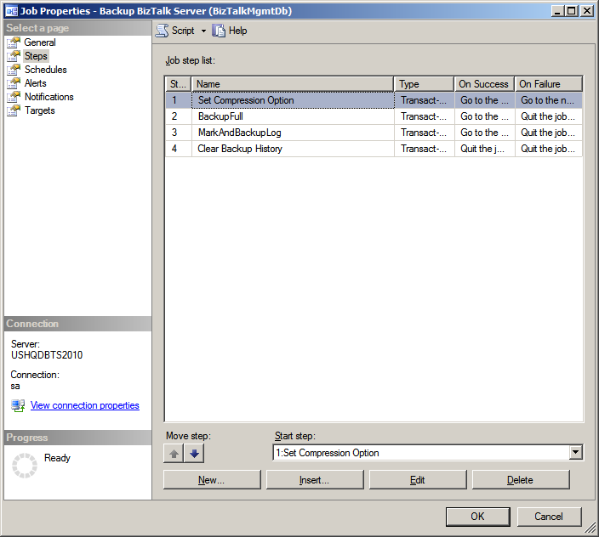
Step 1: Set Compression Option
exec [dbo].[sp_SetBackupCompression] @bCompression = 0 /*0 - Do not use Compression, 1 - Use Compression */
Leave the default settings
Step 2: BackupFull
Original script:
exec [dbo].[sp_BackupAllFull_Schedule] 'd' /* Frequency */, 'BTS' /* Name */, '<destination path>' /* location of backup files */
Change the location of the backup files to match your environment:
exec [dbo].[sp_BackupAllFull_Schedule] 'd' /* Frequency */, 'BTS' /* Name */, 'C:\Program Files\Microsoft SQL Server\MSSQL10_50.MSSQLSERVER\MSSQL\Backup' /* location of backup files */
Step 3: MarkAndBackupLog
Original script:
exec [dbo].[sp_MarkAll] 'BTS' /* Log mark name */, '<destination path>' /* location of backup files */
Change the location of the backup files to match your environment:
exec [dbo].[sp_MarkAll] 'BTS' /* Log mark name */, 'C:\Program Files\Microsoft SQL Server\MSSQL10_50.MSSQLSERVER\MSSQL\Backup' /* location of backup files */
Step 4: Purge Backup History
NOTE: This is a custom step that has been added to remove backups older than 3 days old so the hard drive does not fill up.
Script:
pathstring = "C:\Program Files\Microsoft SQL Server\MSSQL10_50.MSSQLSERVER\MSSQL\Backup\"
daysBack = 2
Set fso = CreateObject("Scripting.FileSystemObject")
For Each file In fso.GetFolder(pathstring).files
If DateValue(file.datelastModified) < DateValue(Now - daysBack) Then
fso.DeleteFile file.Path
End If
Next
Set fso = nothing
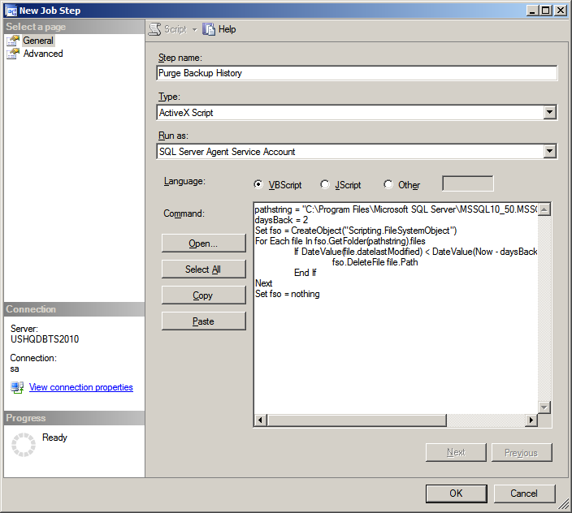
NOTE: You must grant the account NETWORK_SERVICE ‘Modify’ permissions to the ‘C:\Program Files\Microsoft SQL Server\MSSQL10_50.MSSQLSERVER\MSSQL\Backup \’ directory so it can delete files if needed, this is the account SQL Server Agent is running as.
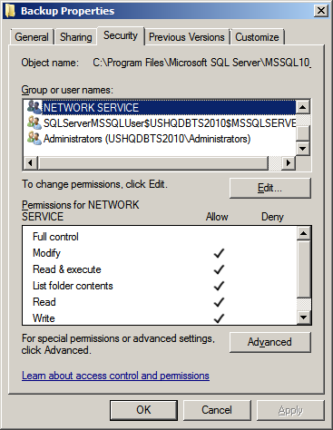
Step 5: Clear Backup History
Original script:
exec [dbo].[sp_DeleteBackupHistory] @DaysToKeep=14
Leave the default settings, enable the job, and run the job and make sure it is successful

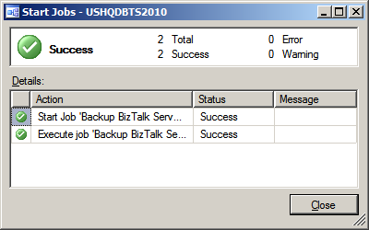
The Backup BizTalk Server job can be manually kicked off, you should see no errors.
Next review the ’Job Activity Monitor’
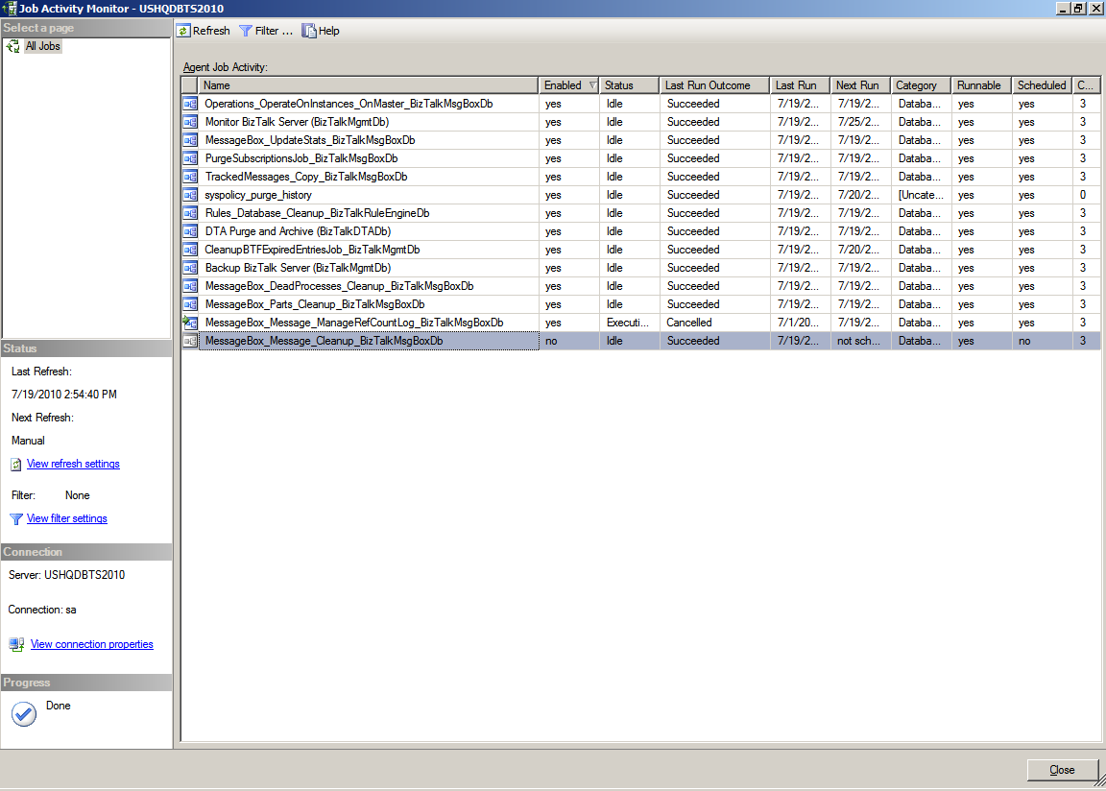
You should see only 1 job not enabled, do not enable this job, it is called by another BizTalk job. The BizTalk jobs are now configured. You must have one of the host instances running otherwise the ‘Monitor BizTalk Server’ job will fail.
NOTE: If you have custom BizTalk databases then you need to perform the steps in the next section to enable BizTalk to mark these databases for point in time recovery using the same process as the BizTalk Server databases

Backing Up Custom BizTalk Databases

To back up custom BizTalk databases you need a add entries into two BizTalk tables, see link below;
http://msdn.microsoft.com/en-us/library/aa561198(BTS.10,printer).aspx

Optional Step – Install the /n software BizTalk Adapters 3.5 Community Edition
Contains excellent FTP Adapters and Zip/UnZip Pipeline components and the ‘Community Edition’ is free
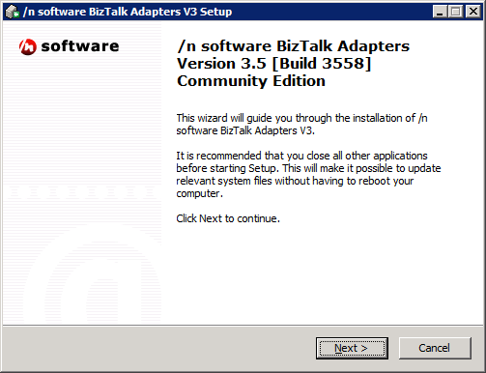
Click ‘Next’
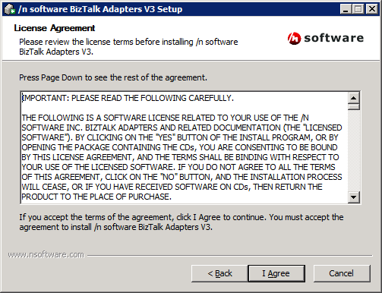
Click ‘I Agree’

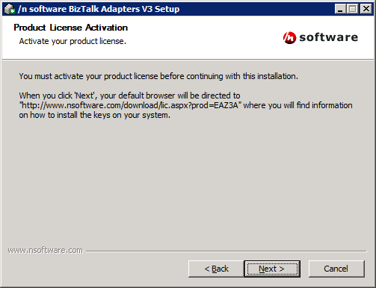
Click ‘Next’
On the webpage, fill out the information and download the file that contains the registry keys to your server, double-click the .reg file to install the keys
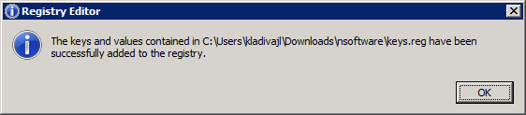
Click ‘OK”

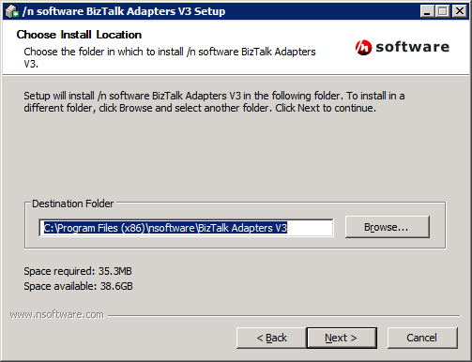
Click ‘Next’
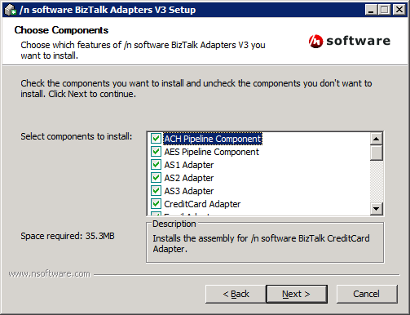
Select the options you want and click ‘Next’

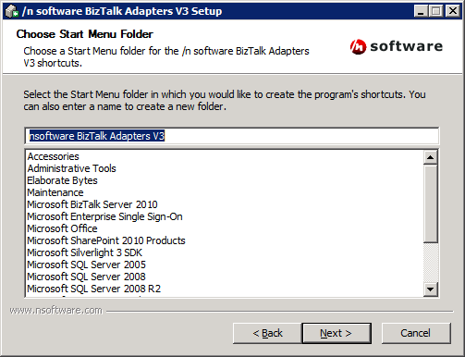
Click ‘Next’

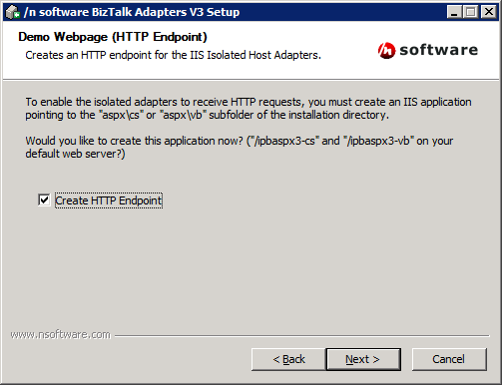
Click ‘Next’
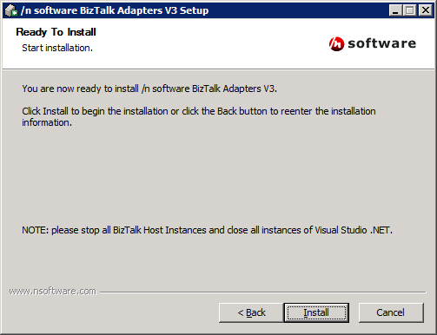
Click ‘Install’

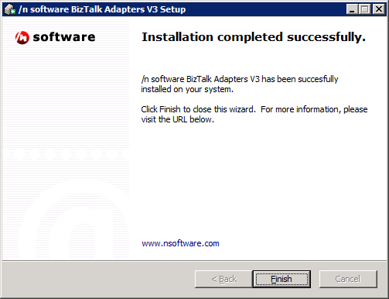
Click ‘Finish’

